Analysis of Concurrent Backscatter Coefficients from In-situ Cloud Probes and Airborne Lidar
Shawn W. Wagner
University of North Dakota, Department of Atmospheric Sciences
Grand Forks, North Dakota, United States
David J. Delene
University of North Dakota, Department of Atmospheric Sciences
Grand Forks, North Dakota, United States
Abstract
Jet engine power loss due to ice particle accumulation is a recognized aviation hazard. High-altitude cirrus clouds can have ice particle concentrations high enough to be dangerous; therefore, pilots need to be informed when aircraft enter such environments. One approach to determining ice particle concentration is an onboard lidar system. A lidar does not directly measure ice particle concentrations but uses the measured backscatter coefficient. Concurrent lidar measurements are compared to backscatter coefficients derived from the particle size distribution. Particle measurements are obtained from wing-mounted, in-situ probes during four sixty-second flight segments at different temperatures (+7°C, +4°C, -33°C, -46°C). The backscatter coefficients derived from external cloud probes (ECP) are correlated (R² of 0.9) with measurements by an airborne lidar system known as the Optical Ice Detector (OID). Differences between the backscatter coefficients range from less than one, to more than three standard deviations of the combined OID and ECP uncertainties. The OID and ECP backscatter coefficients are primarily in agreement for three of the four cases, with disagreement for the -33°C case. The ECP derived backscatter coefficients are lower than the OID for three of the cases, with +7°C being the exception. Measurements over four research flights indicate that the total water content is correlated (R² of 0.74) with the OID backscatter coefficient. The strong correlation indicates that the OID is a useful instrument for determining ice particle concentrations over a broad range of environments, including at ice water contents as low as 0.02 g per m³.
Significance Statement
The purpose is to evaluate an airborne lidar system’s ability to make observations in clouds using research aircraft measurements of Florida thunderstorms. Development of such a system is important for warning flight crews of potentially dangerous conditions. Our results indicate that the lidar system is useful for the detection of such dangerous environments and is a positive step toward improved aircraft passenger safety. Future work should include a wider range of environmental conditions, with more advanced analysis to account for clouds with both liquid water and ice particles.

1. Introduction
Airborne ice particle ingestion into the engines of high-altitude jets can become a serious aviation hazard in certain conditions. A number of power loss events caused by ice ingestion have occurred since 1990 (Lawson et al. 1998), which prompted revised regulations of acceptable flight conditions in glaciated clouds. New regulations have created the need for instruments to alert flight crews whenever aircraft enter clouds with ice particle concentrations that pose a threat. The Optical Ice Detector (OID) is an onboard, short-range cloud lidar designed to detect and characterize hazardous cloud environments (Ray et al. 2009; Halama et al. 2010; Ray and Anderson 2015). As with any cloud lidar, the OID measures backscatter from liquid droplets and ice crystals. The objective of this study is to evaluate OID measurements of unattenuated backscatter using backscatter coefficients derived from particle size distributions obtained from state-of-the-art cloud probe observations. The evaluation uses backscatter coefficient uncertainty obtained by summing the uncertainty in each spectrum size channel. Each channel’s uncertainty is obtained by using both particle concentration and the channel width. Quantitative comparisons of OID backscatter to research grade cloud probes is a major step in the deployment of an onboard lidar system to alert flight crews of dangerous ice concentration conditions.
Since the early 1990s, there have been over 240 ice ingestion-related incidents involving commuter and large transport aircraft (Mason et al. 2006). Many of these aircraft incidents occurred at altitudes greater than 3000 m above MSL (mean sea level) (Bravin et al. 2015) and near convective clouds (Haggerty et al. 2018). Before the early 2000s, the ice particles in convective clouds were believed not to be a threat since they would not adhere to cold aircraft components. However, power loss incident frequency continued to increase as the number of high altitude flights increased. Analysis of 46 power loss events above 3000 m MSL indicated that aircraft would gradually lose power, with some aircraft experiencing total engine shut down. Once the aircraft descended to below 3000 m MSL, failed engines were restarted and normal engine performance was restored.
In 2002, a transport aircraft with dual ice detectors experienced engine power loss without the presence of supercooled liquid water (Mason et al. 2006). Post event analysis concluded that ice ingestion-related shutdowns can take place in environments consisting entirely of ice crystals, not simply in environments with super-cooled liquid water. This aircraft hazard due to ice particles causing engine power loss was termed “ice particle icing” (Mason et al. 2006) or “ice crystal icing” (Haggerty et al. 2018) to differentiate it from “icing” of surfaces from the impaction of super-cooled liquid droplets. A 2013 event that occurred above 10 km caused permanent damage to engine compressors and prompted an Airworthiness Directive issuance (Airworthiness Directives 2013) on 27 November 2013. The Directive required specific Boeing aircraft (models 747-8, 747-8f, and 787-8) to avoid any high ice concentration operations and advise flight crews of potentially dangerous ice particle icing conditions.
Cirrus clouds have been shown to contain potentially high ice crystal concentrations that can be harmful to aircraft engine performance (Gayet et al. 2012; Heymsfield 1986). Lawson et al. 2006a analysis of 22 mid-latitude cirrus clouds had an average ice particle concentration of 1 cm⁻³, with some concentrations above 5 cm⁻³. However, most cirrus clouds have concentrations from 0.01 cm⁻³ to 1 cm⁻³ (Krämer et al. 2009). Ice crystal concentration increases with higher updraft speed and the subsequent increase in supersaturation (Heymsfield and Miloshevich 1993). Frey et al. 2011 found that outflow from developing mesoscale convective systems in Africa contained ice particle concentrations as high as 8.3 cm⁻³, with subvisible cirrus having an average ice particle concentration of 0.01 cm⁻³. See Heymsfield et al. 2017 for details on cirrus cloud development and properties.
Due to their potentially high concentrations, and often lack of visibility to pilots, cirrus clouds pose a large risk for aircraft engine power loss. Mitigating this flight risk requires alerting flight crews of dangerous ice particle concentrations using onboard instrumentation. Research grade instruments for measuring ice particle concentration have been available since the 1970s (Baumgardner et al. 2017). Optical array probes are a class of in-situ instruments that measure individual particle size using the blockage of light (shadows) on an array of diodes (Fig. 1). The size of all observed particles are binned into channels and combined over a time interval to obtain the particle size spectrum. Optical array probes are attached to aircraft wings via a canister (Fig. 1) that is attached to pylons (Fig. 2) to obtain in-situ measurements while passing through clouds. Direct contact of ice particles with probe arms (Fig. 1) can produce particle shattering which corrupts the particle size spectrum measurement. Particle shattering is mitigated using heated anti-shattering tips (Korolev and Isaac 2005). In-situ probes and pylons can affect particles within the observation volume, which may alter measurements by reorganization of particle location by size (known as size sorting) and by rotation of ice crystal (Baumgardner 1984).
To avoid placing instruments directly into the air stream, instruments have been developed that use flush-mounted windows which allow observations without altering the air flow around an aircraft. One such system is the Backscatter Cloud Probe (BCP), which measures the backwards scattering of a continuous wave laser beam from cloud water droplets and ice crystals (Beswick et al. 2014). The BCP has a sample volume of approximately 125 cm³ s⁻¹ (at an aircraft speed of 100 m s⁻¹) that is located approximately 4 cm from the aircraft skin. The BCP can measure particle size distributions from a commercial aircraft platform (Beswick et al. 2015). BCP measurements were validated by comparing results to those of a Cloud Droplet Probe (CDP) and a Cloud and Aerosol Spectrometer (CAS) probe.

2. Measurements
The OID is similar to the BCP in using an observation window; however, the OID uses a lidar with a conical sample volume that extends up to 10 m from the aircraft (Ray and Anderson 2015). The OID sample volume is 4500 cm³ s⁻¹ at 100 m s⁻¹ with a viewing direction perpendicular to the forward motion of the aircraft (Fig. 2). The BCP uses a single linearly polarized wavelength of 658 nm, while the OID uses two wavelengths: a circularly polarized wavelength of 905 nm and a randomly orientated, linearly polarized wavelength of 1550 nm. The circular polarization of the 905 nm beam enables measurement of the fourth Stokes parameter (V) (Liou and Yang 2016; Hulst 1981). Backscatter from the 1550 nm wavelength channel of the OID is not used in this study.
The OID has been deployed on the North Dakota Cessna Citation Research Aircraft (Delene et al. 2019) during several field projects, including a 2015 field project (CAPE2015) to study Florida thunderstorms (Schmidt et al. 2019). The Citation Research Aircraft has conducted several research projects to collect cloud microphysical observations using various instrumentation configurations (Skofronick-Jackson et al. 2014; Jensen et al. 2015; Delene 2016). Multiple field projects have included OID measurements; however, this study analyzes data (Wagner and Delene 2020a) only from CAPE2015 flights, which focused on measurements of cirrus cloud anvils from convective storms. An OID is mounted in the Citation Research Aircraft’s fuselage to measure backscattered light from cloud particles slightly ahead of and along the span of the aircraft wing (Fig. 2). A port is fitted with an anti-reflection coated optical window. A fan moves cabin air across the window to prevent water and ice condensation on the inside surface. A detailed OID diagram of the design of the OID appears in Fig. 1 of Ray and Anderson 2015.
The OID measurement of backscatter coefficient (β in units of km-1 ster-1) assumes a homogeneous cloud particle distribution over the sampling distance R. The backscatter coefficient is calculated by inverting the returned lidar power P(R) equation,
, | (1)
where G_{(R)} is a light collection efficiency as a function of particle range, ε is the extinction coefficient, and R is the range to the particles (Ray and Anderson 2015). The OID emits light pulses at a repetition rate of 20 kHz, with each pulse having a temporal width of 4 ns full width at half maximum (Halama et al. 2010). The 20 kHz measurements are aggregated to produce 5 Hz raw data. Raw data is averaged to match the 1 Hz external cloud probe (ECP) processed data. While the OID transmits both 905 nm and 1550 nm laser light, absorption at 905 nm by water is approximately one thousand times less than that at 1550 nm. Hence, using only the 905 nm wavelength simplifies analysis by eliminating the consideration of absorption. While a complete OID error analysis is not yet available, the primary error source is likely the inversion of the range-resolved lidar signal to estimate extinction. For additional details regarding lidar retrievals, see Lolli et al. 2013.
The North Dakota Citation Research Aircraft instruments measures atmospheric state parameters such as temperature, relative humidity, and wind velocities, as well as the cloud size distribution using a set of in-situ cloud probes. In-situ cloud microphysical instrumentation (Fig. 2) includes a Two-Dimensional Stereo (2D-S) probe (Lawson et al. 2006b), a High-Volume Precipitation Spectrometer Version Three (HVPS3) probe (Kumjian et al. 2016), and a Nevzorov probe (Korolev et al. 2013a). Optical array probes, such as the 2D-S and HVPS3, use a laser beam between probe arms directed onto an array of photo-diodes to observe cloud particles during flight (Fig. 1). The 2D-S has 128 diodes with a 10 µm resolution and the HVPS3 has 128 diodes with a 150 µm resolution. Ice crystals and water droplets passing through the laser beam between the arms block light, causing reduced illumination on the photo-diode array. Images are produced when at least one array element is “shadowed” (i.e. reduced in intensity by 50%). The sampling frequency of the photo-detector array is adjusted using the measured true air speed to produce correctly scaled cloud particle images. When cloud particle concentrations are high, the 2D-S probe may not have sufficient time to off-load the array buffer, which results in reduced probe activity (Lawson et al. 2006b). CAPE2015 has no “dead time” issues as the particle concentration is low enough that the probe’s activity is 100% during all flights analyzed.
The Nevzorov probe is a hot-wire instrument with sensors to measure cloud liquid and total (liquid + ice) water content (Korolev et al. 1998). The total water content sensor uses a conical receiver to collect both liquid water droplets and ice crystals, while the liquid water content sensor uses a round wire to collect droplets but very few ice particles. Both sensors have corresponding reference sensors that are exposed to the airflow but not cloud particles. The additional power required to maintain constant temperature for particle sensors compared to reference sensors is directly related to water mass. Mass measurements and Aircraft true airspeed are used to determine liquid and total water content. Ice water content is not directly measured but calculated by subtracting the liquid water content from the total water content. Nevzorov probe data processing uses multiple linear regressions of the measured static pressure and indicated airspeed to obtain a per-flight calibration, and an automatic baseline correction ensures out-of-cloud water content is zero (Delene et al. 2019). The uncertainty of Nevzorov measurements increases with hydrometeor size because large ice crystals may bounce out of the conical receiver, while large water droplets may not evaporate completely before bouncing from the conical receiver or shedding from the round wire.
In recent years, efforts have been made to collectively document the uncertainties associated with optical cloud microphysical probes (Baumgardner et al. 2017). These uncertainties include the possibility of particles counted in the wrong size channel (Korolev et al. 1991; Baumgardner and Korolev 1997), sizing uncertainty for ice particles outside of the focal volume (Connolly et al. 2007), approximation of irregular ice particles as spheres (Wu and McFarquhar 2016), and particle coincidence (Cooper 1988; Lance 2012; Johnson et al. 2014). These uncertainties are accounted for as much as possible in the data processing and analysis methodology. Additionally, splashing of water droplets and the shattering of ice crystals can cause measurement errors; hence, anti-shattering probe tips and data processing methods have been employed to minimize such issues.

3. Data Processing
The 2D-S and HVPS3 images are processed to obtain particle concentrations using the sample volume (SV) given by
, | (2)
where DOF is the depth of field, w is the effective width of the photo-diode array, TAS is the aircraft’s true airspeed measured by a pitot tube, and t is elapsed time (McFarquhar et al. 2017). The depth of field (Fig. 1) is the region along the laser beam where particles are sufficiently within focus to create a clear shadow on a photo-diode (Korolev 2007). DOF*w is the sample area, while TAS*t provides the third dimension in determining SV. The nose gust boom measured TAS and left wing pitot tube (Fig. 2) measured TAS agree within 3% for the CAPE2015 field project.
Quality control conducted during the CAPE2015 field project involved instrument maintenance and performance checks. Instrument maintenance included cleaning the outside windows on all optical probes before each flight. Performance checks included reviewing the voltages of the first and last (edge) photo-diodes in the cloud probe arrays and ground testing instruments with spray water to ensure correct performance. To minimize the duration of measurement issues cloud particle data are reviewed during and following each research flight. Cloud particle data are monitored by cabin scientist during flight for instrument malfunctions such as stuck-bits (elements with persistently reduced voltages that continuously indicate shadowing) on the photo-diode arrays. To enable timely post-flight data review, the open source Airborne Data Processing and Analysis (ADPAA) software package (Delene 2011) is used to automatically process and visualize data after each flight.
ADPAA assists with post-project quality assurance that is conducted by experienced instrument operators to ensure the data set is satisfactory for the intended scientific analysis. For example, the two-dimensional probe images are reviewed for diode malfunctions, such as stuck-bits, that would be problematic for software processing. Data quality issues are documented in an “edit” file, and the parameter’s value is replaced with the missing value code for the affected time interval. Even with rigorous instrument quality control and assurance, data set problems can still occur. For example, the liquid cloud droplet size spectrum measured by a CDP is inconsistent (i.e. a factor of ten low) compared to the 2D-S size spectrum in the overlapping region. Misalignment of the CDP laser discovered after the CAPE2015 project makes the CDP measurements validity questionable; therefore, only the 2D-S and HVPS3 instruments are used to create a combined size spectrum.
All CAPE2015 two-dimensional optical array probe data are automatically processed using ADPAA code (Delene et al. 2020) that interfaces with the System for Optical Array Probe Data Analysis Version 2 (SODA2) software package (Bansemer 2013). Data processing uses SODA2’s fast-circle method for determining particle diameter from two-dimensional probe images. The fast-circle method uses the diameter of the smallest particle-encompassing circle to represent the particle diameter (Wu and McFarquhar 2016). A data processing correction for out-of-focus droplets (Korolev 2007) is used during periods when only liquid droplets are sampled. A liquid water droplet acts as a lens, causing light refraction that results in a bright spot (known as a Poisson spot) in the center of the particle shadow. This results in out-of-focus particles having larger shadowed areas. SODA2’s water processing corrects for these excessively large particle diameters by comparing the Poisson spot area to the area of the whole particle shadow. This area ratio is used to reduce the droplet diameter to the correct size. Out-of-focus ice crystals also have Poisson spots; however, due to their irregular shape, a similar correction cannot be made and is a potential source of error in this study. Even when using Korolev anti-shatter tips, bursts of particles over a short sampling period are likely shattering artifacts (Field et al. 2006); therefore, SODA’s shattering artifact rejection methodology is used for all CAPE2015 data processing.
SODA2 processing of the CAPE2015 2D-S and HVPS3 images uses the center-of-mass-in method (Heymsfield and Parrish 1978) to obtain particle concentrations. Center-of-mass-in processing calculates concentration using only particles where the estimated center of the particle shadow is between the edge elements of the photo-diode array. An ADPAA script merges 2D-S horizontal arms size channels (5 to 1000 µm) and HVPS3 (1000 to 30 000 µm) size channels produced by SODA2 to create a combined particle size distribution (Table 1). The full reconstruction method has also been used to process and analyze CAPE2015 data (Wagner 2020). Full particle reconstruction includes all particles instead of only reconstructing particles where the center of mass is determined to be within the edge of the photo-diode array. An image with only a couple of edge elements shadowed is interpreted as a small particle using the full reconstruction method, while the center-of-mass-in method excludes such particles. While edge element images are not that frequent, a few small particles have a large effect on the 5 to 105 µm diameter size spectrum since the sample volume within this size range is so small. Small particles have a limited depth of field for in-focus particles, which results in the small sample volume. Additionally, determining particle diameter using an image where most of the particle is outside the photo-diode array results in a large uncertainty for irregularly shaped particles since accurate reconstruction is difficult. Furthermore, using full particle reconstruction for CAPE2015 is not necessary since HVPS3 measurements are available to cover the larger particle size range, and the observed cirrus clouds do not contain many particles large enough to be excluded by center-of-mass-in HVPS3 processing. Hence, the center-of-mass-in method is used exclusively for the following analysis.

4. Methodology
Cloud particles are typically much larger than the wavelengths (905 nm and 1550 nm) of the OID, especially particles in cirrus cloud anvils. The ratio of particle diameter to wavelength defines the type of light scattering (geometric, Mie, or Rayleigh) and is known as the size parameter α, which is given by:
, | (3)
where D is the cloud particle diameter, and λ is the wavelength of incident light (Hulst 1981). Light scattering is in the geometric regime when the size parameter is greater than 100, in the Mie regime when the size parameter is between 0.1 and 100, and in the Rayleigh regime when the size parameter is less than 0.1 (Bohren and Huffman 1983). Most size channels of the combined cloud probe spectrum are in the geometric scattering regime (Table 1). However, determining backscatter coefficients from particle size distributions using geometric optics methods produces inaccuracies due to a lack of higher-order scattering terms (Zhou and Yang 2015; Yang and Liou 1995). While Mie theory strictly applies to spherical particles, studies have found that uncertainties in using spherical Mie theory code for aspherical scatterers are far less than uncertainties associated with measurements of cloud particle sizes (Cairo et al. 2011). Compared to spherical particles, aspherical particles tend to increase side scattering and reduce forward and backward scattering, which can result in an over estimation of backscatter coefficients by a factor of four (Mishchenko et al. 1996; Cairo et al. 2011). Considering the low backscatter coefficient uncertainty when a sufficient number of terms in the Mie Theory series approximations are used, the entire cloud probe derived size range is processed using Mie theory.
Backscatter coefficients depend on particle scattering efficiency at 180° (backscatter efficiency), the number concentration, and the particle size (Bohren and Huffman 1983). The backscatter coefficient equation (Zhang et al. 2015) is given by
, | (4)
where β_{ECP} is derived backscatter coefficient using the combined particle size distribution from external cloud probes (ECP), i is particle channel number (see Table 1), ni is number of particles in channel i, Q_{i} is scattering efficiency at 180° for channel i, and ri is particle radius of the channel’s midpoint. Backscatter efficiency indicates effectiveness of a particle at scattering in the 180° direction with regard to incident light. Backscatter efficiency is calculated for 100 000 particle diameters spanning 1 µm to 30 mm using the Python based software, MiePlot (Laven 2018). Backscatter efficiency calculations use 20°C for the medium temperature, 905 nm for the incident light wavelength, and refractive indices of 1.3263 + 5.6 x 10⁻⁷j for water at 20°C (Kedenburg et al. 2012) and 1.3031 + 5.6 x 10⁻⁷j for ice (Warren and Brandt 2008). The refractive indices depend not only on incident wavelength but also on particle temperature (Wesely 1976). However, sensitivity tests using 0°C and 10°C water refractive indices show a difference of less than 1% for particle diameters up to 105 µm. Correct utilization of MiePlot for determination of water backscatter efficiency has been confirmed by obtaining results comparable to Fig. 61 of Hulst 1981 and Fig. 1 of Lolli et al. 2013.
Backscatter efficiency is averaged for all particle diameters within each channel (Shishko et al. 2020) in the combined particle size spectrum (Fig. 3). Diameters are distributed log-normally between 1 µm and 30 mm, with intervals ranging from 0.0001 µm between the smallest diameters to 3 µm between the largest diameters. Averaging over channel intervals smooths out rapid changes in backscatter efficiencies with diameter. As a result, the backscatter efficiencies for water and ice are nearly constant (within approximately 10%) for particle diameters up to 105 µm (the upper limit of size bin 10 in Table 1). Above 105 µm, water has a backscatter efficiency that increases, while ice has a backscatter efficiency that decreases. There is a backscatter efficiency dip around 10 000 µm diameter, which is likely due to destructive interference of surface waves. Backscatter can be conceptualized as a light wave scattering back to the source by exiting at a 180° angle after traveling around the droplet’s surface, sometimes traversing around many times. The existence of surface waves in droplets has been directly observed (Fahlen and Bryant 1966) and is responsible for the well-known “glory phenomenon” (Gillis et al. 1998) that is produced by strong light backscattering. Surface waves traveling around the droplet a variable number of times can destructively interfere resulting in rapid backscatter efficiency changes as seen in Fig. 3 (Hovenac and Lock 1992). While interesting, the backscatter efficiency dip around 10 000 µm diameter is irrelevant for this study since observed water droplets are much smaller. For more information about the effects of surface waves on light scattering, see Chýlek et al. 1980.
Uncertainty in the backscatter coefficient (δβ_{ECP}) is derived using a weighted error propagation in quadrature method (Berendsen 2011):
, | (5)
where δn_{i} is concentration uncertainty for channel i and δr_{i} is particle radius uncertainty for channel i. Poisson statistics determine absolute uncertainty in concentration:
, | (6)
where N_{i} is counted particle number per channel (Horvath et al. 1990). Another example of applying Poisson statistics to cloud probe analysis can be found in Baumgardner et al. 2014. One half the channel width is used as the particle radius uncertainty, which is a lower bound on the uncertainty. Additional factors could result in a larger uncertainty. For example, particles outside the depth of field appear too large and hence not within the correct size channel (O’Shea et al. 2019).
The 1Hz OID backscatter coefficient uncertainty (δβ_{OID}) is the standard deviation of the 5 Hz OID data. The standard deviation includes some natural variability, as the aircraft traverses different cloud conditions, in addition to random uncertainty; hence, the uncertainty is an upper bound. OID and ECP agreement is considered to occur when the measurement difference is less than three standard deviations (Berendsen 2011), which is calculated using:
, | (7)
Thus, a time series plot of the OID and ECP backscatter coefficient difference is useful to determine periods of measurement agreement and disagreement. Neither (5) nor (7) include any systematic errors (e.g. uncertainty in scattering efficiency).

5. Results
OID backscatter coefficients are compared to 1 Hz backscatter coefficients derived from the external cloud probes. Case study analysis and discussion is done on four, 60 s, CAPE2015 flight segments before examining the larger CAPE2015 data set. The cases (Table 2) are at four different temperatures (+7°C, +4°C, -33°C and -46°C), which provide two warm cloud cases and two cold cloud cases at constant flight heading and altitude (Fig. 4). The warm cases (Fig. 4A and 4B) are at approximately 3 km altitude over the ocean, just off the east coast of Florida. The warm cloud cases have small liquid droplets that are not observerable on radar (Table 2). The +7°C case occurred early in the flight while waiting for air traffic control climb permission. Similarly, the +4°C case also occurred before ascending to sample cirrus clouds. As expected for these warm temperatures, the 2D-S images (Fig. 4A and 4B) show small spherical droplets. Many droplets are out-of-focus, which requires special data processing to size correctly. The cold cases (Fig. 4C and 4D) occurred above 9 km in cirrus cloud anvils. Melbourne radar observations has cloud bases at 1000 m MSL (Table 2) for both cold cloud cases, which indicates sampling is above the stratus rain region, instead of the cirrus anvil outflow region of the storm. Cloud tops are located at 11 000 m MSL for the -33°C case, and 15 000 m MSL for the -46°C case. The 2D-S images show mostly irregularly shaped particles indicative of ice crystals. The -33°C case has some small particles appearing round, which could indicate liquid water in the cloud. Many crystals are out-of-focus; however, special data processing software does not exist to correct the crystal size.
Cloud probe images (2D-S and HVPS3) are processed and combined to create a 1 Hz particle size spectrum. The particle size spectrum is used to derive backscatter coefficients (4) and uncertainty (5). The absolute uncertainty is greatest for the +7°C case (Fig. 5A) because the backscatter coefficient magnitude is ten times the +4°C case and one hundred times the cold cases. Fig. 6A shows that OID and ECP backscatter coefficients are in agreement (within three standard deviations) at all times for the +7°C case. The greatest difference occurs at 69 520 seconds from midnight (sfm), where the ECP backscatter coefficient is twice the OID’s. Overall, the +7°C case ECP backscatter coefficient is typically higher than the OID. The +7°C water cloud contains high concentrations of small droplets (i.e. 20 µm mean diameter), with the majority of the calculated backscatter due to droplets less than 30 µm (Fig. 7).
Figure 5B shows that the +4°C case has ECP backscatter coefficients that vary with the OID backscatter coefficient; however, the ECP backscatter coefficient is consistently lower. The OID and ECP backscatter coefficients agree within uncertainties (Fig. 6B) throughout most of the period; however, the OID backscatter coefficients are approximately twice the ECP backscatter coefficients at 57 864 sfm and 57 878 sfm. The difference changes little because the particle concentration (Fig. 7A) and mean diameter (Fig. 7B) are approximately constant. Compared to the +7°C case, the concentration is an order of magnitude less, and the mean diameter is greater, being approximately 50 µm instead of 10 µm. Many of the observed drops are from 30 µm to 70 µm, with the particle size distribution peaking at approximately 50 µm. Particles from 100 to 300 µm diameter are one hundred times more plentiful than in the +7°C case.
For the -33°C case (Fig. 5C and Fig. 6C), the OID and ECP backscatter coefficients are in agreement for the first 20 s. Similarly to the +4°C case, the OID backscatter coefficient is consistently higher than that ECP backscatter coefficient. However, around 71 735 sfm there is a sudden change in backscatter coefficient agreement that corresponds to an increase in mean particle size and concentration. Figure 7A shows particle concentration increasing from approximately 0.02 cm⁻³ to 0.2 cm⁻³, and Fig. 7B shows the mean particle diameter increasing from 300 µm to slightly over 1000 µm around the 71 735 sfm change. For the last 30 s, the OID backscatter coefficient is approximately twice the ECP backscatter coefficient, with disagreement exceeding three standard deviations. The particle size spectrum (Fig. 7C) and backscatter coefficient (Fig. 7D) are much broader and flatter than in the warm cloud cases. Figure 7D indicates the majority of the backscatter coefficient is due to particles from 200 to 3000 µm in diameter.
The -46°C case (Fig. 5D) has the smallest differences between the backscatter coefficients. For the first 40 s, the ECP derived backscatter coefficient is nearly equal to, but consistently less than, that of the OID; however, both measurements exhibit the same temporal trends. For the last half of the period, the backscatter coefficients are shown by Fig. 6D to always be in agreement. As Fig. 7B shows, the mean particle diameter is constant at approximately 500 µm, with a decrease at the end of the period. Both the -46°C case and -33°C case show 2D-S images with large, irregularly shaped particles (Fig. 4D and 4C, respectively). The -46°C case has small particles that are irregular in shape, while the -33°C case contains small particles that appear round.
There is a strong correlation (R² of 0.90) between β_{ECP} versus β_{OID} with the linear fit line being slightly greater than one-to-one (Fig. 8.) Figure 9 shows the total water content (TWC) versus backscatter coefficient has a power-law relationship. The Backscatter-TWC relationship indicates the OID instrument is sensitive to TWC over a wide range of cloud conditions, including in clouds with particle concentrations as low as 0.02 g m⁻³. Additionally, the OID is sensitive to small values of TWC (plot insert in Fig. 9) in thin ice clouds, which is an important characteristic for deployment on high flying aircraft. The OID has less scatter than the ECP for the Backscatter-TWC plots, likely due to the larger sample volume of the OID. Figure 10 includes all data greater than 0ºC and less than -20ºC for the complete case study flights. Data between 0ºC and 20ºC are omitted to exclude strongly mixed-phase cloud conditions. Figure 10 shows much more scatter between the ECP and OID backscatter coefficients than Fig. 8. Unlike Fig. 8, the trend of Fig. 10 indicates the ECP produces higher values than the OID as backscatter coefficients increase. Similarly, Fig. 10 shows more scatter between the OID backscatter coefficient and the Nevzorov probe TWC than seen in Fig. 9 (R² of 0.74).

6. Discussion
The +7°C case has the largest backscatter coefficient and the only case where ECP derived backscatter coefficient is larger than the OID measurement. This is due to high droplet concentrations saturating the OID above its detection limit of 22 km⁻¹ sr⁻¹. The OID’s limited dynamic range in a dense cloud of small water droplets is not a serious liability since sensing ice particle concentration is the main measurement objective and warm water clouds do not produce ice particle icing. Environments containing severe liquid water icing conditions would be flagged without having to exceed measurements of 22 km⁻¹ sr⁻¹. Note that the cumulus cloud sampled in the +7°C case has a large water content (Table 2), and the backscatter coefficients to water content comparisons indicates the OID is able to measure over 1.0 g m⁻³ before saturation (Fig. 9).
Excluding the +7°C case, ECP backscatter coefficients are consistently lower than those measured by the OID (Fig. 5B, 5C, and 5D). The consistent difference between the OID and ECP suggests a possible systematic error. Two-dimensional cloud imaging probes (Fig. 1) have several factors that can bias sizing and counting of particles. For example, particle diameters less than 100 µm are difficult for the 2D-S to measure due to the small depth of field, which could result in lower backscatter coefficients than those measured by the OID. However, the 2D-S liquid water content (LWC) is larger than the Nevzorov probe measurements for the CAPE2015 field project. It seems the Nevzorov LWC is low, which may result from an inability to fully capture and/or evaporate the largest water droplets. The OID measurements may have a bias despite no indication of malfunctions. Another possibility is the OID receiving backscatter from particles too small to be measured by the two-dimensional cloud imaging probes; however, Fig. 7D indicates low backscatter coefficient contribution from the smallest sized channels.. Additional measurements with carefully calibrated instruments are necessary to resolve the discrepancy between the OID and ECP for liquid water droplets; however, the OID and ECP measurements do agree within the calculated uncertainties most of the time for liquid clouds (Fig. 6).
There are other possible errors which affect both liquid water and ice water measurements. A bias in concentration could be due to an error in air speed used for determining the sampling volume (2). However, the aircraft’s air speed error is estimated to be between 1% and 3% based on measurement comparisons, which is too small to account for the bias. Another error source may be coupling probes to the ambient environment. Air flow around instrument pylons can be affected even when probes are placed well in front of the wing’s leading edge (Baumgardner 1984). Pressure changes and streamlines alter particle flow around both wings and instruments, with small particles being most heavily affected (Spanu et al. 2020). This phenomenon results in lower measured concentrations of small particles. Another possible concentration bias is in processing asynchronous 2D probe images to calculate the sample area. Errors in determining sample area are size dependent and larger for small particles (Korolev et al. 2013b); therefore, such errors are more important for the +7°C and +4°C cases.
A sample area error affects particle concentration, which has the larger uncertainty contribution. The +4°C case (Fig. 9) has an average contribution to uncertainty (6) of 0.36 km⁻¹ sr⁻¹ from particle concentration, while only 0.04 km⁻¹ sr⁻¹ from particle size. Similarly, the -46°C case (Fig. 5D) has uncertainty of 0.40 km⁻¹ sr⁻¹ from concentration and only 0.05 km⁻¹ sr⁻¹ from particle size. Hence, the primary contributor to total uncertainty is fluctuation in concentration. Concentration uncertainty can be reduced by averaging over longer time periods; however, systematic differences between the OID and ECP would not be reduced.
Bias in calculated sample volume cannot explain the change in agreement between OID and ECP backscatter coefficients that occurred between 71 730 sfm and 71 740 sfm for the -33°C case (Fig. 4C, 5C, and 6C). Onset of the discrepancy could be due to a change in the particle size spectrum (Fig. 11). Manually reviewing 2D-S and HVPS3 images indicates an increased number of larger particles between the first and last 20 s of the -33°C case. This change in particle size distribution is believable since there is a smooth decrease in concentration with increasing size. Furthermore, the 2D-S/HVPS3 particle size distribution is similar to the Two Dimensional Cloud (2D-C) probe (Fig. 2) distribution (Fig. 11), and performance checks conducted by the manufacturers after CAPE2015 found no measurement issues. Additionally, there is no reason not to believe the OID measurements as a manufacturer’s review indicated no measurement issues. Therefore, both the OID and ECP measurements seem to be valid for the -33°C case.
A notable difference between the -33°C and -46°C cases is LWC measured by the Nevzorov probe (Fig. 12). The Nevzorov probe measurement for the -46°C case has near zero LWC, as expected for a temperature below homogeneous freezing. However, the Nevzorov probe measurement indicates a mixed phase cloud for the -33°C case. While there is LWC data shown for the entire -33°C case, LWC increases from an average of 0.022 g m⁻³ to 0.027 g m⁻³ (~30% of the TWC) just after disagreement between backscatter coefficients begins. It should be noted that while the Nevzorov probe has a collection efficiency of nearly 1 for droplets with a diameter less than 100 µm (Korolev et al. 1998), collection efficiency is approximately 0.5 for clouds with a mean particle volume diameter of 150 – 200 µm (Biter et. al 1987). During the disagreement period, there are significantly more particles with diameters from 150 to 200 µm (Fig. 11), which would require a greater, and not readily available, correction to Nevzorov probe LWC measurements.
Even at temperatures as low as -33°C, supercooled liquid water droplets can still exist (Rosenfeld and Woodley 2000). Supercooled liquid water droplets have even been observed by the same OID at temperatures as low as -30°C in Anderson and Ray 2019. Similarly to Anderson and Ray 2019, such supercooled liquid water droplets are evident, but not proven, by the round particles seen in 2D-S images taken at the LWC measurement peak (Fig. 4C). Additionally, the Rosemount Icing Detector (Fig. 2) rod frequency (not shown) indicates the presence of LWC. We speculate that the presence of supercooled liquid water droplets in the -33°C case results in larger OID backscatter coefficients due to higher (see Q Ratios in Table 1) water backscatter efficiency (Fig. 3). Using liquid water scattering efficiencies to calculate ECP backscatter coefficients for particles less than 500 μm results in ECP/OID agreement for the -33°C case. Accounting for mixed phase conditions in ECP backscatter coefficients would require a methodology able to simultaneously utilize a particle size spectrum for both liquid water and ice, which is beyond the scope of this study.

7. Conclusions
A backscatter coefficient comparison is conducted for both warm and cold clouds of an in-situ lidar (OID) and estimates from externally mounted cloud particle probes (ECP). ECP derived backscatter coefficients are consistently lower than OID measurements for the +4°C, -33°C, and -46°C cases, suggesting a systematic bias in either or both data sets. However, the ECP derived backscatter coefficient is higher than OID measurement for the +7°C case due to OID saturation. ECP backscatter coefficients are less than three standard deviations from OID measurements, indicating agreement for the +7°C case and most of the +4°C and -46°C cases. The -33°C case has disagreement for 35 s out of 60 s, which is likely due to using ice scattering efficiencies for all particles when small particles are liquid. All case comparisons show qualitatively that backscatter coefficients are a suitable proxy for liquid and ice water contents as low as 0.02 g m⁻³. A comparison between OID and ECP backscatter coefficients to Nevzorov probe total water content for all times during four CAPE2015 flights (Fig. 10) has a correlation above 0.7. Considering the measurement uncertainties, the case study analysis, and overall flight comparison, the OID is a useful tool in detecting dangerous ice particle icing conditions, even at low concentrations.
The CAPE2015 field project analysis could be expanded to include additional field projects. Additionally, future work could include both the 905 nm and 1550 nm OID wavelengths. Using both wavelengths would allow two parameters of cloud particle size distributions to be determined, helping to obtain a total water content. Additionally, OID polarization measurements could distinguish the liquid/ice fraction of clouds (Yang et al. 2003). New instrumentation, such as the Particle Habit Imaging and Polar Scattering (PHIPS) probe (Schön et al. 2011) deployed during the CapeEx19 Florida field project, would be very useful in determining the fraction of liquid water in mixed phase clouds. Quantifying the liquid water fraction of mixed phase clouds would allow for creation of both liquid and ice 1 Hz particle size distributions, so liquid and ice scattering efficiencies could simultaneously be used to obtain the backscattering coefficient. PHIPS data would also aid in the identification of ice particle habits. Knowing the ice particle habits would allow for more accurate scattering calculations to be utilized (Yang et al. 2005).

8. Data and Software Availability
The paper’s data set is freely accessible online through the Chester Fritz Library’s data collection (Wagner and Delene 2020a). Archived data consists of 1 Hz data from four Florida flights in 2015. Data set measurements include the Two-Dimensional Stereo probe (2D-S), High-Volume Precipitation Spectrometer Version Three (HVPS3) probe and Nevzorov probe. 2D-S and HVPS3 spectrum are combined to create a single particle size distribution spanning both probe size ranges. Backscatter coefficients are computed from this composite size spectrum. Atmospheric variables such as pressure, temperature, dew point, and wind velocity are also included in the data archive.
ADPAA software used to process the raw data is freely available from a software repository (Delene et al. 2020). Also, specialized software used in the paper’s analysis is available in a publicly accessible repository (Wagner and Delene 2020b). Software processing configuration details are documented in a work-flow script entitled “oid_analysis_workflow” (Wagner 2020). The work-flow script contains execution calls to ADPAA modules used to process and analyze the paper’s data set. Whereas ADPAA processes data from many field projects, the work-flow script applies only to this paper’s analysis. The MiePlot software package (Laven 2018) used to calculate backscatter efficiencies is readily available online.

Acknowledgments
First author, Shawn Wagner, conducted data analysis and lead manuscript writing. Co-author David Delene developed the project’s design and scope. David Delene headed external cloud probe analysis. Both authors reviewed and edited the manuscript. Opinions expressed in this paper are those of the authors and do not reflect opinions of others who aided in this research.
We are grateful to the National Center for Atmospheric Research (NCAR), and the lead developer Aaron Bansemer, for making available the SODA software used in this research. Thank you to NASA for use of 2D-S, HVPS3, and Nevzorov probe instruments during the CAPE2015 field project. Kaare Anderson provided processed OID data for CAPE2015. The CAPE2015 aircraft flight crew members included flight engineers Jamie Ekness (Graduate Student), Kryzsztof Markowicz (Graduate Student) and Nicholas Gapp (Undergraduate Student), flight scientist David Delene, and research pilots Wayne Schindler and Jonathan Sepulveda. Thanks to Andrew Detwiler for providing comments on draft versions of the paper. CAPE2015 was sponsored by the Naval Surface Warfare Center, Dahlgren Division, grant (UND0020625, UND0020633, UND0020634). Funding to conduct data analysis was provided by the North Dakota Department of Commerce (UND0021191).
References
Airworthiness Directives, 2013: The Boeing Company Airplanes. Federal Register. https://www.federalregister.gov/documents/2013/11/27/2013-28638/airworthiness-directives-the-boeing-company-airplanes (Accessed January 21, 2020).
Anderson, K. J., and M. D. Ray, 2019: SLD and Ice Crystal Discrimination with the Optical Ice Detector. SAE International.
Bansemer, Aaron, 2013: Software for OAP Data Analysis Version 2. Github,. https://github.com/abansemer/soda2.
Baumgardner, D., 1984. The effects of air-flow distortion on aircraft measurement: A workshop summary. Bulletin Of The American Meteorological Society, 65, 1212-1213.
——, and A. Korolev, 1997: Airspeed Corrections for Optical Array Probe Sample Volumes. J. Atmos. Oceanic Technol., 14, 1224–1229, https://doi.org/10.1175/1520-0426(1997)014<1224:ACFOAP>2.0.CO;2.
——, and Coauthors, 2017: Cloud Ice Properties: In Situ Measurement Challenges. Meteorological Monographs, 58, 9.1-9.23, https://doi.org/10.1175/AMSMONOGRAPHS-D-16-0011.1.
——, R. Newton, M. Krämer, J. Meyer, A. Beyer, M. Wendisch, and P. Vochezer, 2014: The Cloud Particle Spectrometer with Polarization Detection (CPSPD): A next generation open-path cloud probe for distinguishing liquid cloud droplets from ice crystals. Atmospheric Research, 142, 2–14, https://doi.org/10.1016/j.atmosres.2013.12.010.
Berendsen, H. J. C., 2011: A Student’s Guide to Data and Error Analysis. Cambridge Core, https://doi.org/10.1017/CBO9780511921247.
Beswick, K., D. Baumgardner, M. Gallagher, A. Volz-Thomas, P. Nedelec, K.-Y. Wang, and S. Lance, 2014: The backscatter cloud probe; a compact low-profile autonomous optical spectrometer. Atmospheric Measurement Techniques, 7, 1443–1457, https://doi.org/10.5194/amt-7-1443-2014.
——, and Coauthors, 2015: Properties of Small Cirrus Ice Crystals from Commercial Aircraft Measurements and Implications for Flight Operations. Tellus B: Chemical and Physical Meteorology, 67, 27876, https://doi.org/10.3402/tellusb.v67.27876.
Biter, C. J., J. E. Dye, D. Huffman, and W. D. King, 1987: The Drop-Size Response of the CSIRO Liquid Water Probe. J. Atmos. Oceanic Technol., 4, 359–367, https://doi.org/10.1175/1520-0426(1987)004<0359:TDSROT>2.0.CO;2.
Bohren, C. F., and D. R. Huffman, 1983: Absorption and scattering of light by small particles. Wiley, xiv+530 pp.
Bravin, M., J. W. Strapp, and J. Mason, 2015: An Investigation into Location and Convective Lifecycle Trends in an Ice Crystal Icing Engine Event Database. SAE International.
Cairo, F., G. D. Donfrancesco, M. Snels, F. Fierli, M. Viterbini, S. Borrmann, and W. Frey, 2011: A comparison of light backscattering and particle size distribution measurements in tropical cirrus clouds. Atmospheric Measurement Techniques, 4, 557–570, https://doi.org/10.5194/amt-4-557-2011.
Chýlek, P., J. T. Kiehl, M. K. W. Ko, and A. Ashkin, 1980: Surface Waves in Light Scattering by Spherical and Non-Spherical Particles. Light Scattering by Irregularly Shaped Particles, D.W. Schuerman, Ed., Springer US, 153–164.
Connolly, P. J., M. J. Flynn, Z. Ulanowski, T. W. Choularton, M. W. Gallagher, and K. N. Bower, 2007: Calibration of the Cloud Particle Imager Probes Using Calibration Beads and Ice Crystal Analogs: The Depth of Field. J. Atmos. Oceanic Technol., 24, 1860–1879, https://doi.org/10.1175/JTECH2096.1.
Cooper, W. A., 1988: Effects of Coincidence on Measurements with a Forward Scattering Spectrometer Probe. J. Atmos. Oceanic Technol., 5, 823–832, https://doi.org/10.1175/1520-0426(1988)005<0823:EOCOMW>2.0.CO;2.
Delene, D. J., 2011: Airborne data processing and analysis software package. Earth Sci Inform, 4, 29–44, https://doi.org/10.1007/s12145-010-0061-4.
——, 2016: Suitability of North Dakota for Conducting Effective Hygroscopic Seeding. JournalWeaMod, 48, 43–67.
——, K. Hibert, M. Poellot, and N. Brackin, 2019: The North Dakota Citation Research Aircraft Measurement Platform. 2019 SAE International Conference on Icing of Aircraft, Engines, and Structures.
——, A. Skow, J. O'Brien, N. Gapp, S. Wagner, K. Hibert, K. Sand, and G. Sova, 30 March 2020, Airborne Data Processing and Analysis Software Package (Version 3981), Zenodo, doi:10.5281/zenodo.3733448.
Fahlen, T. S., and H. C. Bryant, 1966: Direct Observation of Surface Waves on Water Droplets*. J. Opt. Soc. Am., JOSA, 56, 1635–1636, https://doi.org/10.1364/JOSA.56.001635.
Field, P. R., A. J. Heymsfield, and A. Bansemer, 2006: Shattering and Particle Interarrival Times Measured by Optical Array Probes in Ice Clouds. J. Atmos. Oceanic Technol., 23, 1357–1371, https://doi.org/10.1175/JTECH1922.1.
Frey, W., and Coauthors, 2011: In situ measurements of tropical cloud properties in the West African Monsoon: upper tropospheric ice clouds, Mesoscale Convective System outflow, and subvisual cirrus. Atmospheric Chemistry and Physics, 11, 5569–5590, https://doi.org/10.5194/acp-11-5569-2011.
Gayet, J. F., and Coauthors, 2012: On the observation of unusual high concentration of small chain-like aggregate ice crystals and large ice water contents near the top of a deep convective cloud during the CIRCLE-2 experiment. Atmospheric Chemistry and Physics, 12, 727–744, https://doi.org/10.5194/acp-12-727-2012.
Gillis, P., C. Deleuze, V. P. Henri, and J. M. Lesceux, 1998: Backscattering of light from a water droplet: The glory effect. American Journal of Physics, 50, 416, https://doi.org/10.1119/1.12828.
Haggerty, J., and Coauthors, 2018: Detecting Clouds Associated with Jet Engine Ice Crystal Icing. Bull. Amer. Meteor. Soc., 100, 31–40, https://doi.org/10.1175/BAMS-D-17-0252.1.
Halama, G., M. Ray, K. Anderson, M. Nesnidal, and R. Ide, 2010: Optical Ice Detection: Test Results from the NASA Glenn Icing Research Tunnel. AIAA Atmospheric and Space Environments Conference, American Institute of Aeronautics and Astronautics.
Heymsfield, A. J., 1986: Ice Particle Evolution in the Anvil of a Severe Thunderstorm during CCOPE. J. Atmos. Sci., 43, 2463–2478, https://doi.org/10.1175/1520-0469(1986)043<2463:IPEITA>2.0.CO;2.
——, and L. M. Miloshevich, 1993: Homogeneous Ice Nucleation and Supercooled Liquid Water in Orographic Wave Clouds. J. Atmos. Sci., 50, 2335–2353, https://doi.org/10.1175/1520-0469(1993)050<2335:HINASL>2.0.CO;2.
——, and J. L. Parrish, 1978: A Computational Technique for Increasing the Effective Sampling Volume of the PMS Two-Dimensional Particle Size Spectrometer. J. Appl. Meteor., 17, 1566–1572, https://doi.org/10.1175/1520-0450(1978)017<1566:ACTFIT>2.0.CO;2.
——, and Coauthors, 2017: Cirrus Clouds. Meteor. Monogr., 58, 2.1-2.26, https://doi.org/10.1175/AMSMONOGRAPHS-D-16-0010.1.
Horvath, H., R. L. Gunter, and S. W. Wilkison, 1990: Determination of the Coarse Mode of the Atmospheric Aerosol Using Data from a Forward-Scattering Spectrometer Probe. Aerosol Science and Technology, 12, 964–980, https://doi.org/10.1080/02786829008959407.
Hovenac, E. A., and J. A. Lock, 1992: Assessing the contributions of surface waves and complex rays to far-field Mie scattering by use of the Debye series. J. Opt. Soc. Am. A, JOSAA, 9, 781–795, https://doi.org/10.1364/JOSAA.9.000781.
Hulst, H. C. van de, 1981: Light Scattering by Small Particles. Corrected Edition edition. Dover Publications, 496 pp.
Jensen, M. P., and Coauthors, 2015: The Midlatitude Continental Convective Clouds Experiment (MC3E). Bull. Amer. Meteor. Soc., 97, 1667–1686, https://doi.org/10.1175/BAMS-D-14-00228.1.
Johnson, A., S. Lasher-Trapp, A. Bansemer, Z. Ulanowski, and A. J. Heymsfield, 2014: Difficulties in Early Ice Detection with the Small Ice Detector-2 HIAPER (SID-2H) in Maritime Cumuli. J. Atmos. Oceanic Technol., 31, 1263–1275, https://doi.org/10.1175/JTECH-D-13-00079.1.
Kedenburg, S., M. Vieweg, T. Gissibl, and H. Giessen, 2012: Linear refractive index and absorption measurements of nonlinear optical liquids in the visible and near-infrared spectral region. Opt. Mater. Express, OME, 2, 1588–1611, https://doi.org/10.1364/OME.2.001588.
Korolev, A., 2007: Reconstruction of the Sizes of Spherical Particles from Their Shadow Images. Part I: Theoretical Considerations. J. Atmos. Oceanic Technol., 24, 376–389, https://doi.org/10.1175/JTECH1980.1.
——, E. F. Emery, J. W. Strapp, S. G. Cober, and G. A. Isaac, 2013b: Quantification of the Effects of Shattering on Airborne Ice Particle Measurements. J. Atmos. Oceanic Technol., 30, 2527–2553, https://doi.org/10.1175/JTECH-D-13-00115.1.
——, and G. A. Isaac, 2005: Shattering during Sampling by OAPs and HVPS. Part I: Snow Particles. J. Atmos. Oceanic Technol., 22, 528–542, https://doi.org/10.1175/JTECH1720.1.
——, S. V. Kuznetsov, Y. E. Makarov, and V. S. Novikov, 1991: Evaluation of Measurements of Particle Size and Sample Area from Optical Array Probes. J. Atmos. Oceanic Technol., 8, 514–522, https://doi.org/10.1175/1520-0426(1991)008<0514:EOMOPS>2.0.CO;2.
——, J. W. Strapp, G. A. Isaac, and E. Emery, 2013a: Improved Airborne Hot-Wire Measurements of Ice Water Content in Clouds. J. Atmos. Oceanic Technol., 30, 2121–2131, https://doi.org/10.1175/JTECH-D-13-00007.1.
——,——, ——, and A. N. Nevzorov, 1998: The Nevzorov Airborne Hot-Wire LWC–TWC Probe: Principle of Operation and Performance Characteristics. J. Atmos. Oceanic Technol., 15, 1495–1510, https://doi.org/10.1175/1520-0426(1998)015<1495:TNAHWL>2.0.CO;2.
Krämer, M., and Coauthors, 2009: Ice supersaturations and cirrus cloud crystal numbers. Atmospheric Chemistry and Physics, 9, 3505–3522, https://doi.org/10.5194/acp-9-3505-2009.
Kumjian, M. R., S. Mishra, S. E. Giangrande, T. Toto, A. V. Ryzhkov, and A. Bansemer, 2016: Polarimetric radar and aircraft observations of saggy bright bands during MC3E. Journal of Geophysical Research: Atmospheres, 121, 3584–3607, https://doi.org/10.1002/2015JD024446.
Lance, S., 2012: Coincidence Errors in a Cloud Droplet Probe (CDP) and a Cloud and Aerosol Spectrometer (CAS), and the Improved Performance of a Modified CDP. J. Atmos. Oceanic Technol., 29, 1532–1541, https://doi.org/10.1175/JTECH-D-11-00208.1.
Laven, P., 2018: MiePlot. http://www.philiplaven.com/mieplot.htm (Accessed January 20, 2020).
Lawson, R. P., L. J. Angus, and A. J. Heymsfield, 1998: Cloud Particle Measurements in Thunderstorm Anvils and Possible Weather Threat to Aviation. Journal of Aircraft, https://doi.org/10.2514/2.2268.
——, B. Baker, B. Pilson, and Q. Mo, 2006a: In Situ Observations of the Microphysical Properties of Wave, Cirrus, and Anvil Clouds. Part II: Cirrus Clouds. J. Atmos. Sci., 63, 3186–3203, https://doi.org/10.1175/JAS3803.1.
——, D. O’Connor, P. Zmarzly, K. Weaver, B. Baker, Q. Mo, and H. Jonsson, 2006b: The 2D-S (Stereo) Probe: Design and Preliminary Tests of a New Airborne, High-Speed, High-Resolution Particle Imaging Probe. J. Atmos. Oceanic Technol., 23, 1462–1477, https://doi.org/10.1175/JTECH1927.1.
Liou, K.-N., and P. Yang, 2016: Light Scattering by Ice Crystals by Kuo-Nan Liou. Cambridge Core, https://doi.org/10.1017/CBO9781139030052.
Lolli, S., E. J. Welton, and J. R. Campbell, 2013: Evaluating Light Rain Drop Size Estimates from Multiwavelength Micropulse Lidar Network Profiling. J. Atmos. Oceanic Technol., 30, 2798–2807, https://doi.org/10.1175/JTECH-D-13-00062.1.
Mason, J., W. Strapp, and P. Chow, 2006: The Ice Particle Threat to Engines in Flight. 44th AIAA Aerospace Sciences Meeting and Exhibit, 44th AIAA Aerospace Sciences Meeting and Exhibit, Reno, Nevada, American Institute of Aeronautics and Astronautics.
McFarquhar, G. M., and Coauthors, 2017: Processing of Ice Cloud In Situ Data Collected by Bulk Water, Scattering, and Imaging Probes: Fundamentals, Uncertainties, and Efforts toward Consistency. Meteorological Monographs, 58, 11.1-11.33, https://doi.org/10.1175/AMSMONOGRAPHS-D-16-0007.1.
Mishchenko, M. I., L. D. Travis, and D. W. Mackowski, 1996: T-matrix computations of light scattering by nonspherical particles: A review. Journal of Quantitative Spectroscopy and Radiative Transfer, 55, 535–575, https://doi.org/10.1016/0022-4073(96)00002-7.
O’Shea, S. J., J. Crosier, J. Dorsey, W. Schledewitz, I. Crawford, S. Borrmann, R. Cotton, and A. Bansemer, 2019: Revisiting particle sizing using greyscale optical array probes: evaluation using laboratory experiments and synthetic data. Atmospheric Measurement Techniques, 12, 3067–3079, https://doi.org/10.5194/amt-12-3067-2019.
Ray, M., and K. Anderson, 2015: Analysis of Flight Test Results of the Optical Ice Detector. SAE Int. J. Aerosp., 8, 1–8, https://doi.org/10.4271/2015-01-2106.
——, M. Nesnidal, and D. Socha, 2009: Optical Detection of Airborne Ice Crystals and Liquid Water Droplets. 1st AIAA Atmospheric and Space Environments Conference, American Institute of Aeronautics and Astronautics.
Rosenfeld, D., and W. L. Woodley, 2000: Deep convective clouds with sustained supercooled liquid water down to -37.5 °C. Nature, 405, 440–442, https://doi.org/10.1038/35013030.
Schmidt, J. M., and Coauthors, 2019: Radar Detection of Individual Raindrops. Bull. Amer. Meteor. Soc., https://doi.org/10.1175/BAMS-D-18-0130.1.
Schön, R., and Coauthors, 2011: Particle Habit Imaging Using Incoherent Light: A First Step toward a Novel Instrument for Cloud Microphysics. J. Atmos. Oceanic Technol., 28, 493–512, https://doi.org/10.1175/2011JTECHA1445.1.
Shishko, V. A., A. V. Konoshonkin, N. V. Kustova, and D. N. Timofeev, 2020: Light scattering by spherical particles for data interpretation of mobile lidars. OE, 59, 083103, https://doi.org/10.1117/1.OE.59.8.083103.
Skofronick-Jackson, G., and Coauthors, 2014: Global Precipitation Measurement Cold Season Precipitation Experiment (GCPEX): For Measurement’s Sake, Let It Snow. Bull. Amer. Meteor. Soc., 96, 1719–1741, https://doi.org/10.1175/BAMS-D-13-00262.1.
Spanu, A., M. Dollner, J. Gasteiger, T. P. Bui, and B. Weinzierl, 2020: Flow-induced errors in airborne in situ measurements of aerosols and clouds. Atmospheric Measurement Techniques, 13, 1963–1987, https://doi.org/10.5194/amt-13-1963-2020.
Wagner, S., 2020: Comparison of Backscatter Coefficients for Airborne Cloud Probes. Masters Thesis, Dept. of Atmospheric Sciences, University of North Dakota, 64 pp.
——, Delene, D., 2020a: Analysis of Concurrent Backscatter Coefficients from In-situ Cloud Probes and Airborne Lidar. University of North Dakota, accessed 05 May 2020, https://commons.und.edu/data/15
——, ——, 2020b: OID Analysis (Version 1), Zenodo, doi:10.5281/zenodo.3740798.
Warren, S. G., and R. E. Brandt, 2008: Optical constants of ice from the ultraviolet to the microwave: A revised compilation. Journal of Geophysical Research: Atmospheres, 113, https://doi.org/10.1029/2007JD009744.
Wesely, M. L., 1976: The Combined Effect of Temperature and Humidity Fluctuations on Refractive Index. J. Appl. Meteor., 15, 43–49, https://doi.org/10.1175/1520-0450(1976)015<0043:TCEOTA>2.0.CO;2.
Wu, W., and G. M. McFarquhar, 2016: On the Impacts of Different Definitions of Maximum Dimension for Nonspherical Particles Recorded by 2D Imaging Probes. J. Atmos. Oceanic Technol., 33, 1057–1072, https://doi.org/10.1175/JTECH-D-15-0177.1.
Yang, P., and K. N. Liou, 1995: Light scattering by hexagonal ice crystals: comparison of finite-difference time domain and geometric optics models. J. Opt. Soc. Am. A, JOSAA, 12, 162–176, https://doi.org/10.1364/JOSAA.12.000162.
——, H. Wei, G. W. Kattawar, Y. X. Hu, D. M. Winker, C. A. Hostetler, and B. A. Baum, 2003: Sensitivity of the backscattering Mueller matrix to particle shape and thermodynamic phase. Appl. Opt., AO, 42, 4389–4395, https://doi.org/10.1364/AO.42.004389.
——, ——, H.-L. Huang, B. A. Baum, Y. X. Hu, G. W. Kattawar, M. I. Mishchenko, and Q. Fu, 2005: Scattering and absorption property database for nonspherical ice particles in the near- through far-infrared spectral region. Appl. Opt., AO, 44, 5512–5523, https://doi.org/10.1364/AO.44.005512.
Zhang, F., J. Pyle, and G. R. North, 2015: Encyclopedia of Atmospheric Sciences. Academic Press.
Zhou, C., and P. Yang, 2015: Backscattering peak of ice cloud particles. Opt. Express, OE, 23, 11995–12003, https://doi.org/10.1364/OE.23.011995.

Tables
TABLE 1. Table listing parameters for the particle size distribution created by combining Two-Dimensional Stereo (2D-S) and High-Volume Precipitation Spectrometer Version 3 (HVPS3) probe measurements. The Number Column lists the combined spectrum channel number, the Probe Column indicates which probe made the measurements, and Bin Columns gives the original probe’s channel number and total channels. The Size Range Column gives the lower and upper size of particles within the channel. The Size Parameter Column gives the scattering size parameter (3) range for the lower and upper particle sizes and a wavelength of 905 nm. The Water Column lists backscatter efficiency for water particles, and the Ice Column lists backscatter efficiency for ice particles. The Q Ratio Column gives ratio of backscatter efficiency of water to the backscatter efficiency of ice. The MiePlot software package is used to calculate average efficiencies using particles diameters that span the combined spectrum width (black circles in Fig. 3).
Number | Probe | Bin | Size Range | Size Parameter | Q(Water) | Q(Ice) | Q Ratio
1 | 2D-S | 1 / 29 | 5 – 15 µm | 17 – 52 | 0.1184 | 0.1276 | 0.9276
2 | 2D-S | 2 / 29 | 15 – 25 µm | 52 – 87 | 0.1128 | 0.1204 | 0.9369
3 | 2D-S | 3 / 29 | 25 – 35 µm | 87 – 122 | 0.1137 | 0.1412 | 0.8052
4 | 2D-S | 4 / 29 | 35 – 45 µm | 122 – 156 | 0.1142 | 0.1463 | 0.7806
5 | 2D-S | 5 / 29 | 45 – 55 µm | 156 – 191 | 0.1183 | 0.1456 | 0.8125
6 | 2D-S | 6 / 29 | 55 – 65 µm | 191 – 226 | 0.1172 | 0.1398 | 0.8383
7 | 2D-S | 7 / 29 | 65 – 75 µm | 226 – 260 | 0.1280 | 0.1355 | 0.9446
8 | 2D-S | 8 / 29 | 75 – 85 µm | 260 – 295 | 0.1269 | 0.1328 | 0.9556
9 | 2D-S | 9 / 29 | 85 – 95 µm | 295 – 330 | 0.1401 | 0.1247 | 1.1235
10 | 2D-S | 10 / 29 | 95 – 105 µm | 330 – 364 | 0.1399 | 0.1184 | 1.1816
11 | 2D-S | 11 / 29 | 105 – 125 µm | 364 – 434 | 0.1546 | 0.1137 | 1.3597
12 | 2D-S | 12 / 29 | 125 – 145 µm | 434 – 503 | 0.1634 | 0.1032 | 1.5833
13 | 2D-S | 13 / 29 | 145 – 175 µm | 503 – 607 | 0.1809 | 0.0932 | 1.9410
14 | 2D-S | 14 / 29 | 175 – 225 µm | 607 – 781 | 0.2070 | 0.0786 | 2.6336
15 | 2D-S | 15 / 29 | 225 – 275 µm | 781 – 955 | 0.2277 | 0.0663 | 3.4344
16 | 2D-S | 16 / 29 | 275 – 325 µm | 955 – 1128 | 0.2547 | 0.0590 | 4.3169
17 | 2D-S | 17 / 29 | 325 – 400 µm | 1128 – 1389 | 0.2728 | 0.0508 | 5.3701
18 | 2D-S | 18 / 29 | 400 – 475 µm | 1389 – 1649 | 0.2966 | 0.0486 | 6.1029
19 | 2D-S | 19 / 29 | 475 – 550 µm | 1649 – 1909 | 0.3182 | 0.0424 | 7.5047
20 | 2D-S | 20 / 29 | 550 – 625 µm | 1909 – 2170 | 0.3434 | 0.0404 | 8.5000
21 | 2D-S | 21 / 29 | 625 – 700 µm | 2170 – 2430 | 0.3581 | 0.0369 | 9.7046
22 | 2D-S | 22 / 29 | 700 – 800 µm | 2430 – 2777 | 0.3860 | 0.0321 | 12.025
23 | 2D-S | 23 / 29 | 800 – 900 µm | 2777 – 3124 | 0.3988 | 0.0314 | 12.701
24 | 2D-S | 24 / 29 | 900 – 1,000 µm | 3124 – 3471 | 0.4157 | 0.0276 | 15.062
25 | HVPS3 | 5 / 28 | 1000 – 1200 µm | 3471 – 4166 | 0.4390 | 0.0270 | 16.259
26 | HVPS3 | 6 / 28 | 1200 – 1400 µm | 4166 – 4860 | 0.4793 | 0.0238 | 20.139
27 | HVPS3 | 7 / 28 | 1400 – 1600 µm | 4860 – 5554 | 0.5139 | 0.0238 | 21.592
28 | HVPS3 | 8 / 28 | 1600 – 1800 µm | 5554 – 6248 | 0.5532 | 0.0215 | 25.730
29 | HVPS3 | 9 / 28 | 1800 – 2200 µm | 6248 – 7637 | 0.5831 | 0.0190 | 30.690
30 | HVPS3 | 10 / 28 | 2200 – 2600 µm | 7637 – 9025 | 0.6419 | 0.0171 | 37.538
31 | HVPS3 | 11 / 28 | 2600 – 3000 µm | 9025 – 10 414 | 0.6952 | 0.0154 | 45.143
32 | HVPS3 | 12 / 28 | 3000 – 3400 µm | 10 414 – 11 803 | 0.7173 | 0.0147 | 48.796
33 | HVPS3 | 13 / 28 | 3400 – 3800 µm | 11 803 – 13 191 | 0.7722 | 0.0132 | 58.500
34 | HVPS3 | 14 / 28 | 3800 – 4200 µm | 13 191 – 14 580 | 0.8018 | 0.0130 | 61.677
35 | HVPS3 | 15 / 28 | 4200 – 4600 µm | 14 580 – 15 968 | 0.8290 | 0.0121 | 68.512
36 | HVPS3 | 16 / 28 | 4600 – 5000 µm | 15 968 – 17 357 | 0.8433 | 0.0122 | 69.123
37 | HVPS3 | 17 / 28 | 5000 – 6000 µm | 17 357 – 20 828 | 0.8479 | 0.0118 | 71.856
38 | HVPS3 | 18 / 28 | 6000 – 7000 µm | 20 828 – 24 300 | 0.8409 | 0.0116 | 72.491
39 | HVPS3 | 19 / 28 | 7000 – 8000 µm | 24 300 – 27 771 | 0.8017 | 0.0111 | 72.225
40 | HVPS3 | 20 / 28 | 8000 – 9000 µm | 27 771 – 31 242 | 0.7330 | 0.0110 | 66.636
41 | HVPS3 | 21 / 28 | 9000 – 10 000 µm | 31 242 – 34 714 | 0.6373 | 0.0104 | 61.279
42 | HVPS3 | 22 / 28 | 10 000 – 12 000 µm | 34 714 – 41 656 | 0.4916 | 0.0101 | 48.673
43 | HVPS3 | 23 / 28 | 12 000 – 14 000 µm | 41 656 – 48 599 | 0.3467 | 0.0100 | 34.670
44 | HVPS3 | 24 / 28 | 14 000 – 16 000 µm | 48 599 – 55 542 | 0.2962 | 0.0104 | 28.481
45 | HVPS3 | 25 / 28 | 16 000 – 18 000 µm | 55 542 – 62 485 | 0.3878 | 0.0098 | 39.571
46 | HVPS3 | 26 / 28 | 18 000 – 20 000 µm | 62 485 – 69 427 | 0.5822 | 0.0103 | 56.524
47 | HVPS3 | 27 / 28 | 20 000 – 25 000 µm | 69 427 – 86 784 | 0.9381 | 0.0098 | 95.725
48 | HVPS3 | 28 / 28 | 25 000 – 30 000 µm | 86 784 – 104 141 | 0.9826 | 0.0092 | 106.80

TABLE 2. Table listing details of the 60 s segments for the Florida, CAPE2015 case studies. Numbers in parentheses in the Flight Row indicate the first (1) or second (2) flight conducted on the given day. The Time Row gives the segment start and end times in seconds from midnight (sfm) UTC. The Altitude Row gives the average and standard deviation of the Citation Aircraft’s GPS altitude. The Temp Row gives the average and standard deviation of the aircraft measured air temperature. The Latitude Row gives minimum and maximum latitudes. The Longitude Row gives minimum and maximum longitudes. The Cloud Base and Cloud Top rows give cloud base and top altitudes, respectively, derived from the National Weather Service Melbourne radar. “Not Available” indicates insufficient radar reflectivity to detect the cloud. The TWC Row gives the average and standard deviation of the total water content (TWC) measured by the Nevzorov probe.
Case | +7°C | +4°C | -33°C | -46°C
Flight | 02 August 2015 | 01 August 2015 (1) | 31 July 2015 | 01 August 2015 (2)
Time | 69 510 – 69 570 sfm | 57 850- 57 910 sfm | 71 710 – 71 770 sfm | 72 700 – 72 760 sfm
Altitude | 3043 m ± 17.2 m | 3440 m ± 3.3 m | 9479 m ± 3.8 m | 10 971 m ± 6.8 m
Temp | 6.7°C ± 0.42°C | 4.3°C ± 0.11°C | -33.0°C ± 0.12°C | -45.9°C ± 0.27°C
Latitude | 28.446° - 28.497°N | 28.725° - 28.761°N | 28.326° - 28.402°N | 28.408° 28.480°N
Longitude | 80.4916° - 80.4859°W | 80.5915° - 80.5577°W | 80.445° - 80.4373°W | 80.714° - 80.686°W
Cloud Base | Not Available | Not Available | 1000 m | 1000 m
Cloud Top | Not Available | Not Available | 11 000 m | 15 000 m
TWC | 1.2 g m⁻³ ± 0.47 g m⁻³ | 0.5 g m⁻³ ± 0.08 g m⁻³ | 0.1 g m⁻³ ± 0.05 g m⁻³ | 0.1 g m⁻³ ± 0.02 g m⁻³

Figures
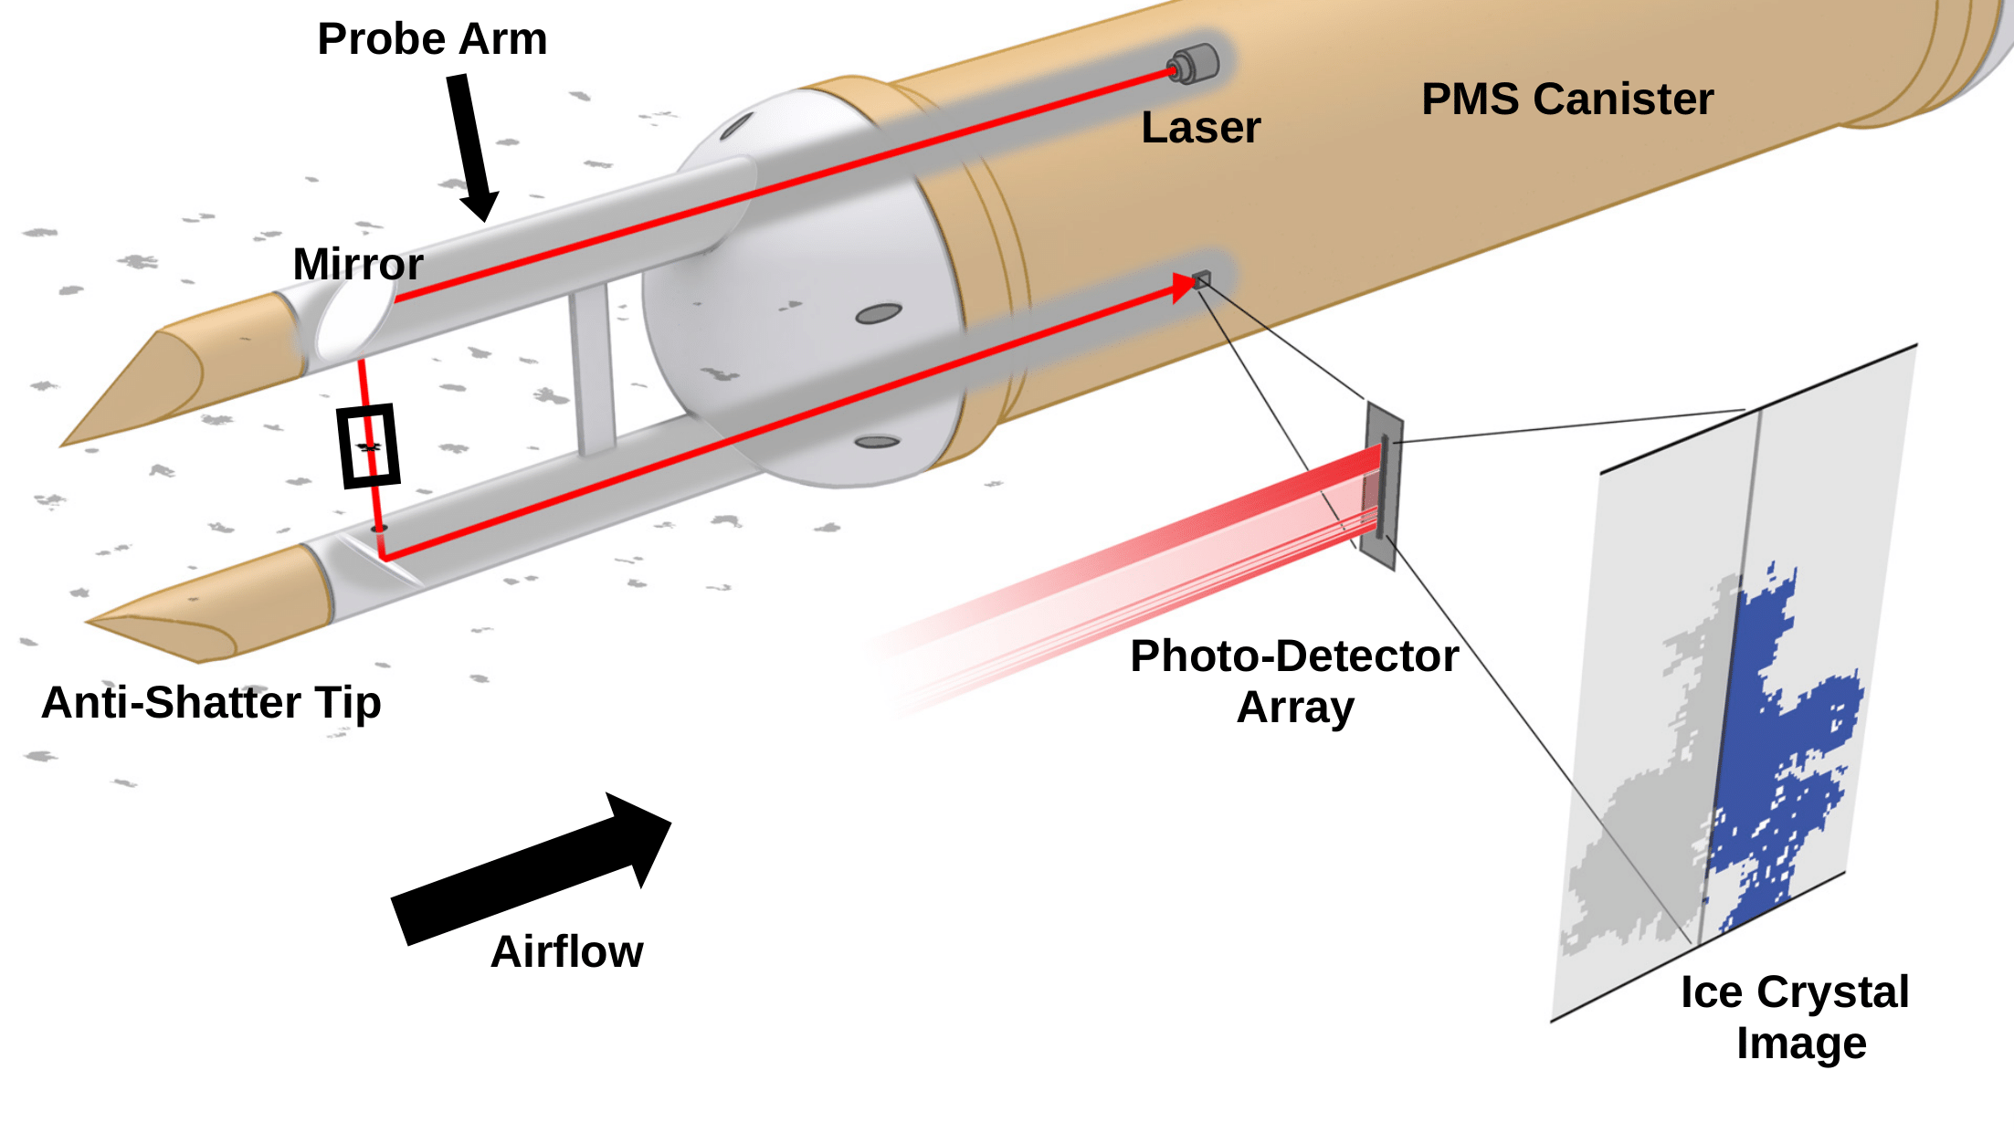FIG. 1. Illustration showing the side view of a two-dimensional optical array probe in a particle measurement system (PMS) canister. Images are obtained as particles pass through the laser beam (red line) when the aircraft’s speed creates airflow past the probe. The laser beam is directed between the probe arms using two 90 degree mirrors. Particles passing through the laser beam block light causing reduced illumination on the photo-diode array. Images are produced when at least one array element is reduced in intensity by a set amount (e.g. 50%). The depth of field (the location where the particle must cross the beam to be clearly imaged) is indicated with a black rectangle. The sampling frequency of the photo-detector array is adjusted using the measured true air speed so images (example given in lower right) have symmetric pixel elements. Heated, anti-shattering tips prevent ice accretion and reduce the number of shattered particles that enter the sample volume.
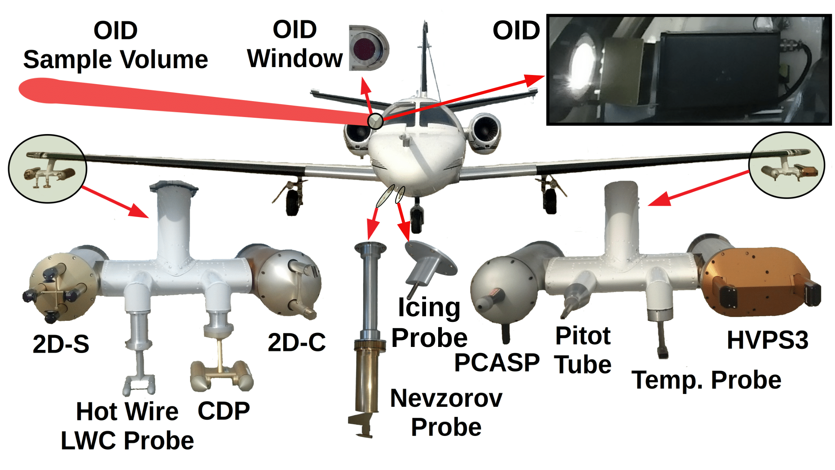
FIG. 2. Image showing the North Dakota Citation Research Aircraft with an enlarged view of the wing-tip pylons, the Nevzorov probe and the Rosemount Icing Probe as mounted for the 2015 field project over Cape Canaveral, Florida (CAPE2015). OID Window (upper center) is the viewing port through the pressurized cabin for the Optical Ice Detector (OID). The OID is angled slightly (10-15 degrees) forward of the wing so the sampling region (OID Sample Volume) is in front of and above the right wing. An image of the OID in the Citation fuselage is shown in the upper right. The Cloud Droplet Probe (CDP) measures particles from two to 50 µm (30 channels) using forward light scattering. The Two-Dimensional Stereo (2D-S) probe measures particles using shadowed diodes (two (one horizontal and one vertical) 128 element arrays) of 10 µm. The High-Volume Precipitation Spectrometer Version 3 (HVPS3) measures particles using shadow diodes (128 element array) of 150 µm. The Two Dimensional Cloud probe (2D-C) is an older probe that also measures particles using shadowed diodes (32 element array) of 30 µm. The Rosemount Icing Probe detects super-cooled liquid water using a vibrating metal rod. The Nevzorov probe is a hot-wire probe that measures liquid and total water content. Subtracting the liquid water content from the total water content determines the ice water content. The King Hot Wire Liquid Water Content (LWC) Probe is an older probe that only measures liquid water content. The Passive Cavity Aerosol Spectrometer Probe (PCASP) model measures aerosols from 0.1 to 3.0 µm. The Rosemount temperature probe (Temp. Probe) measures ambient air temperature, and the pitot tube measures air speed using a differential pressure transducer connected to a static and a forward facing port.
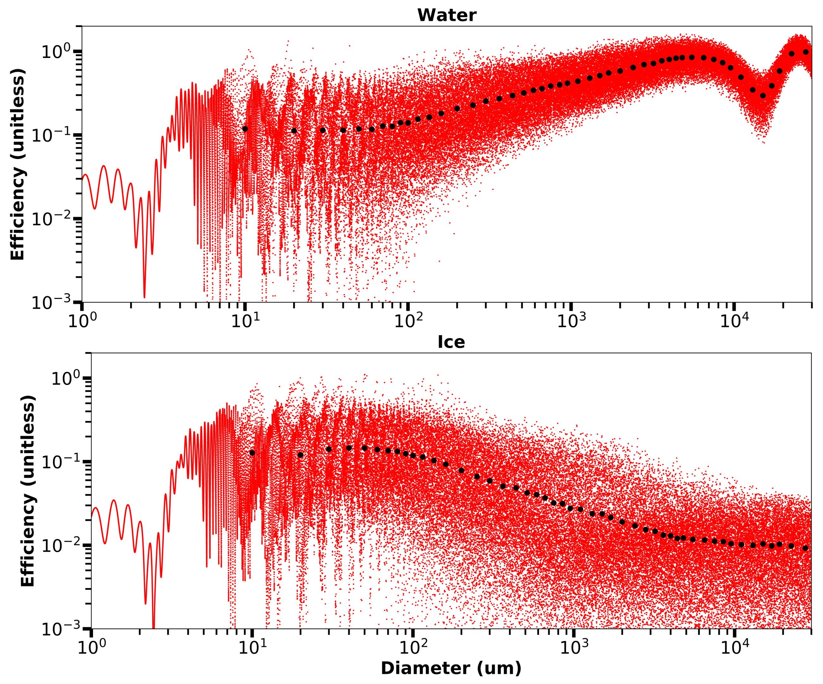FIG. 3. Plots showing backscatter efficiencies using Mie theory for spherical water (top) and ice (bottom) particles. The MiePlot software package (Laven 2018) is used to calculate efficiencies for 100 000 particle diameters distributed log-normally between 1 µm and 30 mm (red dots). Intervals range from 0.0001 µm between the smallest diameters to 3 µm between the largest diameters. Black circles are average efficiencies over the combined spectrum channel widths (see Table 1 for numerical values). A refractive index of 1.3263 + 5.6 x 10⁻⁷j is used for water (Kedenburg et al. 2012) and 1.3031 + 5.6 x 10⁻⁷j for ice (Warren and Brandt 2008). Scattering is for an air medium at 20°C and incident light of 905 nm.
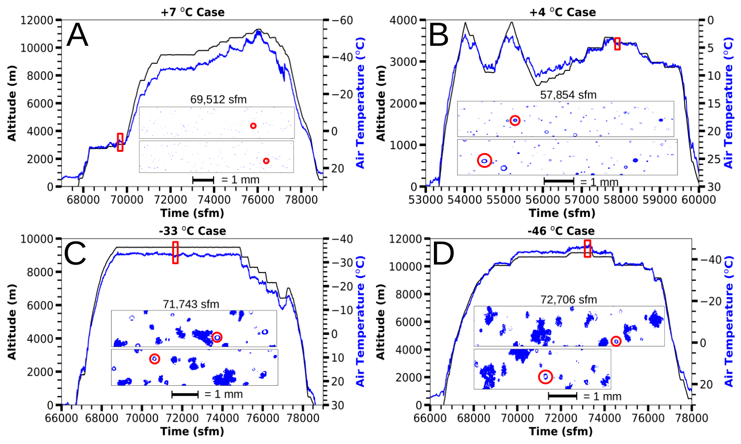FIG. 4. Plots showing time series in seconds from midnight (sfm) Coordinated Universal Time (UTC) of altitude (black) and air temperature (blue) for four analyzed flights. The red rectangles enclose the 60 s case study segments associated with each flight. Details for each segment are given in Table 2. Center panels contain representative 2D-S images from within the analyzed cases. Red circles within the 2D-S images show examples of particles with Poisson spots that are discussed in the text. The upper, red circle marked particle for the -33ºC case is approximately 180 µm in diameter.
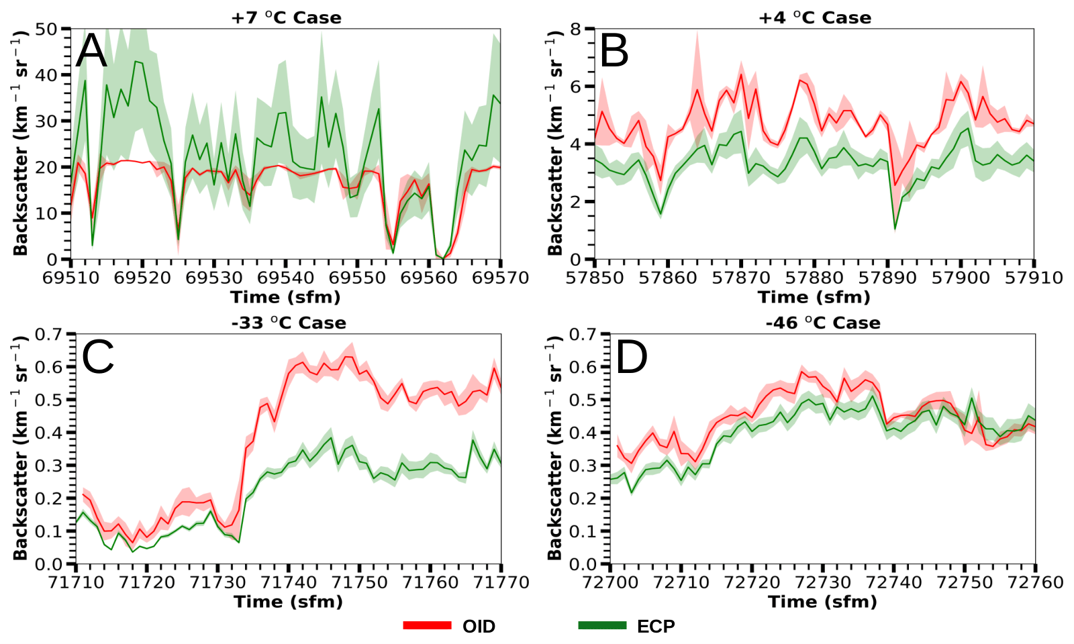FIG. 5. Plots showing 1 Hz time series in seconds from midnight (sfm) Coordinated Universal Time (UTC) of backscatter coefficients with a shadowed range for the four case study segments (Table 2). Note the differing backscatter coefficient scales for the warm cloud cases. The external cloud probes (ECP) shadowed range is the measurement uncertainty determined from (5), and represents one standard deviation. The Optical Ice Detector (OID) shadowed range is one standard deviation computed from averaging the OID data rate from 5 Hz to 1 Hz.
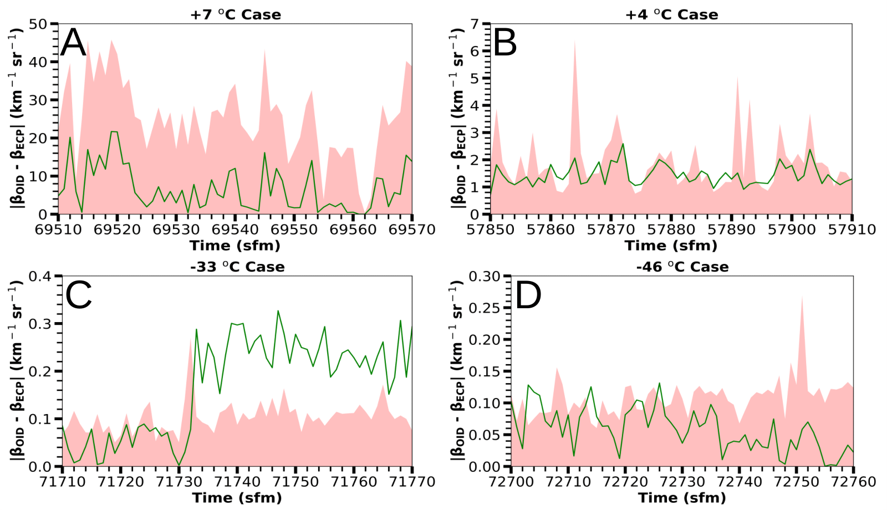FIG. 6. Plots showing 1 Hz time series in seconds from midnight (sfm) Coordinated Universal Time (UTC) of the absolute difference between the Optical Ice Detector (OID) and external cloud probes (ECP) backscatter coefficients for the four case study segments (Table 2). The green line is the absolute difference of the OID and ECP backscatter coefficients. The shadowed region top represents three standard deviations of OID and ECP backscatter coefficients, determined using (7).
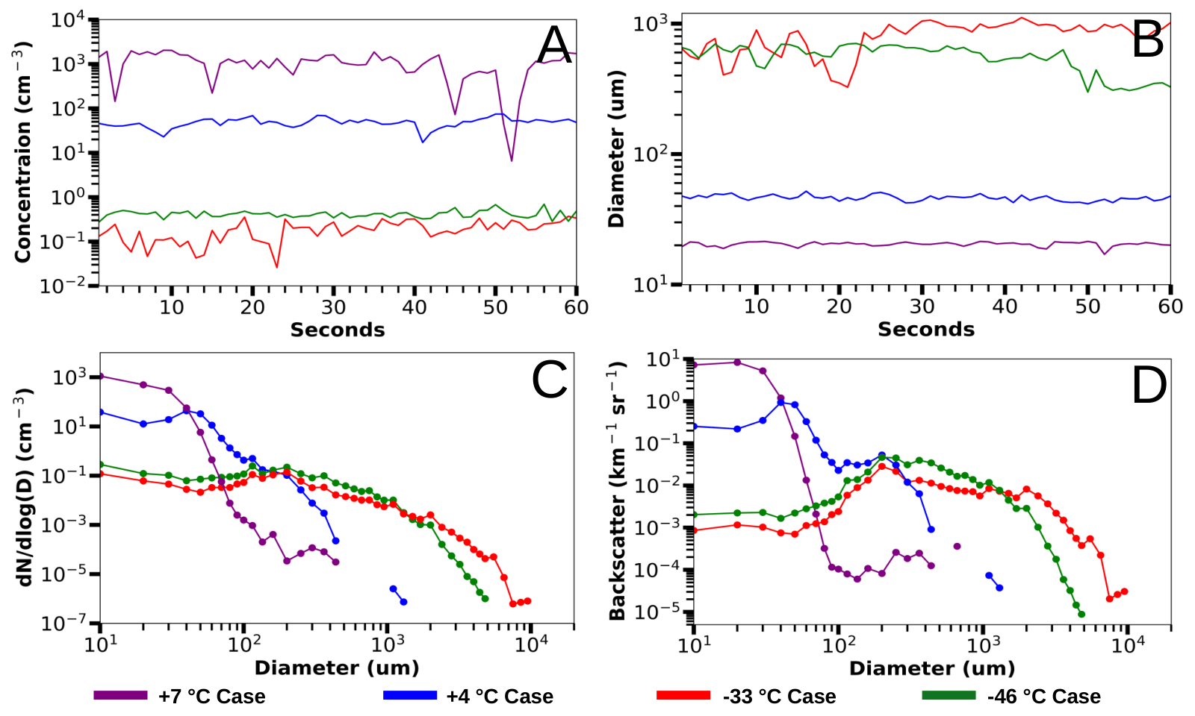FIG. 7. Plots showing measurements within the 60 s segments of four analyzed cases (Table 2). The upper left plot (A) is total number concentration measured by the external cloud probes (ECP), specifically the Two-Dimensional Stereo (2D-S) and High-Volume Precipitation Spectrometer Version Three (HVPS3) probes (Table 1). The upper right plot (B) is mean particle diameter measured by the ECP. The lower left plot (C) is a log-log plot of number density function vs. diameter measured by the ECP. The lower right plot (D) shows ECP backscatter coefficient versus the particle diameter. The y-axis of plot D is not normalized by size channel width.
FIG. 8. The Optical Ice Detector (OID) versus external cloud probes (ECP) backscatter coefficients for four analyzed cases (Table 2). Each dot is colored by case (see legend) and represents 1 s of data (Fig. 5) with bars indicating uncertainty. The least square fit is given by the black line (see equation in legend). The dashed line is a one-to-one correspondence for the ECP and OID data.
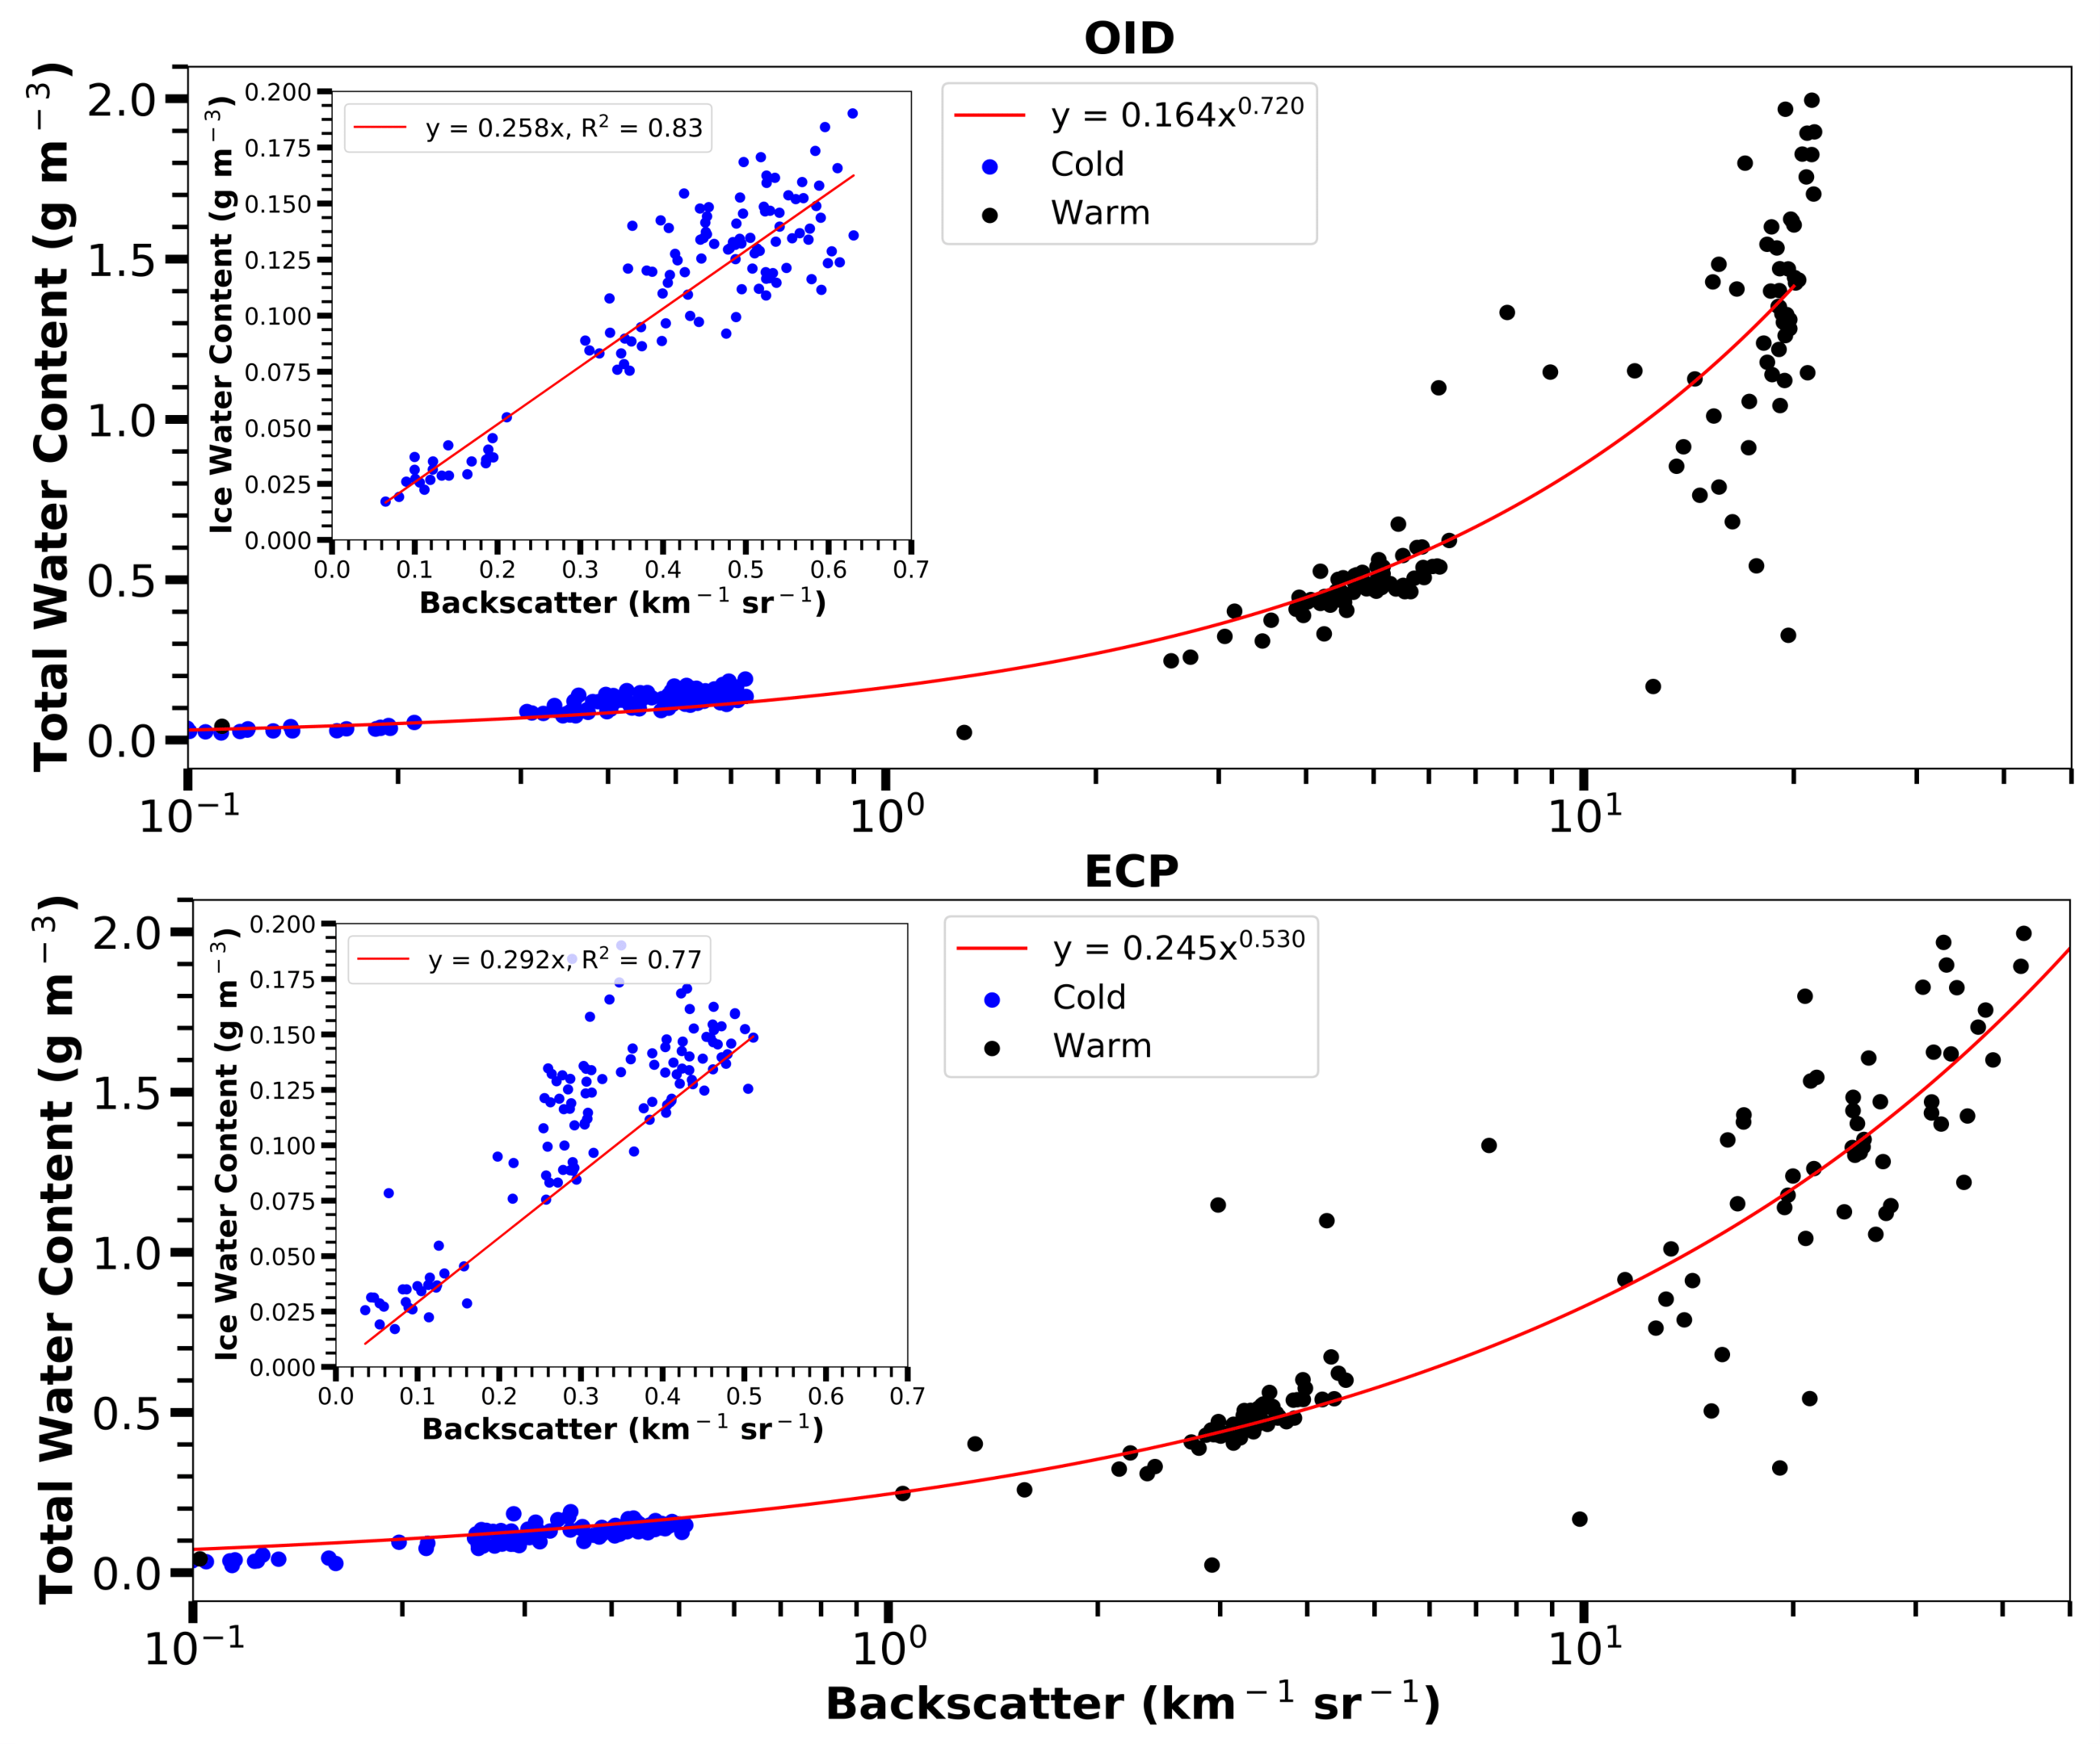FIG. 9. Plots showing Nevzorov probe total water content versus Optical Ice Detector (OID) backscatter coefficients (top) and external cloud probes (ECP) backscatter coefficients (bottom) with a logarithmic x-axis. Backscatter coefficients are separated by warm (+7°C and +4°C) cases and cold (-33°C and -46°C) cases (Table 2). Insets in the top-left corners show further detail of Nevzorov probe total water content versus respective backscatter coefficients for the -33°C and -46°C cases. Each dot represents 1 s of Nevzorov, OID, and ECP data.
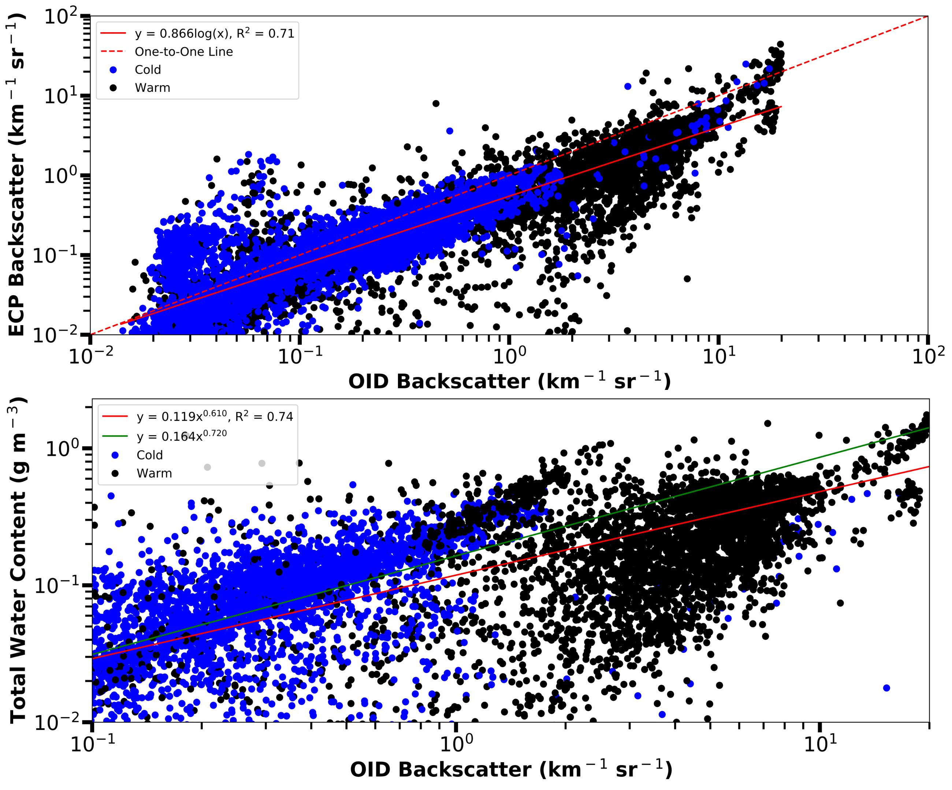FIG. 10. The external cloud probes (ECP) backscatter coefficients versus Optical Ice Detector (OID) backscatter coefficients (top) and Nevzorov probe total water contents versus OID backscatter coefficients (bottom) for all times within the four flights (Table 2) that contain the four temperature cases. The 1 Hz data is grouped by cold (blue) and warm (black) environments. Data are excluded when temperatures are between 0°C and –20°C. Liquid scattering efficiencies are used for temperatures greater than 0°C and ice scattering efficiencies used for temperatures below –20°C. OID data has a 20 km⁻¹sr⁻¹ limit to avoid times where observations are above the OID’s detection limit. The lower plot’s green line indicates the fit equation in Fig. 9.
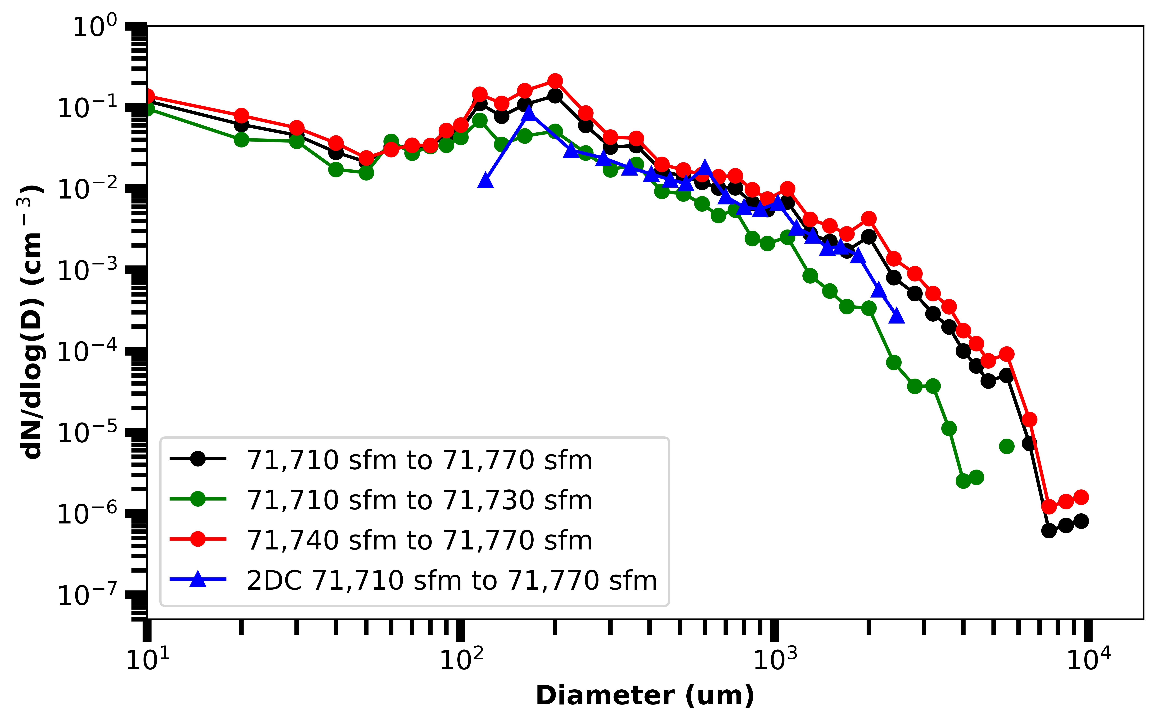FIG. 11. The size spectrum normalized by bin width measured by the external cloud probes (ECP) for the -33°C case (Table 2). The spectrum of the entire 60 s case (black) has been separated according to times of more (green) and less (red) agreement between ECP and Optical Ice Detector (OID) backscatter coefficients. Also given is the 2D-C spectrum obtained using the full particle reconstruction processing method.
FIG. 12. Nevzorov probe measured total water content (black) and liquid water content (blue) for the -33°C case (Table 2). Each dot represents 1 s of Nevzorov data. The average liquid water content is 0.022 g m⁻³ ± 0.009 g m⁻³ and the average total water content is 0.032 g m⁻³ ± 0.008 g m⁻³ during times of Optical Ice Detector (OID) and external cloud probe (ECP) backscatter coefficient agreement (71 710 sfm to 71 730 sfm). The average liquid water content is 0.027 g m⁻³ ± 0.009 g m⁻³ and the average total water content is 0.092 g m⁻³ ± 0.05 g m⁻³ during times of OID and ECP backscatter coefficient disagreement (71 740 sfm to 71 770 sfm).

