Suitability of North Dakota for Conducting Effective Hygroscopic Seeding
David J. Delene
Department of Atmospheric Sciences, University of North Dakota,
Grand Forks, North Dakota, United States of America
Abstract. One goal of the Polarimetric Cloud Analysis and Seeding Test (POLCAST) project is to determine if North Dakota clouds created by surface-base convection are suitable for treatment with hygroscopic flares to enhance surface rainfall amounts. The suitability evaluation examines the processes involved in the hygroscopic seeding conceptual model to determine how supportive North Dakota's environment is to conducting an effective rain enhancement program. POLCAST field measurements are used to determine if important environmental factors support an increase in cloud precipitation efficiency from hygroscopic seeding. Current scientific theories and modeling results indicate that the most important environmental factors are cloud condensation nuclei (CCN) concentrations, droplet size distribution, and cloud base temperature and height. Cloud model results indicate North Dakota's high CCN concentration supports the conclusion that releasing large hygroscopic particles at cloud base produces more collector droplets which increases precipitation efficiency. North Dakota's cloud base temperatures and several kilometer thick clouds indicates that ice phase hydrometeors are important in the precipitation formation process. Hence, increases in precipitation efficiency is not a simple warm rain process but involves more graupel production in the cold cloud region. North Dakota's low cloud base heights indicate that increases in precipitation would increase rain at the surface. All environmental factors examined indicate North Dakota's suitability for conducting hygroscopic seeding to enhance precipitation; however, some cloud processes are impossible to fully evaluate with the current POLCAST data set. A complete aerosol/cloud physics data set would provide a valuable resource for further understanding physical processes and help in constructing a more accurate regional precipitation forecast model. Development, validation, and use of a precipitation forecast model with a known uncertainty would be an effective method for determining precipitation increases from hygroscopic seeding.

INTRODUCTION
North Dakota has a long weather modification history which includes a commitment to conducting research (Stith 1983), development of evaluation methods (Miller et al. 1983), and using the latest technology (Boe and Jung 1990; Schneider and Langerud 2011). North Dakota cloud seeding started in the 1950s with ground-based silver iodide (AgI) activities with the primary goal to augment precipitation and in 1961 hail suppression activities began (Miller and Fuhs 1987). Since the 1960s, airborne platforms have been the preferred method of delivering seeding material (Langerud and Moen 1998). North Dakota sponsored research in the 1960s and 1970s to investigate reducing hail damage and increasing rainfall (Boyd et al. 1976; Rose and Jameson 1986). The State created the North Dakota Weather Modification Board in 1975. A state managed cost-sharing program, North Dakota Cloud Modification Project (NDCMP), started in 1976 (Smith et al. 1992). In 1981, the Weather Modification Board became part of the State Water Commission. Legislation in 1987 changed the Board's name to the Atmospheric Resource Board. On August 1, 1995, the Atmospheric Resource Board became an official division of the State Water Commission with responsibility for administering cloud seeding activities in the state, conducting weather modification research and development, and collecting weather-related data.
Over half the annual losses to North Dakota's small grain crops are from hail damage and drought (Rose and Jameson 1986) which has a significant impact on the State's economy (Bangsund and Leistritz 2009). Hence, when new research results indicated that hygroscopic cloud seeding can enhance precipitation (Bruintjes 1999), there was interest in knowing if North Dakota was a suitable location for the technique. Therefore, the North Dakota Atmospheric Resource Board started the Polarimetric Cloud Analysis and Seeding Test (POLCAST) research program in 2006 to determine effectiveness of hygroscopic cloud seeding in North Dakota. While hygroscopic cloud seeding in South Africa, Mexico City and Thailand (Mather et al. 1997; Terblanche 2005) had positive statistical results, it is important to understand if North Dakota is similar before beginning an operational rain enhancement program. Furthermore, the new statistically positive results did not fully take into account the potential effects of multiplicity of analyses (Silverman 2003) so the POLCAST program included a randomized seeding experiment. Multiplicity is due to conducting more than one statistical test on an experimental data set which results in a p-value being less reliable than many scientists assume (Nuzzo 2014). The goal of this paper is not to conduct a statistical evaluation but to conduct a physical process evaluation of airborne measurements to determine if North Dakota is suitable for effective hygroscopic seeding.
Convective clouds only transform approximately 10 % of ingested water vapor into precipitation that reaches the Earth's surface (Langhans et al. 2015). The low precipitation efficiency of clouds has prompted scientists to propose enhancement of water supplies by means of cloud seeding with hygroscopic material (Czys and Bruintjes 1994). Fresh water supplies would increase if clouds converted more water vapor into precipitation. Laboratory, modeling, and observational studies have demonstrated that aerosols can modify the micro-structure of cumulus clouds (Levin and Cotton 2008). The physical processes are similar if pollution modifies cloud micro-structure inadvertently to produce an undesirable outcome or if seeding material deliberately changes cloud micro-structure to promote a desired outcome, such as precipitation enhancement. As argued by some scientists (Garstang et al. 2005), it seems logical to use the same definition for scientific proof since physical processes are very similar when using aerosols for weather modification and when pollution aerosols effect climate. However, the National Research Council concludes that there is not yet either the statistical nor physical evidence required to establish weather modification's scientific validity (Garstang 2003). Irrespective of a person's scientific proof definition, the larger amount of scientific research related to inadvertent weather modification and anthropogenic climate change is relevant to a conceptual model of hygroscopic seeding.
Cloud seeding involves deliberately modifying some cloud property by introducing seeding material, such as AgI, dry ice, liquid carbon dioxide, or hygroscopic aerosols. Cloud modification projects have preferred using AgI as the seeding material for the past 60 years since AgI has no environmentally harmful effects (Williams and Denhom 2009) and is an ice nuclei that can effectively modify cloud micro-structure. The atmosphere typically lacks naturally occurring ice nuclei because only a small fraction of aerosols nucleate ice formation (DeMott et al. 2011). Hence, there are often areas of super-cooled liquid water in developing clouds where introducing more ice nuclei converts small liquid cloud droplets into larger ice particles which promotes precipitation development (Lohmann and Feichter 2005). While glaciogenic seeding using ice nuclei is a promising technique for precipitation enhancement, hygroscopic seeding has advantages because the seeding material can affect “warm clouds”.

Conceptual Model
Conceptual models incorporate the best scientific understanding and link the chain of events that move the process from cause to effect. A conceptual model should be an “effective theory” (Randall 2011) that incorporates what is important at different scales and uses the precision and accuracy of instruments to determine if observations support the theoretical model. While theoretical models can be based on what turns out to be an incorrect understanding, the conceptual model should incorporate the best current science. If some parts of the model are incorrect, then new observations combined with “skeptical empiricism” (carefully thought-out and tested research) will disprove aspects and the conceptual model will be revised. A provisional conceptual model is not a hindrance to scientific progress but an essential element since it provides statements which researchers may disprove. The lack of a well-defined conceptual frame-work dooms a technique to continue at the level of not being well-supported scientifically. However, a well-defined conceptual model provides a pathway for a technique's elevation to the level of scientifically proven. Scientists can focus on single aspect research instead of trying to address the complete process all at one time. This divide and prove methodology allows for collaboration among researchers whereby different teams focus on different parts of the overall process. Furthermore, it allows research conducted for other purposes (e.g. climate change) to be used to validate a weather modification technique.
Our hygroscopic seeding concept for increasing precipitation from summer North Dakota convective clouds produced by surface heating has the following chain of events. 1.) Burning hygroscopic flares (Mather et al. 1997) produces an air parcel containing larger diameter cloud condensation nuclei (CCN) than what naturally occurs in the environment. 2.) Updrafts loft the air parcel containing seeding material into the base of clouds. 3.) Above the cloud base, the growth process of water vapor condensing on larger CCN produces a broader cloud droplet spectrum which results in treated clouds containing more collector droplets. 4.) The coalescence process produces more large drops by having more collector droplets merging with smaller droplets. 5.) The ice phase process results in more graupel (by number and mass) due to higher concentrations of larger drops which harvest more of the available supercooled water before the air parcel reaches cloud top; thereby, increasing the precipitation efficiency of the cloud. 6.) The increase in cloud precipitation efficiency results in more rain at the surface. Cloud micro-structure changes may also increase surface water by initiating rain earlier and/or prolonging the life of a cloud by strengthening the coupling of the updraft–downdraft storm propagation mechanism.
Previous research studies support the steps in our conceptual model's chain of events. The first item in the chain of events is particles generated by burning the hygroscopic flares. POLCAST employs Ice Crystal Engineering (ICE) hygroscopic flares containing 70% KClO₄, which improves over South Africa flares by burning at a higher temperature. Recent research indicates that ICE hygroscopic flares generate more particles above 0.4 um than the South Africa flares and the larger particles are a result of aggregation of KCl and Ca(Cl)₂ (Bruintjes et al. 2012). Furthermore, parcel model (Cooper et al. 1997) simulations show that the ICE flares produce more large drops at shorter cloud lifetimes than the South Africa flares. Pilot estimates and Aircraft Integrated Meteorological Measurements System (AIMMS) probe measurements below developing North Dakota convective clouds show mean updrafts in the range of 0.6 to 1.4 m/s (120 to 275 ft/min) (Simelane et al. 2013). Therefore, clouds ingest material produced by burning hygroscopic flares on aircraft. Observing effects of hygroscopic material on cloud properties is challenging because it is difficult to know when seeding has affected a cloud parcel. However, model simulations show that seeding with hygroscopic ﬂares could increase rainfall amounts in continental clouds having cloud condensation nuclei (CCN) concentrations (active at 1% supersaturation) of more than about 500 #/cm⁻³, while seeding more maritime clouds resulted in reducing the integrated rain amounts (Yin et al. 2000).

Objectives
The paper's scientific goal is to further understanding of processes involved in the conceptual model of hygroscopic seeding. The specific objective of the paper is to document POLCAST research into hygroscopic seeding of North Dakota convective clouds. Hygroscopic seeding suitability is determined using analysis of POLCAST aircraft measurements combined with modeling research results. In particular, we combine cloud modeling results with calculated statistical distribution of cloud base CCN, cloud base temperature, cloud base height and cloud microphysical measurements to determine if seeded clouds are likely to produce enhanced precipitation compared to naturally occurring clouds. The POLCAST observations are discussed in terms of processes occurring along the chain of events from seeding to rain falling on the ground.
The author's aim in writing the paper is to provide details on instrument deployment, measurement techniques, and analysis tools so results are understandable and reproducible. The paper provides references to papers and other resources where appropriate; however, the paper contains significant details on software tools employed in the hope that readers may use the tools in their own work. While including software information lengthens the article, such details are necessary to enable reproducibility of results, which is fundamental to the scientific method. As scientists learn that some important results cannot be reproduced, research standards are increasing (Begley and Ellis 2012), which means projects require more care and papers greater detail.

AIRCRAFT MEASUREMENTS
The POLCAST field projects are cooperative experiments funded by the North Dakota Atmospheric Resource Board (NDARB). Ice Crystal Engineering LLC (ICE) provides the hygroscopic burn-in-place cloud seeding flares (Ice Crystal Engineering 2016), which are manufactured to the same specification throughout all the POLCAST field projects. Weather Modification Inc. (WMI) provides the seeding aircraft and majority of research instruments. The University of North Dakota (UND) and the National Center for Atmospheric Research are working on analysis of the POLCAST data set. The POLCAST field projects included five different components: 1.) measurements using the UND C-Band Polarimetric Doppler Weather Radar, 2.) cloud seeding and airborne measurements using a Cessna 340 aircraft, 3.) in situ cloud microphysical sampling using the instrumented UND Citation Research Aircraft, 4.) surface aerosol measurements in Grand Forks, North Dakota, and 5.) special Weather Research and Forecasting (WRF) model runs for the project area. Not all the components are part of each field project. The focus on this paper is the airborne measurements conducted in 2008, 2010, and 2012; whereas, additional publications cover other parts of the POLCAST project.
During the summer of 2006 (10 July – 5 August), the Polarimetric Cloud Analysis and Seeding Test (POLCAST2006) field program investigated if hygroscopic seeding could be detected by polarimetric radar observables or by derived radar fields. During the summer of 2008 (9 June – July 11), a second field program (POLCAST2008) expanded on POLCAST2006 with inclusion of airborne measurements. During the summer of 2010 (21 June – July 23), a third field program (POLCAST2010) added airborne measurements from the Citation Research Aircraft (Delene and Poellot 2015). During the summer of 2012 (July 27 – August 3), a fourth field program (POLCAST2012) conducted airborne measurements on the seeding aircraft and deployment of two Droplet Measurement Technologies (DMT) CCN counters and two UWyo CCN counters.
To improve operations, POLCAST2010 included setup and operation of the Weather Research and Forecasting (WRF) model (Mullendore and Starzec 2016). WRF forecasts and radar observations agree well with the ten cases analyzed during June and July 2010, the number of cells of 30 dBZ or greater reflectivity (stratified by cell size) predicted by WRF and observed by radar were generally within 2-3 cells (Starzec 2014). Furthermore, comparison of total number of cells (> 5 dBZ) predicted and observed from the entire project showed matching frequency for the largest cells (greater than 900 km²), under-forecasting of the smallest cells (less than 45 km²) and a slight over-forecasting of mid-range cell bins. Additionally, forecast results were also compared to observations by percent areal coverage, instead of cell count; this alternative verification showed that in cases where both model and observations showed any convection, most cases matched areal coverage within 5%.

Field Operations
Analysis of POLCAST2006 polarimetric derived liquid water content, rainfall rates, and hydrometeor type for seeded and non-seeded convective systems indicated that polarimetric radar could detect the hygroscopic seeding effect; however, with only eight seeded cases the data set is far too small to produce statistically significant results (Kucera et al. 2008). The results from POLCAST2006 indicated that average radar-derived liquid water content (LWC) increased after hygroscopic seeding. One POLCAST2006 case did not show an increase in LWC; however, it was located along the edge of a larger, more stratiform area of precipitation. The rainfall rate analysis indicated positive results, with an increase in average maximum rainfall rate and rain duration. The hydrometeor identification program produced results in agreement with ZDR and reflectivity trends; however, there is considerable uncertainty in hydrometeor identification retrievals without proper verification of the algorithm. No airborne flight measurements are available from POLCAST2006.
POLCAST2008 conducted 12 flights (24.83 hours) between 10 June and 11 July 2008 and found thirteen hygroscopic seeding candidates. Cloud and aerosol measurements are made on 11 research flights (Figure Figure). Randomized (50/50 split) seeding of target candidates enables a robust statistical comparison. The criteria for seeding candidates is that the cloud is relatively isolated from surrounding convection and initial development is within 100 km of the UND radar. Furthermore, the candidate needs to be located within North Dakota, have at least 500 ft/min cloud base updraft (pilot estimated) and the cloud base temperature has to be warmer than 4 °C. The 500 ft/min updraft requirement is an estimate of the maximum updraft and cloud with continuous updrafts in the 200-500 ft/min range for several seconds are seeded. TITAN analysis of six cases indicated that the methodology of using polarimetric radar data to analyze “areas of influence” is a promising seeding effect evaluation technique (Delene et al. 2011). Additionally, airborne measurements show that the cloud base aerosol and droplet concentrations are generally relatively high during summer in North Dakota with Passive Cavity Aerosol Spectrometer Probe (PCASP) aerosol concentrations of 890 #/cm³, CCN concentrations (May 2008 calibration) of 1,030 #/cm³, and cloud droplet concentrations of 360 #/cm³.
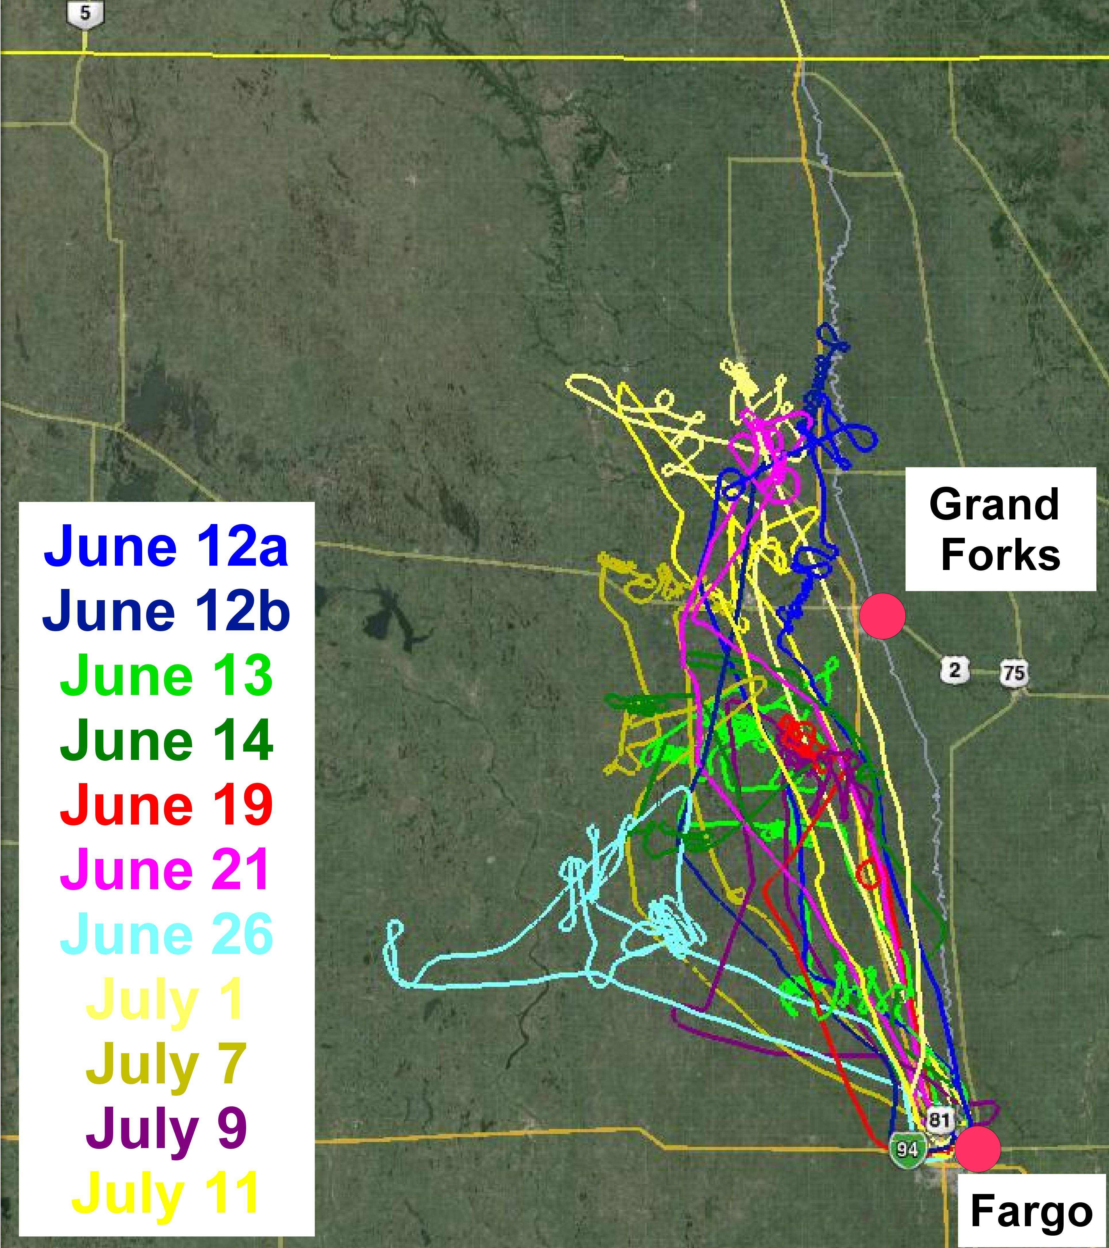
Figure 1: Image showing seeding aircraft tracks for 2008 research flights. Each track is color coded to correspond to the character color of the legend's flight date. The white line going between the cities of Fargo and Grand Forks (red dots), and extending into Canada, is the Red River of the North, which is the boundary between North Dakota and Minnesota. The solid yellow line near the top is the Canadian border and the other yellow lines are major highways. Image is created using Google Earth software to display Keyhole Markup Language files created using the recorded aircraft's GPS position.
POLCAST2010 conducted 11 seeding flights (26.2 hours) between 23 June and 20 July 2010. The seeding aircraft made cloud base measurements and the Citation Research Aircraft made cloud microphysical measurements (Figure Figure). The addition of the Citation Research Aircraft allows measurements of the onset of coalescence while still allowing the seeding aircraft to focus on obtaining cloud targets. Keeping the seeding aircraft at cloud base maximizes the number of cases for the randomized seeding experiment, which is a POLCAST priority. The UND Citation Research Aircraft flew six flights (7.6 hours) to measure cloud properties of seeding targets. POLCAST2010 used the same randomized seeding method as POLCAST2008 and found thirteen hygroscopic seeding targets. The Citation Research Aircraft carried a set of meteorological and cloud physics instruments including the Droplet Measurement Systems (DMT) Cloud Droplet Probe (CDP) to measure cloud droplets between 3 and 50 µm. Additionally, the Citation Research Aircraft carried a Sulfur Hexafluoride (SF₆) analyzer to detect SF₆ released concurrent with the burning of hygroscopic flares on the seeding aircraft. The Citation Research Aircraft did not detect any seeding plume; unfortunately, numerous problems resulted in the SF₆ analyzer only working at the end of POLCAST2010 when weather did not support flight operations.
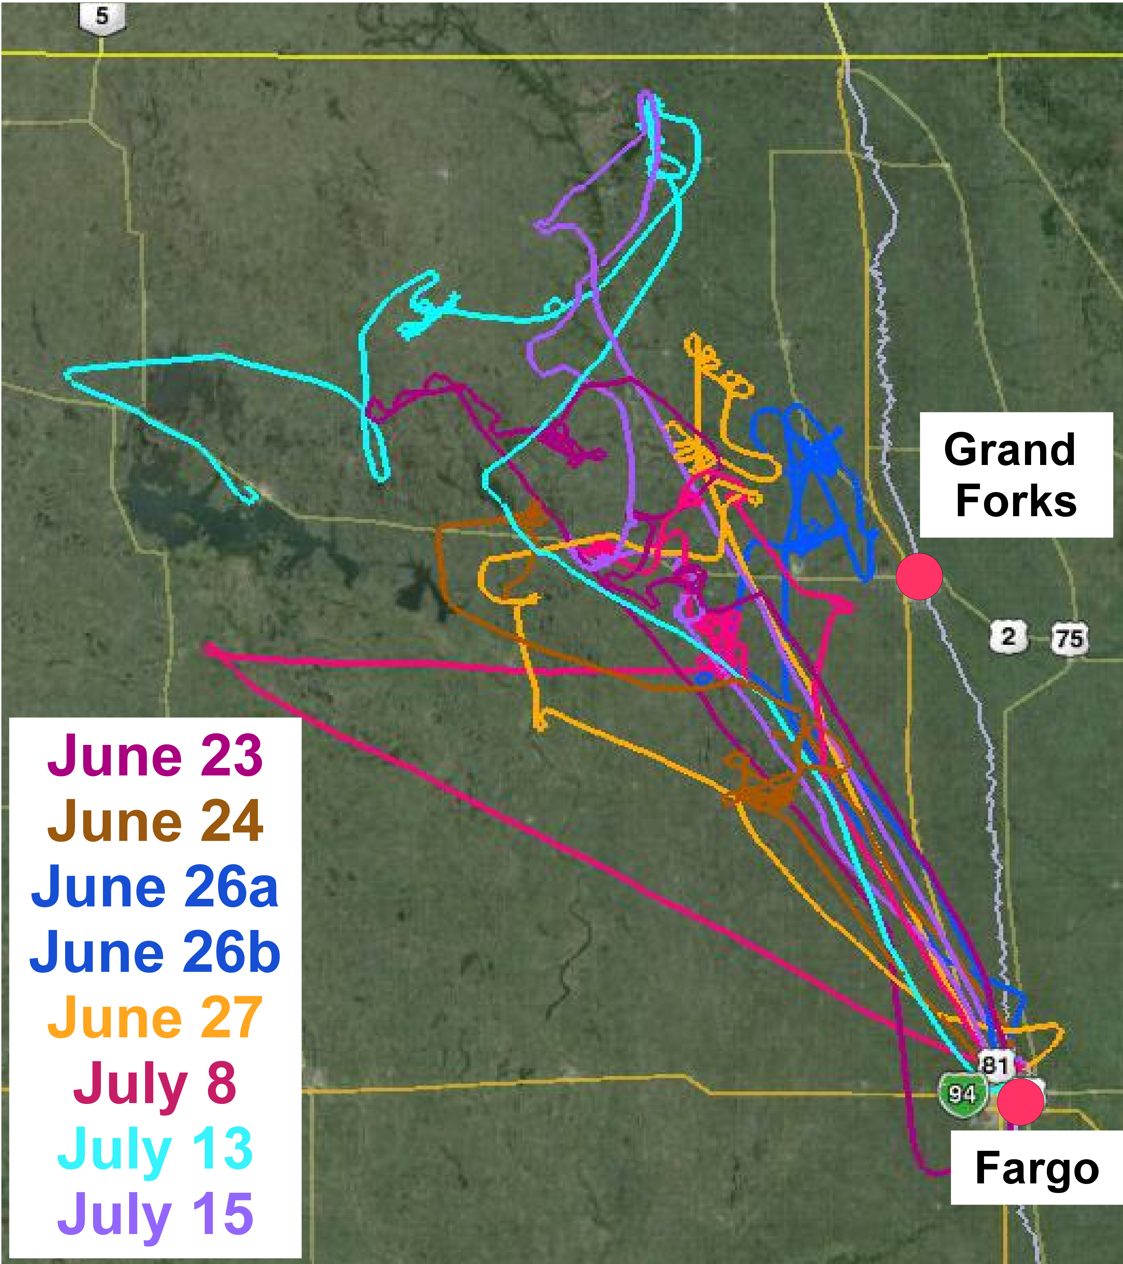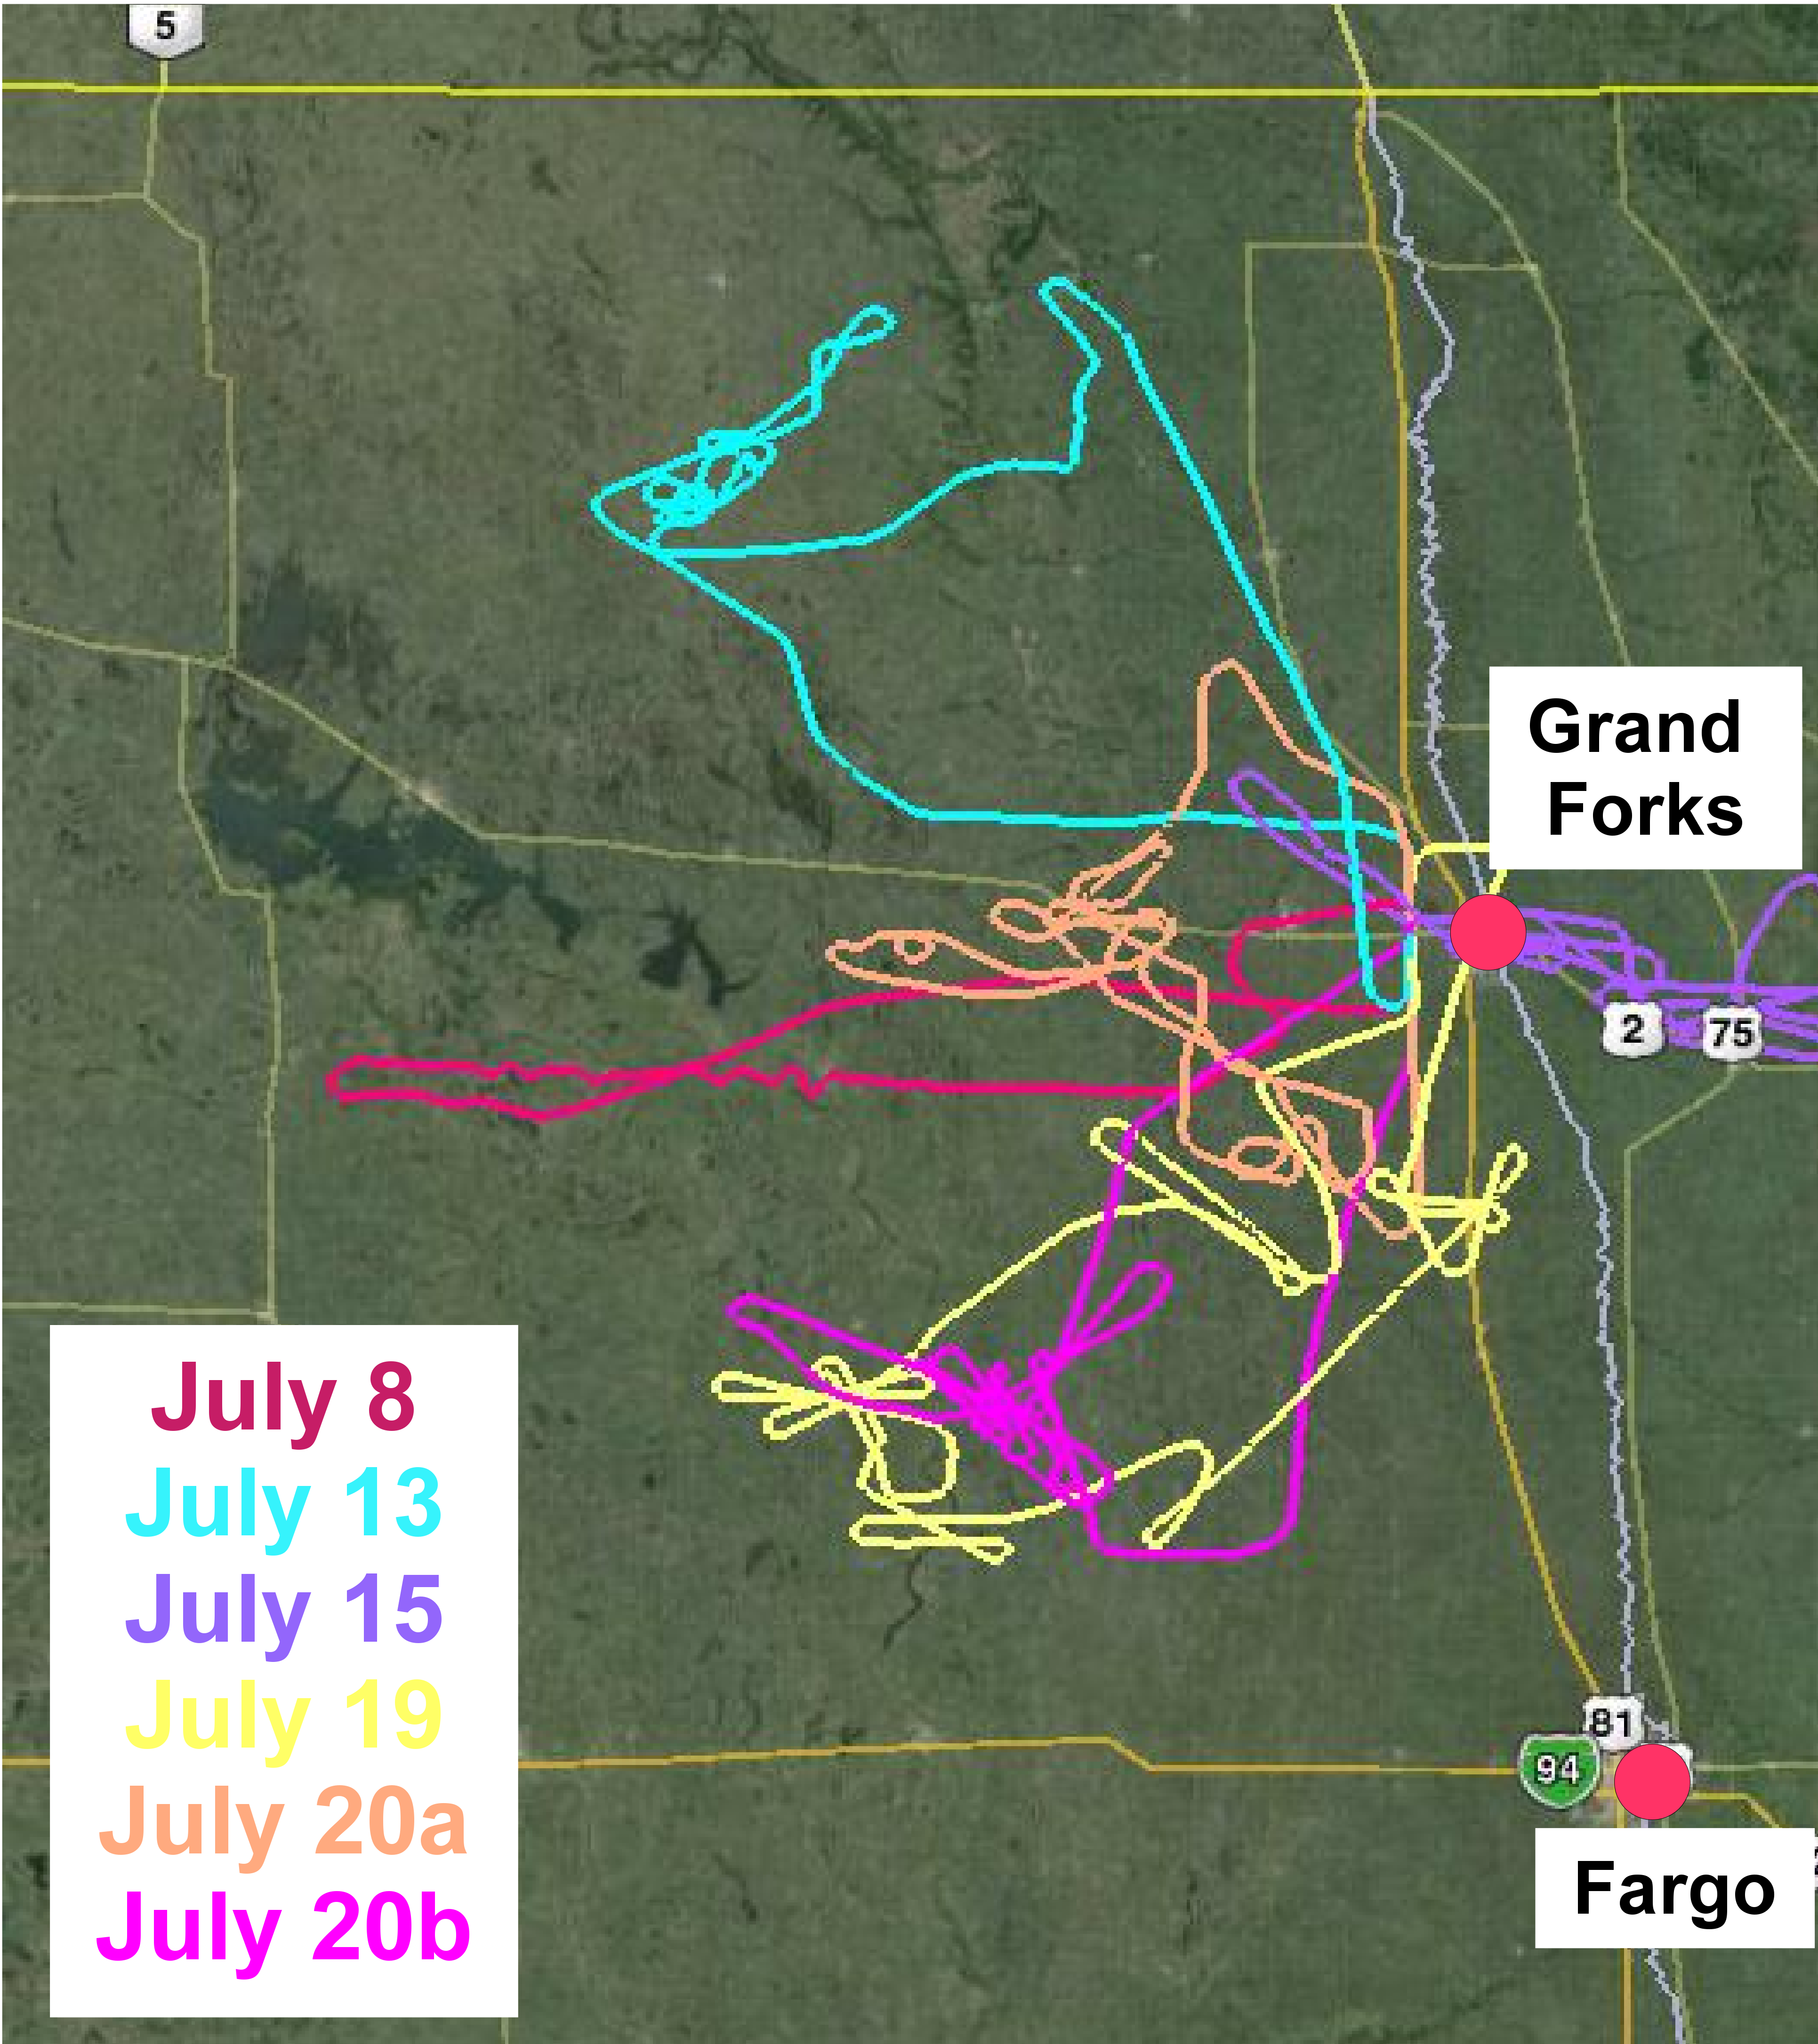

Figure 2: Images showing seeding aircraft tracks (left image) and Citation Research Aircraft tracks (right image) for 2010 research flights. Each track is color coded to correspond to the character color of the legend's flight date. The white line going between the cities of Fargo and Grand Forks (red dots), and extending into Canada, is the Red River of the North, which is the boundary between North Dakota and Minnesota. The solid yellow line near the top is the Canadian border and other yellow lines are major highways. Images created using Google Earth software to display Keyhole Markup Language files created using the recorded aircraft's GPS position.
POLCAST2012 conducted eleven aircraft flights (20.7 hours) between 2 July 2012 and 29 July 2012 but no Citation Research Aircraft flights (Figure Figure). POLCAST2012 found fifteen hygroscopic seeding targets and used the same randomized seeding method as POLCAST2010 and POLCAST2008. The POLCAST2012 campaign started where POLCAST2010 left off with the 50/50 randomized sequence. POLCAST2012 added the AIMMS probe to measure the cloud base updraft velocity. Also, POLCAST2012 deployed an airborne DMT CCN counter to obtain concurrent measurements with the UWyo CCN counter. Two CCN counters are operated together on the seeding aircraft and two CCN counters are operated together on the surface to test for any systematic differences in measurements that may result from the counters employing different measurement techniques. The focus is on airborne measurements conducted during all POLCAST field projects; therefore, analysis of the DMT CCN counter's airborne measurements is beyond the paper's scope.
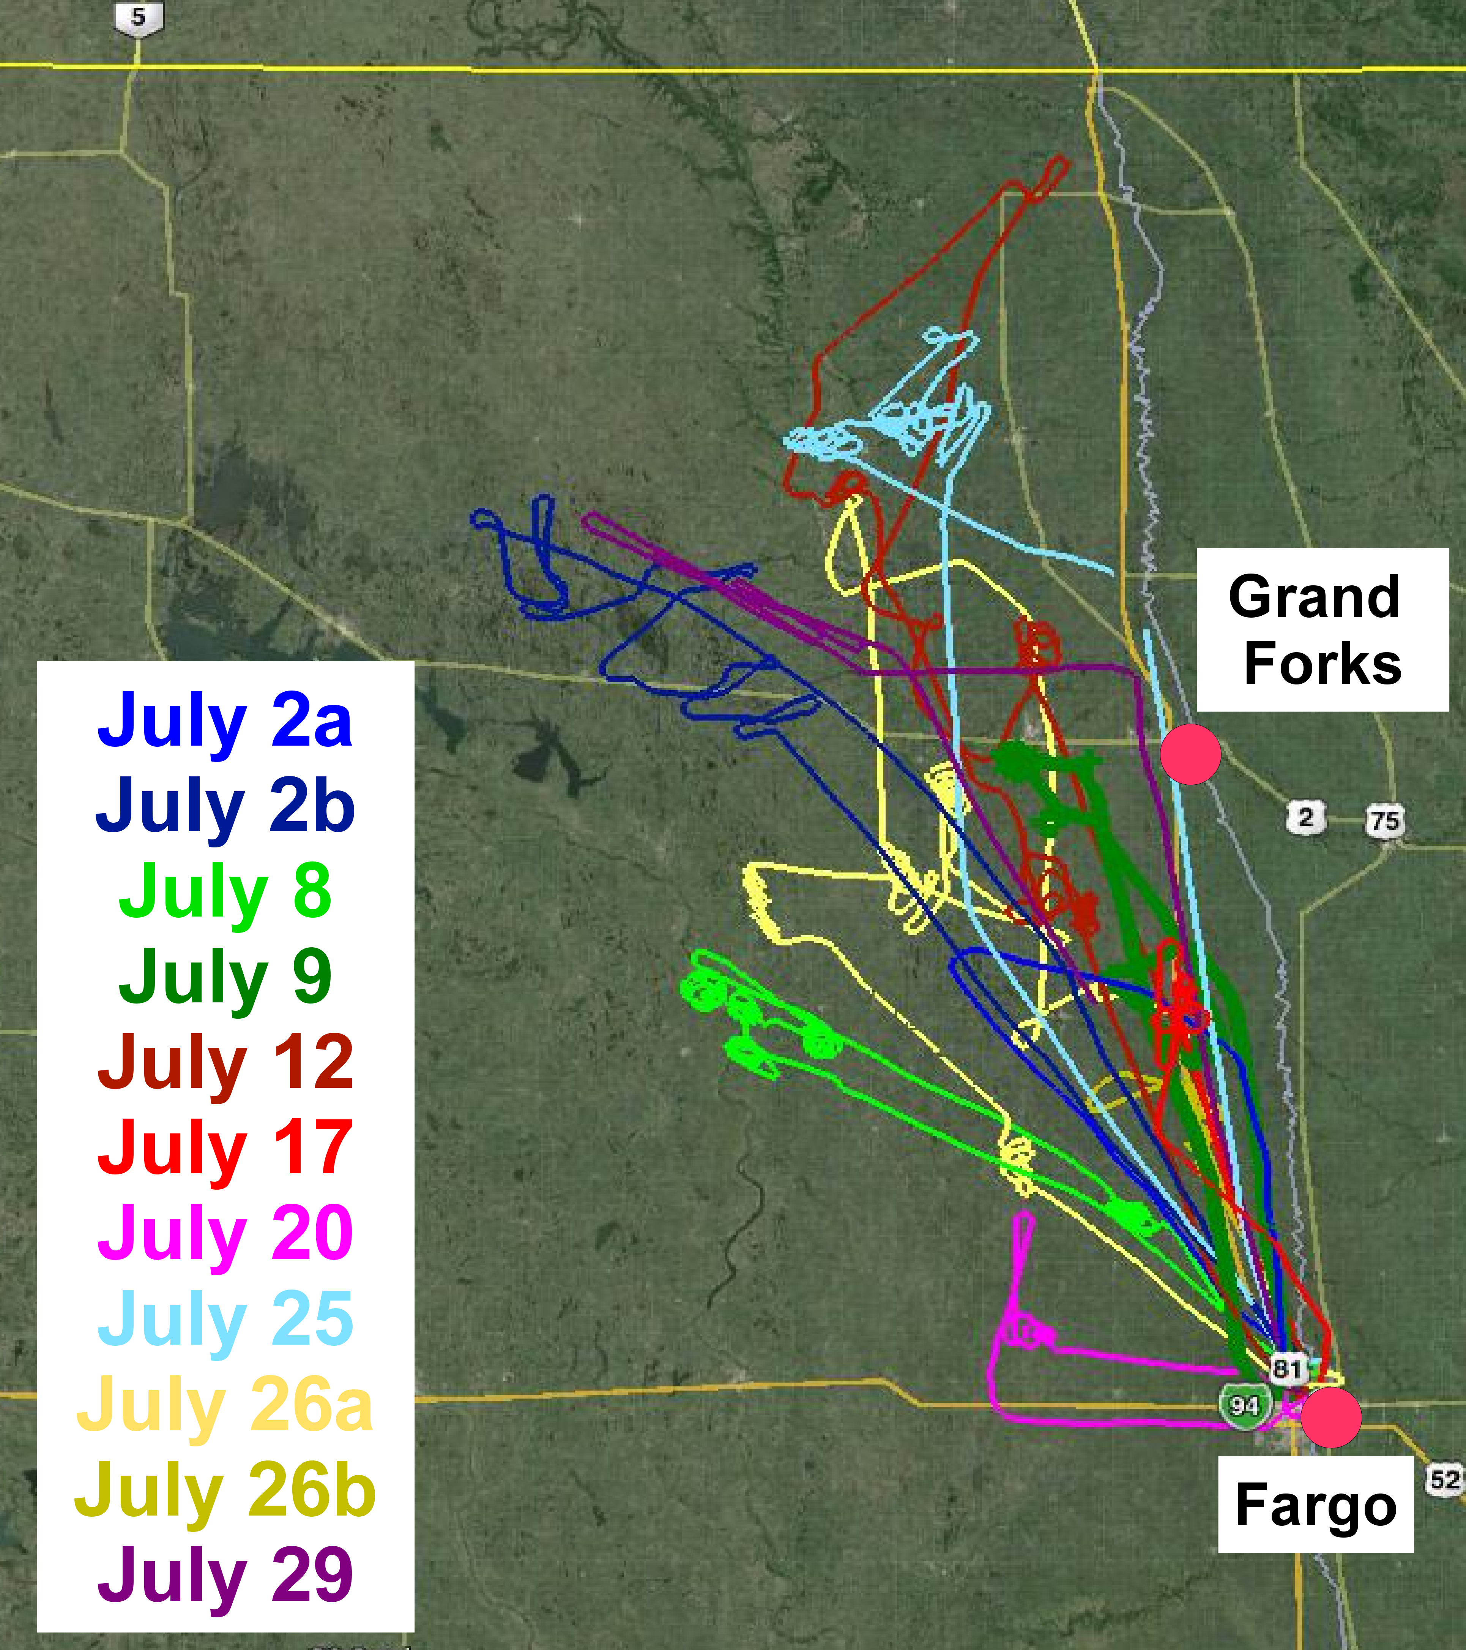
Figure 3: Image of seeding aircraft tracks for 2012 research flights. Each track is color coded to correspond to the character color of the legend's flight date. The white line going between the cities of Fargo and Grand Forks (red dots), and extending into Canada, is the Red River of the North, which is the boundary between North Dakota and Minnesota. The solid yellow line near the top is the Canadian border and the other yellow lines are major highways. Image is created using Google Earth software to display Keyhole Markup Language files created using the recorded aircraft's GPS position.

Airborne Measurements
The POLCAST field projects use a Cessna 340 aircraft (registration number N98585) for cloud base seeding and in-situ measurements. The WMI facility in Fargo, North Dakota is the base of the Cessna 340 aircraft which results in flight scientist personnel based at the operations center in Grand Forks having to drive to Fargo on possible flight days. The POLCAST operations center is the Clifford Hall radar control room on the UND campus. POLCAST conducts aircraft flights only during daylight with a typical take-off time of between 1-4 pm local time. The aircraft is configurable (Figure Figure) for deployment of the following equipment.
- Droplet Measurement Technology (DMT) Cloud Condensation Nuclei (CCN) Counter - Able to measure the number concentration of aerosols that activate to form cloud droplets at supersaturations between 0.1 and 1.0 %.
- University of Wyoming (UWyo) Cloud Condensation Nuclei (CCN) Counter - Able to measure the number concentration of aerosols that activate to form cloud droplets at supersaturation between 0.3 and 1.6 %.
- PMS Passive Cavity Aerosol Spectrometer Probe with SPP100 Electronics (PCASP SPP200) - Measures the particle size spectrum between 0.1 and 3.0 µm in diameter.
- Forward Scattering Spectrometer Probe with SPP100 Electronics (FSSP SPP100) - Able to measure cloud droplets between approximately 3.0 and 47.0 µm in diameter.
- Aventech Aircraft-Integrated Meteorological Measurement System (AIMMS) - Able to measure 3-dimensional winds.
- Rosemount Aircraft Temperature Sensor - Able to measure total air temperature.
- Edgetech Dew Point Sensor - Able to measure dew point temperature.
- Aircraft GPS System - Able to measure position and aircraft's ground speed.
- Science Engineering Associates (SEA) M300 Data System - Able to acquire, display and record data from all research instruments.
- Cloud Seeding Racks - Able to carry up to 24 hygroscopic flares.
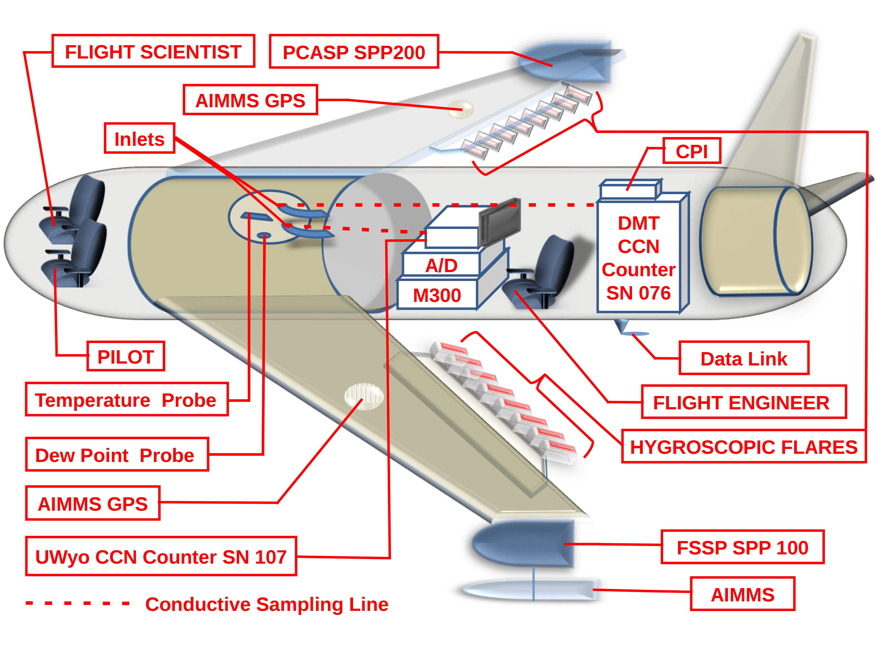
Figure 4: Diagram of the Cessna 340 aircraft configuration for 2012. The 2010 and 2008 aircraft configuration is similar except the Droplet Measurement Technologies (DMT) cloud condensation nuclei (CCN) counter and aircraft integrated meteorological measurements system (AIMMS) probe are not on the aircraft. A DMT constant pressure inlet (CPI) system maintains the DMT CCN counter at a constant pressure of 700 hPa. Flexible conductive tubing of 6.35 mm (0.25 inch) diameter connects the reverse facing inlets to the CCN counters and two additional ports (not shown) on the window insert provide the exit for the air sample. An analog-to-digital board (A/D) records voltage outputs from the University of Wyoming (UWyo) CCN counter, the Dew Point Probe, and Temperature Probe. The Data Link system uses a 465 MHz antenna to down link data. The bullet list of instruments defines all acronyms. Image created using LibreOffice software.
Flight rules only required a single pilot for operation of the Cessna 340 aircraft so during POLCAST a flight scientist occupied the right front seat. The flight scientist is responsible for ensuring the flight achieves its scientific objectives. All POLCAST flights are flown by two experienced WMI pilots, Hans Ahlness and Jody Fisher. Cedric (“Tony”) Grainger and David Delene are the flight scientists for all POLCAST flights and a UND student researcher is the flight engineer. The flight engineer follows a checklist for instrument start-up/shutdown and for checking correct instrument operations. The flight engineer also monitors instruments during the flight for any problems that may arise. A Data Link transmits measurements in real-time to the operational center and during POLCAST2010 to the Citation Research Aircraft (registration number N555DS).
POLCAST2010 uses the following instruments for cloud sampling with the Citation Research Aircraft (Figure Figure).
- Droplet Measurement Technologies (DMT) Cloud Droplet Probe (CDP) - Able to measure cloud droplets between approximately 3 and 50 µm diameter in 30 sized channels while providing particle-by-particle information on the first 256 droplets detected in a sampling interval.
- King Hot Wire Liquid Water Content Probe (LWCP) - Able to measure cloud liquid water content.
- 2-Dimensional Cloud Imaging Probe (2D-C) - Able to measure the number concentration and 2-dimensional shape of cloud droplets.
- SPEC High Volume Precipitation Spectrometer (HVPS) - Able to measure the number concentration and 2-dimensional shape of precipitation sized particles.
- EdgeTech Digital Aircraft Hygrometer (Dew Point Temp.) - Able to measure ambient dew point temperature.
- Rosemount Aircraft Temperature Sensors (Temp. Probe) - Able to measure ambient air temperature when combined with an air speed measurement.
- Applanix Corporation Position and Orientation System for Airborne Vehicles – Provides 3-dimensional atmospheric winds when measurements are combined with the Nose Boom Gust Probe measurements.
- Pitot Tubes with Pressure Transducers (Pitot Tube) - Able to measure the aircraft speed relative to the ambient air.
- Aircraft GPS System - Able to measure position and aircraft's ground speed.
- Sulfur Hexafluoride (SF₆) Analyzer - Able to detect trace amounts of SF₆ released from the seeding aircraft.
- Data Radio – Uses a 465 MHz antenna and data link system to receive real-time position information from the seeding aircraft.
- Science Engineering Associates (SEA) M300 Data System - Able to acquire, display and record data from research instruments.
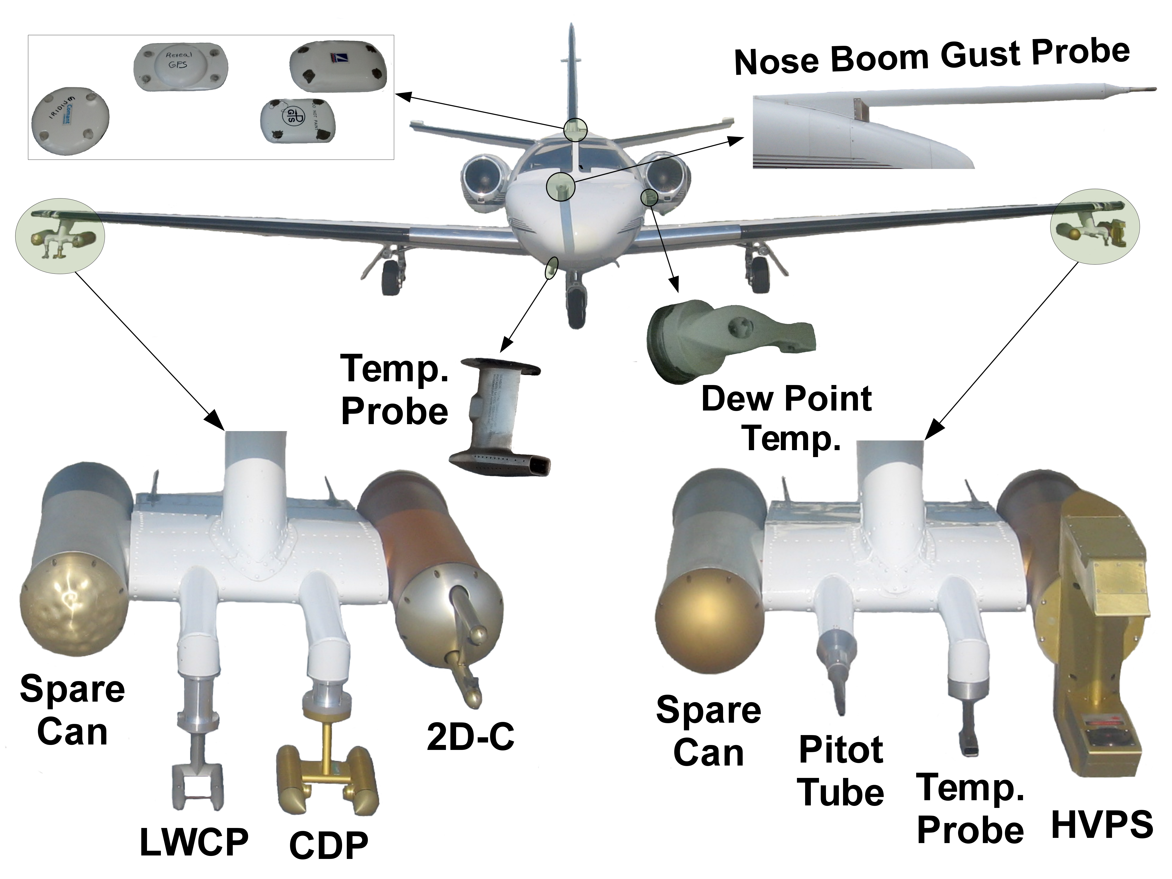
Figure 5: Diagram of the Citation Research Aircraft configuration for 2010, the only year of project participation. An analog-to-digital board (A/D) records voltage outputs from the Dew Point Temp instrument and Temp. Probe. Acronyms are defined in the bullet list of instruments. Image is created using LibreOffice and GNU Image Manipulation Program (GIMP) software.
The Citation Research Aircraft requires two pilots to meet insurance requirements. The flight scientist, David Delene for POLCAST2010, sits behind the pilots and monitors instruments using the M300 data acquisition system. Two seats are available for flight engineers that are responsible for starting and shutting down equipment, and for monitoring instruments for problems during the flight. Flight engineers follow a detailed checklist designed specifically for the project's instrumentation. The checklist includes documenting the value of key parameters and ensuring parameters are within the acceptable range. The M300 data acquisition system on the Citation Research Aircraft obtains and displays the Cessna 340 seeding aircraft position in real-time using a 465 MHz data link. The flight crew uses a special science radio for communication with the seeding aircraft and the POLCAST control center.

Data Processing
The Science Engineering Associates (SEA) model 300 data acquisition system (M300) acquires all measurements during POLCAST flights at a sampling frequency of at least 1 Hz. The open-source Airborne Data Processing and Analysis software package (ADPAA) post-processes the M300 binary file by splitting measurements into individual instrument files, processes the instrumental data using the concept of data levels and creates a summary data file for each flight (Delene 2011). The summary data file contains all important parameters necessary to conduct scientific analysis. ADPAA is able to handle all model M300 and model M200 SEA data acquisition system files. ADPAA includes calibration information to correctly process data from all UND Citation Research Aircraft projects since 2000 and many research projects conducted by WMI in addition to POLCAST. ADPAA is not limited to airborne applications but processes POLCAST surface (Cochran et al. 2013) and laboratory data. We have even processed data from rockets and unmanned aircraft system platforms using ADPAA (Tilley et al. 2011).
All ADPAA files are freely available from the SourceForge subversion repository (Delene et al. 2016) and an archive available at Zenodo (Delene 2016a). Therefore, it is not necessary to describe processing equations here and we refer the interested reader to the ADPAA software itself. The software fully documents how a single module (group of files organized into a directory) processes data from an instrument. Typically, a single file within a module contains the data processing methodology with other files providing data input and output functionality. The level of input data that a module uses provides the top-level organization (i.e. Level1, Level2, Level3, or Level4) to ADPAA's instrument modules. The ADPAA tree (Sourceforge) is available on the Web so particular instrument modules and processing files can easily be located. Obtaining some scientifically important parameters, such as air temperature, requires modules from different levels which can make it difficult to follow the data flow. Hence, the SourceForge ADPAA wiki (Sourceforge Wiki) provides documentation on data flow for important parameters in the “Instrument Processing Streams” section. The wiki defines modules used to derive an important parameter but does not provide step-by-step processing instructions since details are available within the modules themselves.
POLCAST automatically processes flight data on Linux servers by using ADPAA code within the “scripts” module. A wiki page (Sourceforge Wiki) provides details on ADPAA hierarchical structure of scripts. ADPAA's top-level script, process_all_dir, calls POLCAST field project level scripts: process_all_polcast2, process_all_polcast3, and process_all-polcast4. We have re-processed all M300 raw files using the same code version (December 9, 2015) to create our analysis data set. The processing date is in the meta-data of all files and the Sourceforge repository enables extraction of code on a particular day. Therefore, reproducibility of our results is enhanced by having the software openly available since the data set can be regenerated and the code used to create the data set will always be accessible (Ince et al. 2012).

Data Quality Control
Data quality control is defined to involve obtaining an instrument's calibration, conducting periodic checks to ensure expected instrument performance and ensuring measurements are representative of the ambient environment (Delene 2011). Some instruments (e.g. total temperature probes) cannot easily be coupled to the environment so measurements are adjusted to ambient conditions. POLCAST personnel performed weekly quality control procedures on all aircraft instruments. The flight scientist ensures the FSSP and PCASP are sizing correctly by challenging the instrument with standard sized beads. The flight scientists ensures that the CCN counter is not contaminated by challenging the system with an inlet particle filter. Additionally, a hand-held vacuum pump is used to measure the system's leak rate, which should be low for deployment on pressurized aircraft (Delene and Sever 2009). As found during one POLCAST2008 flight, a leak can result in measuring significantly lower CCN concentrations than what is actually in the ambient environment (Delene et al. 2011). The on-board flight crew monitor measurements continuously; however, aircraft flights can be busy so instrument problems can be missed. Since data processing is automated, flight measurements are able to be reviewed by project personnel shortly after each flight. While the ADPAA Cplot2 program (Delene 2016b) is able to generate “quick-look” plots, POLCAST data is reviewed interactively using Cplot2, which allows for re-plotting and examination of all available data.
POLCAST found that CCN counters require more robust quality control procedures and calibrations than most other airborne instruments. The POLCAST field projects use serial number 107 UWyo CCN counter (Delene et al. 1998) for cloud base measurements. POLCAST operates the UWyo CCN counter at a single supersaturation to obtain sufficient samples for accurate average measurements within the time interval (approximately 12 minutes) that seeding material is released into clouds. The UWyo CCN counter requires approximately 30 s to obtain a sample when operated at a single supersaturation; therefore, sampling under a single cloud would provide approximately 24 samples. Occasionally, the CCN counter would sample material from seeding flares. Seeding material is only encountered away from clouds where updrafts are not present to move the material upward before the next aircraft pass. The quality assurance procedure removes flare measurements from the analysis data set. When cloud targets are not seeded as part of the randomized experiment, the aircraft still samples under cloud base for 12 minutes to mark the area of influence for use in radar cell analysis (Delene et al. 2011).
Calibration of the UWyo CCN counter uses a condensation particle counter (CPC) as the concentration standard (Delene and Deshler 2000). TSI CPCs are good calibration standards since the counters use a critical orifice to maintain a constant volumetric flow and count individual particles. The accuracy of the TSI CPC is confirmed before CCN counter calibrations using a bubble flow meter primary standard (Sensidyne Gilibrator-2). To ensure that the CPC and CCN counters detect the same particles, a differential mobility analyzer (DMA) is used to size select from a poly-dispersed ammonium sulfate particle stream (Bart and Delene 2013; Delene and Starzec 2014). The DMA uses electrical mobility to select particles over a very narrow size range (Kulkarni et al. 2011, Chapter 15) that excludes particles that do not activate at the CCN counter's supersaturation. When the DMA selects small diameter particles, for example 20 nm diameter, the UWyo CCN counter 1 % supersaturation (theoretical value) measures is less than 20 #/cm⁻³, which is the noise level of the counter (Delene and Deshler 2000).
The single supersaturation calibration (Delene and Starzec 2014) conducted in January 2011 by UND differs by more than 50 % at concentrations between 2000-3000 #/cm³ from the calibration conducted in May 2008 by the University of Wyoming (Figure Figure). The University of Wyoming calibrations use the supersaturation spectrum method which involves conducting calibrations at several supersaturations and fitting the following equation to the data:
$C=a∗{SS}^{b}∗\left(ΔV\right)$ Eq. 1
where C is the particle concentration, SS is the CCN counter's theoretically determined supersaturation, ΔV is the photo-detector voltage difference between the baseline (particle free) measurement and the peak voltage obtained during the detection cycle, and a and b are fit parameters. During POLCAST, the UWyo CCN counter is operated at a constant theoretical supersaturation of 1.0 %; hence, equation Eq. reduces to:
$C=a∗\left(ΔV\right)$ Eq. 2
While calibrations at 1 % supersaturation are pretty linear, the single supersaturation calibration method can be used to more accurately represent the observed data over all concentrations. The following equation expresses the single supersaturation method.
$C=A∗{\left(ΔV\right)}^{B}$ Eq. 3
Fit parameters A and B in equation Eq. should not be confused with fit parameters a and b in equation Eq. since a different method determines each parameter set. Equation Eq. assumes droplets contribute linearly to light scattering measured by the photo-detector; while, equation Eq. allows the amount of light detected per droplet to change with droplet concentration. Hence, equation Eq. can model multiple scattering by droplets within the laser beam.
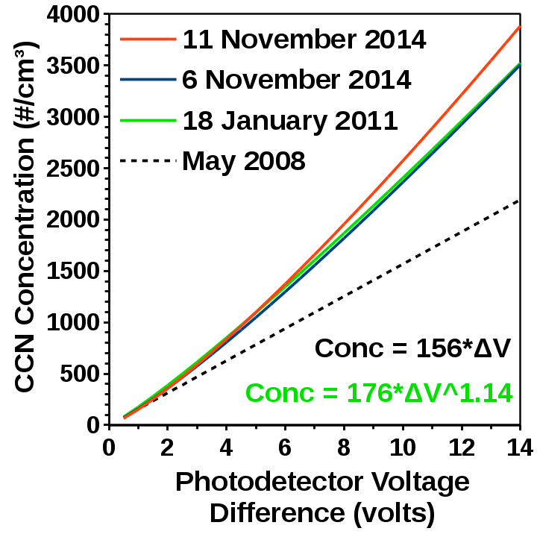
Figure 6: Calibration relationships for the University of Wyoming (UWyo) cloud condensation nuclei (CCN) counter (serial number 107) at 1.0 (theoretical value) supersaturation. The dashed line is the calibration conducted by the UWyo using the supersaturation spectrum method while the solid lines are the calibrations conducted by the University of North Dakota (UND) at a single supersaturation. The legend provides the calibration date. The equations (lower right) provide the relationship between photo-detector voltage difference (ΔV) and the CCN concentration (Conc) for the May 2008 (black) and January 2011 (green) calibrations. Plot created using LibreOffice software.
The supersaturation spectrum calibration method works well when the UWyo CCN counter is operated at several supersaturations during a flight; however, when the supersaturation is constant, the more accurate single supersaturation method can be used. While the calibration difference between May 2008 and January 2011 may be due to different methods, the difference is likely not due to instrument drift since there is little difference in the 2011 and 2014 calibrations (Figure Figure). Considering that the May 2008 supersaturation spectrum calibration did not include 1 % and the reproducibility over time of the January 2011 calibration, we use the January 2011 calibration for the POLCAST data set.
It is important to note that this paper's calibrations and measurements are at the CCN counter's theoretical supersaturation of 1.0 %; however, the actual ambient supersaturation is approximately 0.6 % (Snider et al. 2006). Such a supersaturation difference is important when comparing to models or observations conducted with other CCN counters. The DMT CCN counter (Roberts and Nenes 2005) uses a different measurement method than the UWyo CCN counter so comparisons can be informative. Additionally, more recent measurements will use the DMT CCN counter since parts are no longer available for the UWyo CCN counter. A comparison between the UWyo and DMT CCN counters show agreement within the counter's uncertainty (Figure Figure). We take the combined uncertainty to be greater than 20% since the UWyo CCN counter's uncertainty is approximately 10 % (Delene and Deshler 2000) and the DMT counter uncertainty is at least 10 % (Rose et al. 2008).
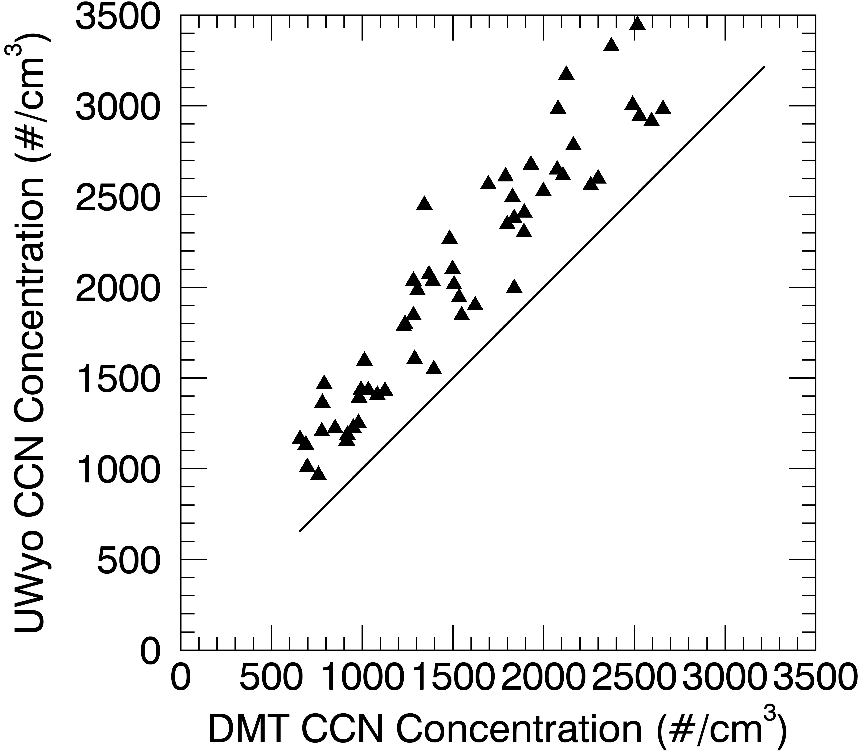
Figure 7: Plot showing measurements from the Droplet Measurement Technology (DMT) cloud condensation nuclei (CCN) counter versus the University of Wyoming (UWyo) CCN counter (serial number 107). Measurements are of poly-dispersed aerosols generated in the lab on 25 June 2014. Concentrations are at standard temperature and pressure conditions using an adjustment to the CCN counters measurement. The solid black line is the one-to-one line. The UWyo CCN counter is using the 18 January 2011 calibration. Plot created using the Airborne Data Processing and Analysis software package (ADPAA).
While the CCN counters agree, the UWyo CCN counter concentrations are approximately 20 % greater than the DMT CCN counter. A number of factors may account for the systematic difference between the two counters. For example, the UWyo CCN counter may be operating at a higher supersaturation than the DMT CCN counter. Supersaturation differences is only one possible explanation and extensive laboratory work is required to refine the CCN counter's calibrations. Detailed discussion of CCN counter uncertainties is beyond the scope of this paper; however, calibration uncertainties is the focus of current research (Hibert and Delene 2015) and a future paper (Hibert and Delene 2016). Here we only note that the counter's agreement is better using the January 2011 calibration than using the May 2008 calibration and that the UWyo CCN measurements should be regarded as having a 10 to 20 % uncertainty in absolute concentration.

Data Set Quality Assurance
The POLCAST data set contains raw M300 data files, all derived data files, the science analysis summary files, and flight documentation such as pictures, videos, and flight notes. The concepts of missing value codes and meta-data are fully incorporated in the POLCAST data set (Delene 2011). All derived data generated from raw M300 files are in the standard NASA/UND ASCII data format (Delene 2011) which has a meta-data file header that fully describes all parameters contained within the file. The Department of Atmospheric Sciences at UND maintains the complete POLCAST data set on the Citation2 Linux server within a standard directory structure (Delene 2011). The Citation2 server is mountable by workstations throughout the department and backup archives are maintained on and off campus. While the POLCAST data set is not openly accessible online, access is available upon request.
Data quality assurance is defined as the process of reviewing a data set to eliminate (replace with missing value codes) measurements that are invalid due to known problems. The complete POLCAST data set is quality assured by UND scientists with instrumentation expertise related to the data under review. Use of an automated process, where programs remove data which does not fall within defined limits, is not employed since not all issues can be addressed in this manner. Furthermore, such an automated process can delay important discoveries; for example, the Antarctic Ozone Hole (Welch 2016). Instead of relying on an automated process, POLCAST scientists employ the ADPAA “Cplot” and “Cplot2” visualization programs (Delene 2016b) to quickly review all important parameters manually.
If a data issue is found, the scientist creates an edit file to address the issue at the lowest possible data level. The edit file stores time periods judged invalid, the scientist's name, the date when the edit is applied, and the reason why data is judged invalid. Data processing software uses the edit file to create a “clean” version of the data file where time periods with identified problems have their “raw” values replaced with missing value codes. The “clean” version of the data is used for all subsequent data processing and thereby incorporated into the science analysis summary file. A detailed description of all POLCAST data edits is beyond the paper's scope and the interested reader is referred to Delene 2011 for a discussion on airborne data editing examples and Delene et al. 2011 for several examples of POLCAST2008 data issues. While removal of all artifacts is impossible, we believe all issues that affect interpretation of the results, such as flare plume contamination of background CCN measurements, have been removed from the analysis data set.

Data Analysis Results
ADPAA is not only for automated data processing, quality control and quality assurance but also contains programs for conducting data analysis. There are utility scripts that work at the file level to extract, subset, merge, combine, and average data (Sourceforge Wiki). Additionally, there is functionality in Cplot to calculate and store statistics (mean and percentiles) given a time range. The ability of Cplot and Cplot2 to quickly visualize all aircraft parameters at different scales and inter-compare the parameters enable analysis periods to be selected. Furthermore, Cplot2 is especially good at quickly creating plots at the resolution required for publication (e.g. Figure Figure), which is difficult with programs such as Microsoft Excel. Compared to other available tools, ADPAA has the following three main advantages. 1.) Details (e.g. time intervals) of the analysis are documented. 2.) The analysis implementation can be openly reviewed. 3.) The analysis can easily be repeated on the existing data set or applied to another data set.
The quality controlled and quality assured POLCAST airborne data set is used to determine suitability of conducting effective hygroscopic seeding in North Dakota. Airborne observations are analyzed to determine cloud base CCN concentration, temperature and height. Statistical distribution of observations are created to document the natural variability that exists in the atmosphere. Natural aerosol variability, and hence CCN variability, arises from patchy sources, temporal variations in sinks (e.g. rain), and an atmospheric residence time of days (Singh 1995, Chapter 5). Variability of cloud base temperature and height arises due to different wind patterns, water vapor distributions and temperature profiles. Hence, cloud properties depend on the residence times, sources, and sinks of CCN and water vapor, which can vary greatly from one region to another. Therefore, it is necessary to know a region's distribution of cloud base CCN concentration, temperature and height to enable theoretical understanding (model results) to determine if seeded clouds are likely to produce enhance precipitation compared to naturally occurring clouds.

Cloud Condensation Nuclei
CCN measurements using the UWyo May 2008 calibration have been presented previously for individual POLCAST field projects (Delene et al. 2011; Bart and Delene 2013; Delene and Starzec 2014). Figure Figure shows all the POLCAST CCN measurements using the UND January 2011 calibration. Figure Figure has a total of 24 flights which is less than the 30 flight tracks given in Figures Figure- Figure since some days are missing due to instrument issues and lack of cloud seeding targets. There are no targets observed on the second flight on 12 June 2008. The CCN counter's inlet has a leak for the 21 June 2008 flight. There is a CCN counter photo-detector issue on 24 June 2010. No targets are observed on the first flight on 02 July 2012, which is a combined test and research flight. There is a wiring issue for the temperature sensor on 17 and 20 July 2012.
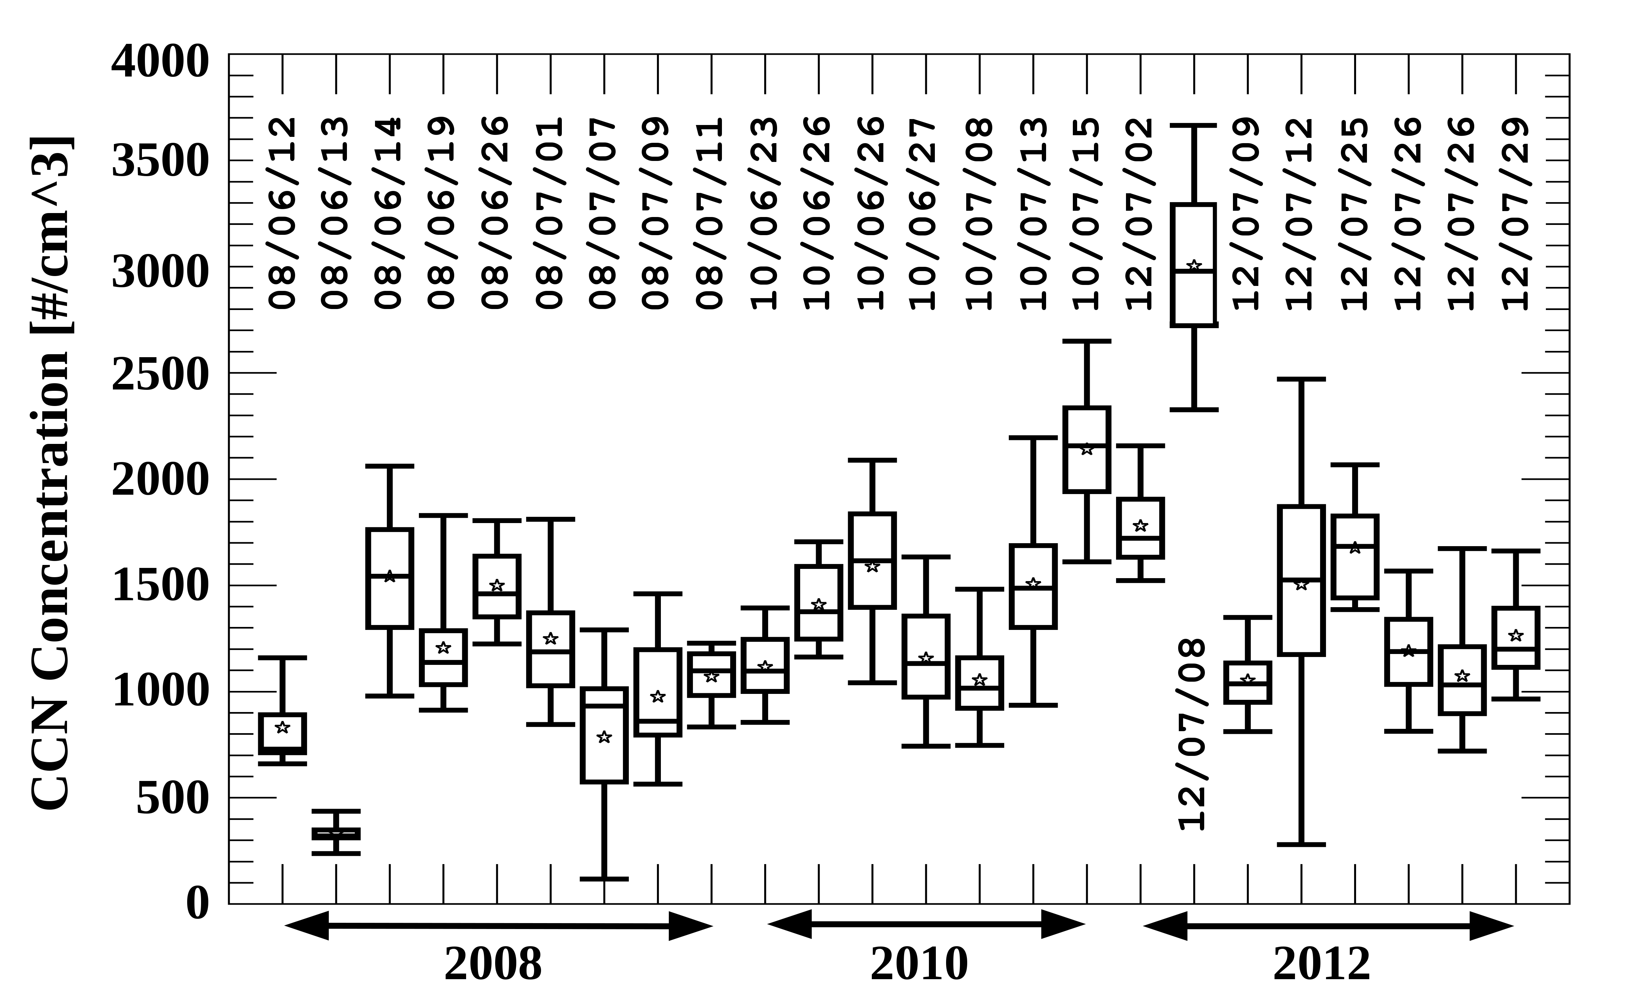
Figure 8: Statistical distributions of cloud condensation nuclei (CCN) measurements below the base of developing cumulus clouds in North Dakota. Measurements are from the University of Wyoming (UWyo) CCN counter (serial number 107) operated at 0.6 % ambient supersaturation. Concentrations have been adjusted to standard temperature and pressure. Measurements are from 30 s samples obtained throughout aircraft flights lasting up to 4 hours. The x-axis label gives the measurement year and the exact flight date is given in the vertical text (YYMMDD format). Note that there were some days with two flights. Star symbols are means, horizontal line is the 50th percentile, top of the box is the 75th percentile, bottom of the box is the 25th percentile, and top and bottom of the whiskers are the 95th and 5th percentiles, respectively. Plot created using the Airborne Data Processing and Analysis software package (ADPAA).
There is smaller variability on individual POLCAST days compared to the variability among POLCAST days. This indicates little change from one day's seeding target (back and forth flight track segments, see Figures Figure- Figure) to another day's seeding target compared with changes from one flight day to another flight day. The POLCAST CCN concentration flight mean maximum is 3000 #/cm³ (8 July 2012), minimum is 330 #/cm³ (13 June 2008), and the POLCAST mean of all flight means is 1260 ± 500 #/cm³. Compared to other aircraft observations of CCN concentrations (Delene and Deshler 2001, Figure 1), POLCAST mean flight CCN concentrations span is wide, ranging from clean continental to polluted. The POLCAST mean of 1260 #/cm³ is twice the concentration observed in West Africa and Saudi Arabia ((Delene et al. 2011, Figure 7). Additionally, the POLCAST CCN mean concentration is larger than lower tropospheric balloon-borne CCN measurements in Wyoming and New Zealand (Delene and Deshler 2001).
POLCAST observations are similar to daily summer, surface-based CCN concentration means of 200 to 1700 #/cm³ for Western North Dakota (Detwiler et al. 2010). Based on several years of surface based aerosol measurements at sites around North America (Sherman et al. 2015; Delene and Ogren 2002), we should expect the Western North Dakota CCN measurements to be similar to POLCAST CCN measurements. The Western North Dakota site and the POLCAST region are less than 500 km apart and it is only in distinctly different regions that statistics of accumulation mode aerosol concentrations, which relate directly to CCN concentrations, vary significantly. Furthermore, analysis of POLCAST ascent/descent profiles indicate that the atmosphere is well-mixed from the surface to cloud base (Bart and Delene 2013). It is only when surface based convection is not present or near a large point source that observations of accumulation mode aerosol show a decrease with height above the surface (Andrews et al. 2011; Delene and Deshler 2001).
While there is little (500 #/cm³) observed small scale (10-1000 km) variations in North Dakota's well-mixed lower tropospheric CCN concentration that affects developing cumulus clouds, there is an observed order of magnitude (~300 to 3000 #/cm³) day to day variation. Even on two consecutive days when convection occurs, the CCN concentration can change significantly. On 13 June 2008 the mean CCN concentration is 330 ± 60 #/cm³ and increases to 1540 ± 60 #/cm³ on the following day. On 8 July 2012 the mean CCN concentration is 3000 ± 430 #/cm³ and decreases to 1050 ± 220 #/cm³ on the following day. Similar to the findings of Detwiler et al. 2010, the daily POLCAST CCN concentration changes are not related to air mass source location as indicated by 24 hour back-trajectories (Delene et al. 2013). However, rain does lower CCN concentration (at least for several hours) and as evident by the 8-9 July 2012 case, boundary layer height may also be important (Delene and Bart 2013) and is investigated in the next section with the analysis of POLCAST cloud base height.

Temperature and Height
Figure Figure shows POLCAST cloud base temperature and altitude measurements, which correspond to the dates of cloud base CCN concentration measurements (Figure Figure). The cloud base, flight mean, maximum temperature is 20.3 ⁰C, (29 July 2012), the minimum temperature is 3.9 ⁰C (12 June 2008 and 9 July 2008), and the POLCAST mean temperature (of all flight mean temperatures) is 12.7 ± 5.9 ⁰C. The cloud base, flight mean, maximum altitude is 2308 m, (14 June 2008), the minimum altitude is 937 m (26 June 2010, second flight), and the POLCAST mean altitude (of all flight mean altitudes) is 1672 ± 408 m.
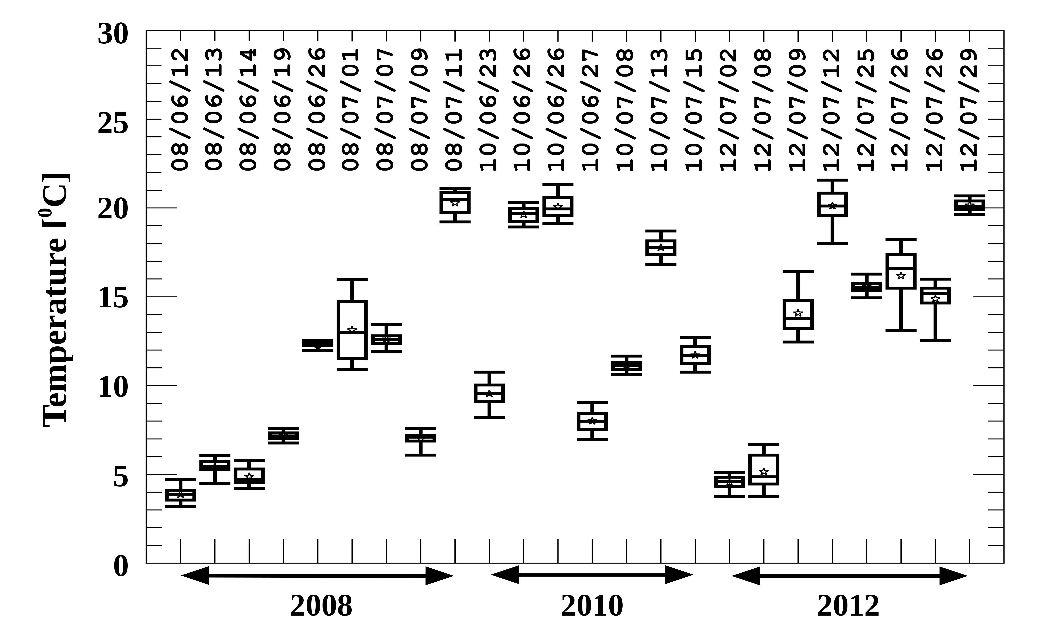
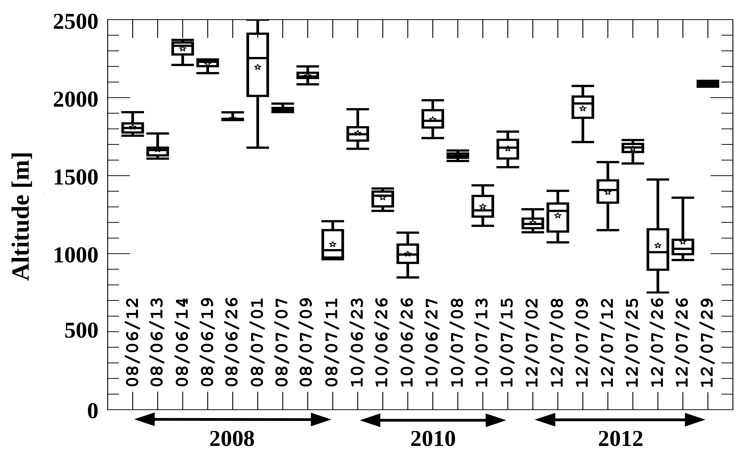
Figure 9: Statistical distributions of just below cloud base ambient air temperature (Top) and altitude (bottom) of developing cumulus clouds in North Dakota. Box-and-whiskers and date text are similar to Figure Figure. Cloud base altitude given above mean sea level (MSL). Plot created using the Airborne Data Processing and Analysis software package (ADPAA).
Grand Forks, North Dakota has a surface elevation of 256 m MSL; hence, approximately 250 m needs to be subtracted from cloud base altitude to obtain cloud base height above the ground (AGL). Therefore, cloud base height ranges from approximately 689 to 2058 m which is a factor of 3.0 change. Hence, changes in mixing height could account for a factor of 3.0 variation in day-to-day CCN concentration assuming the same source rate, sink rate, and horizontal dispersion. However, the POLCAST flight mean CCN concentration and cloud base height has a weak (correlation coefficient of -0.21) relationship. Similarly, cloud base temperature and cloud base height has a weak (correlation coefficient of -0.37) relationship. Therefore, while the 8-9 July 2012 case indicates boundary layer height may be important for predicting CCN concentration, analysis of the complete POLCAST data set indicates that cloud base height itself is not useful for predicting CCN concentration.

Cloud Droplet Growth
While the flight time of the Citation Research Aircraft (Figure Figure) is limited to six flights, there are some interesting cloud droplet growth measurements (Figure Figure). Note that the Citation Research Aircraft penetrated only at certain altitudes and cloud base is determined using ascent/descent profiles. The 15 July 2010 cloud has a slower droplet growth with height than the 13 July and 20 July 2010 clouds. While 13 July 2010 and 15 July 2010 (no 20 July 2010 data is available due to seeding aircraft engine issue) has a typical cloud base temperature and height, the 15 July 2010 CCN concentration is the second highest POLCAST concentration. Hence, the 15 July 2010 observations support the concept that high CCN concentration results in a high droplet concentration and small droplet size which take more cloud depth to grow via the condensation process before reaching a sufficient size (approximately 24 µm) to initiate the coalescent process (Rosenfeld et al. 2008).
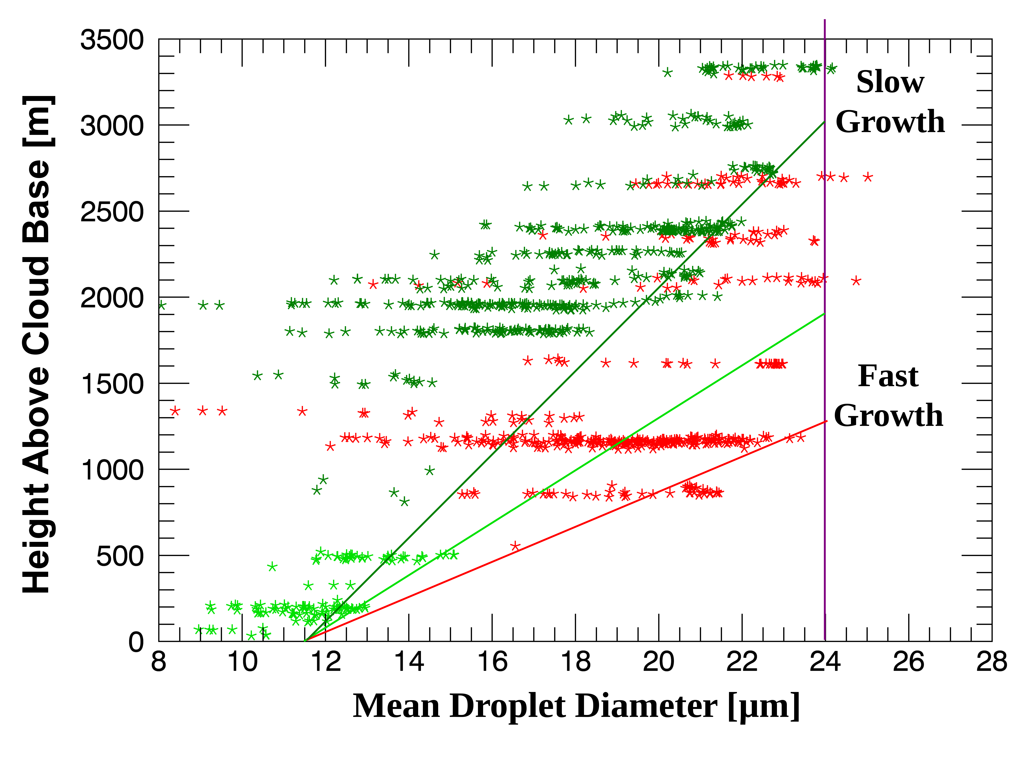
Figure 10: The cloud droplet probe (CDP) mean droplet diameter versus the height above cloud base for aircraft flights near Grand Forks, North Dakota in the summer of 2010 (light green – July 13, dark green – July 15, red – July 20). Only measurements with CDP concentrations above 140 #/cm³ are presented. The color (red, light green, and dark green) lines are manually overlaid to show the increase of maximum droplet diameter observed at each penetration level. The vertical purple line denotes where theory indicates coalescence starts to become an efficient growth process. The plot is created using the Airborne Data Processing and Analysis software package (ADPAA) and LibreOffice software.

Discussion

Instrumentation Challenges
The DMT Cloud Droplet Probe (CDP) is the latest in the family of forward scattering probes which measure cloud droplets. POLCAST2008 uses a Forward Scattering Spectrometer Probe (FSSP) with DMT’s SPP-100 electronics upgrade on the seeding aircraft to obtain droplet concentrations that are related to the cloud base CCN measurements (Delene et al. 2011, Figure 8). The CDP has similar electronics as the SPP-100 FSSP; however, the optical system is different. While the CDP is similar to the FSSP, ADPAA required a new data processing module. As with most new instruments, there is a learning curve to understanding the CDP's operations, calibration and quality control procedures.
The POLCAST team conducted CDP probe cleaning and calibration before (December 16, 2009) the POLCAST2010 field project and performance checks during the project (e.g. July 26, 2010). The performance checks show that the spectrum of 15 and 30 µm diameters particles are not of the correct size and result in an incorrect spectrum. The issue is a software configuration error with the M300 setup, which requires adjustment of the channel boundaries in ADPAA for correct data processing. Even with the channel size adjustment, the CDP calculated liquid water content (LWC) is approximately 50% low compared to the Hot Wire probe LWC. In addition, the total droplet concentration is extremely low compared to POLCAST2008 measurements in similar types of clouds. Other researchers have experienced the same low droplet counts issues (Lance et al. 2010), and the problem is due to not having an optical mask to reject particles that are well outside the instrument's sample volume. By not excluding these droplets, droplets within the sample volume have a large probability of being coincident with droplets out of the sample volume and being rejected, which reduces the droplet concentration. The UND CDP now has an optical mask that has solved the low concentration issues; however, it is not possible to correct the POLCAST2010 CDP droplet concentration measurements.
In addition to using a new probe to measure droplet concentrations, POLCAST uses many cutting-edge technologies and unfortunately not everything worked. While scientists are sometimes reluctant to publish information about what did not work in an experiment, it is important that we all learn from each other. One technology that did not provide results during POLCAST is detection of cloud parcels using a Sulfur Hexafluoride (SF₆) tracer. A large amount of POLCAST2010 field project time is related to getting the SF₆ analyzer installed and operating.
Runjun Li at Texas A&M University built the SF₆ analyzer by putting an oxygen and water vapor removal system in front of an Electron Capture Detector (ECD). The first task after UND received the SF₆ analyzer was configuring the equipment for standard 19” aircraft racks and installation in the Citation Research Aircraft (Figure Figure). The first SF₆ analyzer issue was getting sufficient flow through the instrument which was solved by removing the pre-heater to the ECD. The next problem was with the metal hydride hydrogen storage bottle. The bottle only lasted 20-30 minutes instead of the theoretical value of 7 hours. While the original bottle was new, a replacement bottle had to be purchased to solve the problem. The next problem was that the Nafion dryer used to remove water vapor developed a leak and Runjun Li had to send us another (shorter) dryer to replace the broken dryer. Once the dryer was fixed, the ECD was flooded with water while conducting ground samples, which had to be fixed by passing nitrogen gas through the instrument for 24 hours to dry the ECD. Each problem took an extensive amount of time but the analyzer SF₆ was working at the end of the project; however, the weather conditions were not favorable for cloud seeding so no SF₆ tracer experiments were possible.
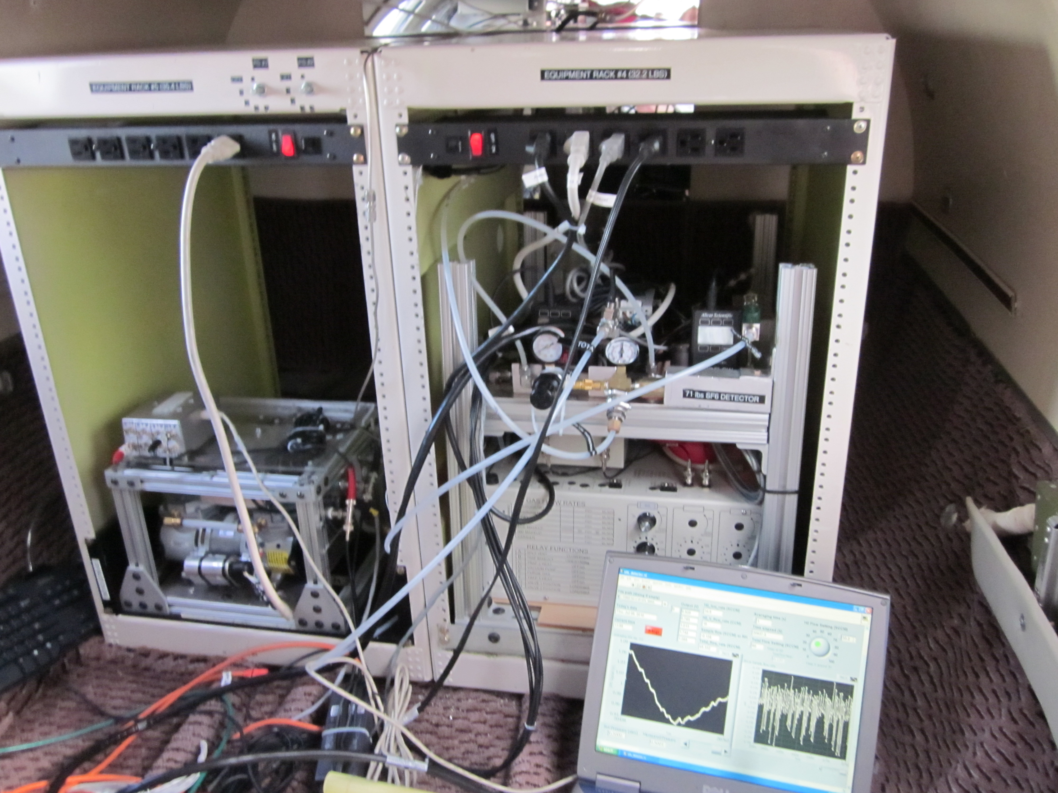
Figure 11: Image of the sulfur hexafluoride (SF₆) analyzer in the back racks on the Citation Research aircraft conducting ground tests during the summer of 2010. The pump and constant pressure inlet system are on the left side of the image. The Electron Capture Detector (ECD) and hydrogen bottle are on the right side of the image.

Suitability for Hygroscopic Seeding
While the POLCAST field projects generated a robust data set of cloud base measurements using instrumentation on the seeding aircraft, it is unfortunate that more above cloud base measurements are not available. However, POLCAST's limited scope is focused on obtaining cloud seeding targets. The 13/15 July 2010 difference in droplet growth with height is interesting considering that North Dakota clouds may not obtain sufficient depth to produce precipitation under 15 July 2010 conditions. Hygroscopic seeding could be very effective under these conditions at increasing the concentration of large droplets and decreasing the height above cloud base where coalescence begins. Such a hygroscopic seeding effect should be clearly documented by measurements; however, this task is difficult. While POLCAST did not obtain in cloud measurements that are clearly affected by seeding, stacked flights between the seeding aircraft and the Citation Research Aircraft were conducted and transmitting the seeding aircraft's position to the Citation Research Aircraft worked well.
The POLCAST project observed large day-to-day variation in CCN concentration (Figure Figure) likely resulting in important variations in droplet growth rates above cloud base (Figure Figure). Therefore, from a cloud seeding operations perspective, it is important to know if a particular day will have high or low CCN concentrations. Since the North Dakota boundary layer is well mixed on days when hygroscopic seeding targets are present and CCN concentrations do not vary significantly on scales of several hundred kilometers and several hours, local surface based measurements can be used to predict afternoon cloud base conditions.
While the POLCAST data set is small, the cloud base, flight mean CCN concentration is Gaussian distributed with one high outlier and one low outlier (Figure Figure). The lack of a bi-modal distribution indicates there is no clear stratification. Based on modeling results (Yin et al. 2000) that hygroscopic seeding is effective in environments when CCN concentration (1 % supersaturation) is greater than 500 #/cm³, most, if not all days, would be suitable for hygroscopic seeding. The POLCAST measurements are obtained at an ambient supersaturation of approximately 0.6 % supersaturation; therefore, the concentrations are lower than CCN concentration at 1 %. Furthermore, even reducing the POLCAST CCN concentration by 20 % (the measurement uncertainty) would result in most POLCAST days having CCN concentration suitable for hygroscopic seeding.

Conclusion and Future Work
POLCAST's relatively high CCN concentration (1260 #/cm³) supports the conclusion that addition of large hygroscopic particles produces more collector droplets which increases precipitation efficiency. Precipitation efficiency in North Dakota convective clouds is not a simple warm rain process but is more complex involving more graupel production in the cold cloud region since cloud base temperatures are relatively cold and clouds are several kilometers thick. POLCAST observations show that cloud base heights are relatively close to the surface which indicates that increases in precipitation results in increased rain reaching the surface. All environmental factors examined indicate that North Dakota is suitable for conducting hygroscopic seeding to enhance precipitation. Details of the onset of the coalescent process is impossible to evaluate since the current POLCAST observations are mostly near cloud base and C-band radar observations, while important tools for validating the seeding conceptual model (Krauss et al. 2010), are likely insufficient.
Several assumptions in the conceptual model require additional observations and further research to validate. A complete aerosol/cloud physics data set for North Dakota would provide a valuable resource for constructing a sufficiently accurate model that cloud seeding changes could be determined. Development, validation, and use of a model with an established uncertainty may be a more cost-effective method for determining precipitation increases from seeding than a randomized seeding experiment. Use of models with unknown uncertainties is typically accepted in other areas of atmospheric research such as climate change. Additionally, with the limited success of the Wyoming randomized cloud seeding experiment, understanding the physical processes sufficiently to validate a precipitation forecast model is gaining support as the most productive path forward to determine cloud seeding effects (Tessendorf et al. 2015). The conceptual cloud seeding model forms the framework for understanding physical processes which can be subsequently incorporated into a precipitation forecasting model. A model validated for a specific region could be used to simulate an operational program for a particular season to determine the precipitation enhancement amount. People should use caution when using such simulations since it is relatively easy to add a seeding module to a forecast model (Xue et al. 2013), however, it is more difficult to prove that the physical processes are accurately represented and the model is producing accurate results.
While the physical processes related to hygroscopic seeding of convective clouds are more complex than AgI seeding of orographic clouds, it is also more difficult to conduct a successful randomized hygroscopic seeding experiment (Tessendorf et al. 2010). New instrumentation allows for improved observations of the physical processes on much smaller spatial scales. The CDP probe with the latest electronics board and a fast RS422 acquisition board enables a 25 Hz data rate while obtaining particle-by-particle information. New cloud imaging probes have 10-15 µm sized diodes that allow for better observations of the onset of the coalescence process. It is now understood how to make airborne DMT CCN counter measurements coupled to the ambient environment and CCN calibration uncertainties are better understood. New measurement techniques (Beals et al. 2015) and laboratory facilities (Shaw 2015) are becoming available. These improvements allow better observations of the physical processes involved in precipitation formation. However, there is still a need for cheaper, smaller, and easier to operate instruments that could be routinely deployed on seeding aircraft to obtain more observations than are possible in a typical research program.
Simultaneous detection of a tracer is very useful to prove a seeding effect is being observed; however, in cloud tracer detection is difficult due to the large (maybe as much as 10⁶) dilution factor involved. Furthermore, clouds are turbulent so a seeding plume does not simply rise straight up. SF₆ has the advantage that there are no natural sources so any observed SF₆ would clearly be from the seeding aircraft emissions. The SF₆ analyzer used in POLCAST2010 can be improved by adding a relative humidity and oxygen detector upstream of the ECD to aid in trouble shooting problems. It is also possible to use another tracer, such as number concentration of nucleation mode aerosols. Hygroscopic flares likely produce high concentrations of particles in the 10-20 µm diameter size range that do not activate as CCN and remain as interstitial aerosols inside clouds. A well designed inlet should allow detection of these particles; however, it is not clear that the concentration would be sufficiently large to eliminate a natural source.
Instrumentation is not the only area of recent improvement. Data processing and analysis software improvements allow handling of more observations. Unlike instruments, software can easily be copied so improvements can quickly be shared among researchers. Also, similar to measurements, software packages can be combined to provide more capability and understanding. For example, we have already utilized Aaron Bansemer's Software for Optical Diode Arrays (SODA) package developed at the National Center for Atmospheric Research with ADPAA (LaRoche 2015). We plan to combine ADPAA with Software for Airborne Measurement of Aerosol and Clouds (SAMAC) package (Gagne 2015) developed initially at Dalhousie University. Additionally, modeling software such as WRF has seen significant improvements. The Thompson aerosol-aware scheme (Thompson and Eidhammer 2014) is able to utilize CCN concentration observations and not have to depend on a fixed cloud water parameterization.
With recent improvements in airborne instruments such as faster electronic, higher resolution diodes, and improved software, we are in a better position to implement process experiments to test each chain in the hygroscopic seeding conceptual model. Such experiments would be closely coupled to improvements and testing of precipitation forecast models. With the interest outside the weather modification community for improving precipitation forecasts, additional funding sources for expanding weather modification field projects may be available such as was done in the AgI Seeding Cloud Impact Investigation (ASCII) campaign (Pokharel and Geerts 2014; Geerts et al. 2013). Additionally, process study experiments can be done in small research projects instead of having to conduct a large randomized experiment which requires sufficient resources to obtain enough cases for statistically significant results.
Acknowledgments The North Dakota Atmospheric Resource Board (NDARB) is the main funding source for the POLCAST project. NDARB also provides the project's lead forecaster who is typically Dan Brothers. Thanks to Darin Langerud, at NDARB, for reviewing a draft of this manuscript. POLCAST receives donated hygroscopic flares from Ice Crystal Engineering. We thank Dennis Afseth and Kelly Bosch for an excellent job installing research instruments on the Cessna 340 aircraft and working hard to resolve instrumentation issues. We would like to thank WMI pilots, Hans Ahlness and Jody Fisher, and UND pilots, Wayne Schindler and Jason Newham, for safe and effective aircraft operations. UND undergraduate student researchers, Dan Adriannsen, Nicole Bart, Emily Danielson, Nicholas Gapp, Matt Ham, Miranda Hilgers, Dan Koller, Christopher Kruse, Robert Mitchell, Phondie Simelane, Korey Southerland, Mariusz Starzec, Timm Uhlmann, and Kelsey Watkins, assisted with the POLCAST project. Graduate students, Gökhan Sever and Kurt Hibert, did significant work related to CCN counter calibrations. Thanks to UND graduate students, Jamie Ekness and Kurt Hibert, for reviews of this manuscript. Thanks to all researchers, especially Andrea Neamann, for contributing code to the ADPAA software package. We join with other scientist to ask authors to publish their code (Barnes 2010) and acknowledge the important research contributions of code developers by referencing software papers and code repositories in their publications. Thanks to Daniel Breed in Research Applications Laboratory (RAL) at the National Center for Atmospheric Research (NCAR) in Boulder, Colorado for extended use of a UWyo CCN counter (serial number 107). Thanks to Don Collins and Runjun Li at Texas A&M University for use and help with the SF₆ analyzer. Thanks to UND professor, Cedric (Tony) Grainger, for trips back and forth to Fargo. Many Fargo trips were on days where convection did not develop sufficiently to warrant an aircraft flight. Paul Kucera, now at NCAR/RAL, began the POLCAST project, is the main designer of the research plan, participated in each POLCAST field project, and leads the POLCAST radar data analysis effort. Thanks to Gretchen Mullendore for POLCAST modeling work and for reviewing a draft of the manuscript. Chris Theisen helped with radar operations during each POLCAST field project. Thanks to the Weather Modification Association (WMA) for free, online availability of back issues of the Journal of Weather Modification (Delene 2015). Being able to easily search past issues saves time when reviewing the weather modification literature. Finally, thanks to WMA members who provided comments on POLCAST presentations at annual meetings, thanks to reviewers for their time and special thanks to WMA Editorial Board member, Bruce Boe, for being the Editor for this manuscript.
References

Andrews, E., P. J. Sheridan, and J. A. Ogren, 2011: Seasonal differences in the vertical profiles of aerosol optical properties over rural Oklahoma. Atmospheric Chem. Phys., 11, 10661–10676, doi:10.5194/acp-11-10661-2011.
Bangsund, D. A., and F. L. Leistritz, 2009: Economic Impacts of Cloud Seeding on Agricultural Crops in North Dakota. North Dakota State University, Department of Agribusiness and Applied Economics, Report prepared for the North Dakota Atmospheric Resource Board, http://www.swc.nd.gov/arb/pdfs/SeedingEconImpact.pdf (Accessed January 28, 2016).
Barnes, N., 2010: Publish your computer code: it is good enough. Nat. News, 467, 753–753, doi:10.1038/467753a.
Bart, N., and D. J. Delene, 2013: North Dakota Aircraft and Surface CCN Measurements during the Summers of 2010 and 2012. 93rd Annual Conference of the American Meteorological Society, Austin, Texas http://aerosol.atmos.und.edu/AMS2013PosterBart_130106.pdf (Accessed June 23, 2013).
Beals, M. J., J. P. Fugal, R. A. Shaw, J. Lu, S. M. Spuler, and J. L. Stith, 2015: Holographic measurements of inhomogeneous cloud mixing at the centimeter scale. Science, 350, 87–90, doi:10.1126/science.aab0751.
Begley, C. G., and L. M. Ellis, 2012: Drug development: Raise standards for preclinical cancer research. Nature, 483, 531–533, doi:10.1038/483531a.
Boe, B. A., and J. A. Jung, 1990: The Application of Geostationary Satellite Imagery for Decision-Making in Convective Cloud Seeding in North Dakota. J. Weather Modif., 22, 73–78.
Boyd, E., J. Miller, and R. Schleusener, 1976: Hail Suppression Effects from Seeding with Silver Iodide in Western North Dakota. J. Weather Modif., 6, 246–259.
Bruintjes, R. T., 1999: A Review of Cloud Seeding Experiments to Enhance Precipitation and Some New Prospects. Bull. Am. Meteorol. Soc., 80, 805–820, doi:10.1175/1520-0477(1999)080<0805:AROCSE>2.0.CO;2.
——, V. Salazar, T. A. Semeniuk, P. Buseck, D. W. Breed, and J. Gunkelman, 2012: Evaluation of Hygroscopic Cloud Seeding Flares. J. Weather Modif., 44, 69–94.
Cochran, R., J. Haewoo, D. J. Delene, and A. Kubatova, 2013: Investigating Chemical Variation in Particulate Matter during the Polarimetric Cloud Analysis and Seeding Test (POLCAST) 2012 Campaign in Grand Forks, North Dakota. 32nd Annual Conference of the American Association for Aerosol Research, Portland, Oregon.
Cooper, W. A., R. T. Bruintjes, and G. K. Mather, 1997: Calculations Pertaining to Hygroscopic Seeding with Flares. J. Appl. Meteorol., 36, 1449–1469, doi:10.1175/1520-0450(1997)036<1449:CPTHSW>2.0.CO;2.
Czys, R. R., and R. Bruintjes, 1994: A Review of Hygroscopic Seeding Experiments to Enhance Rainfall. J. Weather Modif., 26, 41–52.
Delene, D. J., 2011: Airborne data processing and analysis software package. Earth Sci. Inform., 4, 29–44, doi:10.1007/s12145-010-0061-4.
——, 2015: Editor’s Message-2015. J. Weather Modif., 47. http://www.weathermodification.org/publications/index.php/JWM/article/view/529 (Accessed January 16, 2016).
——, 2016a: Airborne Data Processing and Analysis. Source Forge, http://sourceforge.net/projects/adpaa (Accessed January 28, 2016).
——, 2016b: Cplot Software. http://aerosol.atmos.und.edu/ADPAA/cplot.html (Accessed January 27, 2016).
——, and T. Deshler, 2000: Calibration of a Photometric Cloud Condensation Nucleus Counter Designed for Deployment on a Balloon Package. J. Atmospheric Ocean. Technol., 17, 459–467, doi:10.1175/1520-0426(2000)017<0459:COAPCC>2.0.CO;2.
——, and ——, 2001: Vertical profiles of cloud condensation nuclei above Wyoming. J. Geophys. Res. Atmospheres, 106, 12579–12588, doi:10.1029/2000JD900800.
——, and J. A. Ogren, 2002: Variability of Aerosol Optical Properties at Four North American Surface Monitoring Sites. J. Atmospheric Sci., 59, 1135–1150, doi:10.1175/1520-0469(2002)059<1135:VOAOPA>2.0.CO;2.
——, and G. Sever, 2009: Leak Testing the DMT Cloud Condensation Nuclei Counter for Deployment on Pressurized Aircraft. Droplet Measurement Technology Cloud codnsation Nuclei Workshop, Boulder, Colorado http://aerosol.atmos.und.edu/DMT_CCNCAircraft_091210.pdf (Accessed January 21, 2016).
——, and N. Bart, 2013: Concentration of Cloud Condensation Nuclei Before and After Convective Storms. Northern Plains Convective Storm Symposium, Grand Forks, North Dakota Northern Plains Convective Storm Symposium (Accessed January 30, 2016).
——, and M. Starzec, 2014: Cloud Base Cloud Condensation Nuclei Measurements in Summertime North Dakota. 14th Conference on Cloud Physics, Boston, MA, American Meteorological Society http://aerosol.atmos.und.edu/AMSCloudPhysicsSummer2014_140709.pdf (Accessed January 24, 2016).
——, and M. Poellot, 2015: University of North Dakota Citation Research Aircraft. 2015 Weather Modification Association Meeting, Fargo, North Dakota http://aerosol.atmos.und.edu/Delene_Citation_WMA_Poster.pdf (Accessed January 16, 2016).
——, T. Deshler, P. Wechsler, and G. A. Vali, 1998: A balloon-borne cloud condensation nuclei counter. J. Geophys. Res. Atmospheres, 103, 8927–8934, doi:10.1029/98JD00053.
——, C. Grainger, P. Kucera, D. Langerud, M. Ham, R. Mitchell, and C. Kruse, 2011: The Second Polarimetric Cloud Analysis and Seeding Test. J. Weather Modif., 43, 14–28.
——, N. Bart, and D. Langerud, 2013: Analysis of Cloud Condensation Nuclei Measurements Conducted during the Polarimetric Cloud Analysis and Seeding Test Projects. 2013 Annual Weather Modification Association Conference, San Antonio, Texas http://aerosol.atmos.und.edu/Delene_WeatherMod_CCN_130411.pdf (Accessed January 30, 2016).
——, C. Kruse, A. Neumann, R. Mitchell, Gökhan Sever, M. Starzec, J. O’brien, and N. Gapp, 2016: Airborne Data Processing and Analysis. University of North Dakota, Grand Forks, North Dakota, http://sourceforge.net/projects/adpaa/ (Accessed January 16, 2016).
DeMott, P. J., and Coauthors, 2011: Resurgence in Ice Nuclei Measurement Research. Bull. Am. Meteorol. Soc., 92, 1623–1635, doi:10.1175/2011BAMS3119.1.
Detwiler, A., D. Langerud, and T. Depue, 2010: Investigation of the Variability of Cloud Condensation Nuclei Concentrations at the Surface in Western North Dakota. J. Appl. Meteorol. Climatol., 49, 136–145, doi:10.1175/2009JAMC2150.1.
Gagne, S., 2015: Software for Airborne Measurements of Aerosol and Clouds. GitHub, https://github.com/StephGagne/SAMAC/ (Accessed January 19, 2015).
Garstang, M., 2003: Critical Issues in Weather Modification Research. National Academies Press, Washington, D.C., http://www.nap.edu/catalog/10829 (Accessed January 5, 2016).
——, R. Bruintjes, R. Serafin, H. Orville, B. Boe, W. Cotton, and J. Warburton, 2005: Weather Modification: Finding Common Ground. Bull. Am. Meteorol. Soc., 86, 647–655, doi:10.1175/BAMS-86-5-647.
Geerts, B., and Coauthors, 2013: The AgI Seeding Cloud Impact Investigation (ASCII) campaign 2012: overview and preliminary results. J. Weather Modif., 45, 24–43.
Hibert, K., and D. J. Delene, 2015: Calibration Uncertainties in Cloud Condensation Nuclei Counters. American Association for Aerosol Research 34th Annual Conference, Minneapolis Minnesota.
——, and ——, 2016: Calibration Uncertainties in Cloud Condensation Nuclei Counters. In Preparation.
Ice Crystal Engineering, 2016: CaCl2 Hygroscopic Burn-In-Place Cloud Seeding Flares. http://iceflares.com/cloud-seeding-flares/cacl2-hygroscopic-burn-place (Accessed February 1, 2016).
Ince, D. C., L. Hatton, and J. Graham-Cumming, 2012: The case for open computer programs. Nature, 482, 485–488, doi:10.1038/nature10836.
Krauss, T. W., A. A. Sinkevich, and A. S. Ghulam, 2010: Precipitation Characteristics of Natural and Seeded Cumulus Clouds in the Asir Region of Saudi Arabia. J. Weather Modif., 42, 61–77.
Kucera, P., A. Theisen, and D. Langerud, 2008: Polarimetric Cloud Analysis and Seeding Test (POLCAST). J. Weather Modif., 40, 64–76.
Kulkarni, P., P. A. Baron, and K. Willeke, 2011: Aerosol Measurement: Principles, Techniques, and Applications. John Wiley & Sons, 904 pp.
Lance, S., C. A. Brock, D. Rogers, and J. A. Gordon, 2010: Water droplet calibration of the Cloud Droplet Probe (CDP) and in-flight performance in liquid, ice and mixed-phase clouds during ARCPAC. Atmos Meas Tech, 3, 1683–1706, doi:10.5194/amt-3-1683-2010.
Langerud, D. W., and P. T. Moen, 1998: An Update on the North Dakota Cloud Modification Project. J. Weather Modif., 30, 85–90.
Langhans, W., K. Yeo, and D. M. Romps, 2015: Lagrangian Investigation of the Precipitation Efficiency of Convective Clouds. J. Atmospheric Sci., 72, 1045–1062, doi:10.1175/JAS-D-14-0159.1.
LaRoche, K. T., 2015: Multi-doppler Radar and In Situ Cloud Hydrometer Analysis of a North Dakota Snowband and its Environment on 20 November 2010. University of North Dakota, 85 pp. http://aerosol.atmos.und.edu/LaRocheKendell_Thesis.pdf (Accessed January 30, 2016).
Levin, Z., and W. R. Cotton, 2008: Aerosol Pollution Impact on Precipitation: A Scientific Review. Springer Science & Business Media, 399 pp.
Lohmann, U., and J. Feichter, 2005: Global indirect aerosol effects: a review. Atmos Chem Phys, 5, 715–737, doi:10.5194/acp-5-715-2005.
Mather, G. K., D. E. Terblanche, F. E. Steffens, and L. Fletcher, 1997: Results of the South African Cloud-Seeding Experiments Using Hygroscopic Flares. J. Appl. Meteorol., 36, 1433–1447, doi:10.1175/1520-0450(1997)036<1433:ROTSAC>2.0.CO;2.
Miller, J. R., and M. J. Fuhs, 1987: Results of Hail Suppression Efforts in North Dakota as Shown by Crop Hail Insurance Data. J. Weather Modif., 19, 45–49.
Miller, J. R., S. lonescu-Nisc, D. L. Priegnitz, A. A. Doneaud, J. H. Hirsc, and P. L. Smith, 1983: Development of Physical Evaluation Techniques for the North Dakota Cloud Modification Project. J. Weather Modif., 15, 34–39.
Mullendore, G., and M. Starzec, 2016: Forecast Model Activities for North Dakota Cloud Modification Project. J. Weather Modif., 48, This Issue.
Nuzzo, R., 2014: Statistical errors. Nature, 506, 150–152.
Pokharel, B., and B. Geerts, 2014: The Impact of Glaciogenic Seeding on Snowfall from Shallow Orographic Clouds over the Medicine Bow Mountains in Wyoming. J. Weather Modif., 46, 8–28.
Randall, L., 2011: 2011 : WHAT SCIENTIFIC CONCEPT WOULD IMPROVE EVERYBODY’S COGNITIVE TOOLKIT? https://edge.org/response-detail/10359 (Accessed January 31, 2016).
Roberts, G. C., and A. Nenes, 2005: A Continuous-Flow Streamwise Thermal-Gradient CCN Chamber for Atmospheric Measurements. Aerosol Sci. Technol., 39, 206–221, doi:10.1080/027868290913988.
Rose, D., S. S. Gunthe, E. Mikhailov, G. P. Frank, U. Dusek, M. O. Andreae, and U. Pöschl, 2008: Calibration and measurement uncertainties of a continuous-flow cloud condensation nuclei counter (DMT-CCNC): CCN activation of ammonium sulfate and sodium chloride aerosol particles in theory and experiment. Atmos Chem Phys, 8, 1153–1179, doi:10.5194/acp-8-1153-2008.
Rosenfeld, D., W. L. Woodley, D. Axisa, E. Freud, J. G. Hudson, and A. Givati, 2008: Aircraft measurements of the impacts of pollution aerosols on clouds and precipitation over the Sierra Nevada. J. Geophys. Res. Atmospheres, 113, n/a – n/a, doi:10.1029/2007JD009544.
Rose, R. L., and T. C. Jameson, 1986: Evaluation Studies of Long-Term Hail Damage Reduction Programs in North Dakota. J. Weather Modif., 18, 17–20.
Schneider, M. D., and D. W. Langerud, 2011: Operational Imporvments on the North Dakota Cloud Modification Project. J. Weather Modif., 43, 84–88.
Shaw, R. A., 2015: Cloud Physics Laboratory. http://www.phy.mtu.edu/shaw/research.html (Accessed September 17, 2015).
Sherman, J. P., P. J. Sheridan, J. A. Ogren, E. Andrews, D. Hageman, L. Schmeisser, A. Jefferson, and S. Sharma, 2015: A multi-year study of lower tropospheric aerosol variability and systematic relationships from four North American regions. Atmospheric Chem. Phys., 15, 12487–12517, doi:10.5194/acp-15-12487-2015.
Silverman, B. A., 2003: A Critical Assessment of Hygroscopic Seeding of Convective Clouds for Rainfall Enhancement. Bull. Am. Meteorol. Soc., 84, 1219–1230, doi:10.1175/BAMS-84-9-1219.
Simelane, P. S., D. J. Delene, H. Ahlness, and D. Langerud, 2013: Evaluation of Pilot Estimated Updrafts Using Aircraft Integrated Meteorological Measurement System (AIMMS) Measurements. J. Weather Modif., 45, 63–71.
Singh, H. B., 1995: Composition, chemistry, and climate of the atmosphere. Van Nostrand Reinhold, New York,.
Smith, P. L., L. R. Johnson, D. L. Priegnitz, and J. Paul W Mielke, 1992: A Target-Control Analysis of Wheat Yield Data for the North Dakota Cloud Modification Project Region. J. Weather Modif., 24, 98–105.
Snider, J. R., M. D. Petters, P. Wechsler, and P. S. K. Liu, 2006: Supersaturation in the Wyoming CCN Instrument. J. Atmospheric Ocean. Technol., 23, 1323–1339, doi:10.1175/JTECH1916.1.
Sourceforge, Airborne Data Processing and Analysis / Code / [r2524] /trunk/src. http://sourceforge.net/p/adpaa/code/HEAD/tree/trunk/src/ (Accessed January 25, 2016).
Sourceforge Wiki, ADPAA. http://adpaa.sourceforge.net/wiki/index.php/Main_Page (Accessed January 25, 2016).
Starzec, M., 2014: Cloud Condensation Nuclei Retrievals at Cloud Base in North Dakota. University of North Dakota Graduate School Form, Grand Forks, North Dakota http://aerosol.atmos.und.edu/Starzec_CCNMeasurements_GraduateSchoolForm2014.pdf (Accessed June 24, 2014).
Stith, J., 1983: Limitations to Dynamic Seeding of North Dakota Summer Clouds. J. Weather Modif., 15, 28–33.
Terblanche, D. E., 2005: The South African rainfall enhancement programme : 1997-2001. http://reference.sabinet.co.za/sa_epublication_article/waters_v31_n3_a3 (Accessed January 2, 2016).
Tessendorf, S. A., and Coauthors, 2010: Overview of Queensland Cloud Seeding Research Program. J. Weather Modif., 42, 33–48.
Tessendorf, S. A., B. Boe, B. Geerts, M. J. Manton, S. Parkinson, and R. Rasmussen, 2015: The Future of Winter Orographic Cloud Seeding: A View from Scientists and Stakeholders. Bull. Am. Meteorol. Soc., 96, 2195–2198, doi:10.1175/BAMS-D-15-00146.1.
Thompson, G., and T. Eidhammer, 2014: A Study of Aerosol Impacts on Clouds and Precipitation Development in a Large Winter Cyclone. J. Atmospheric Sci., 71, 3636–3658, doi:10.1175/JAS-D-13-0305.1.
Tilley, J., and Coauthors, 2011: On the use of low-cost unmanned aircraft platforms as part of a system to determine short-term electromagnetic propagation characteristics in the surface and boundary layers. Second Aviation, Range and Aerospace Meteorology Special Symposium on Weather-Air Traffic Management Integration, Seattle,Washington, American Meteorological Society http://aerosol.atmos.und.edu/AMS11JT1.pdf (Accessed October 23, 2013).
Welch, C., 2016: The Ozone Hole History. http://www.theozonehole.com/ozoneholehistory.htm (Accessed January 27, 2016).
Williams, B. D., and J. A. Denhom, 2009: An Assessment Of The Environmental Toxicity Of Silver Iodide-With Reference To A Cloud Seeding Trial In The Snowy Mountains Of Australia. J. Weather Modif., 41, 75–96.
Xue, L., and Coauthors, 2013: Implementation of a Silver Iodide Cloud-Seeding Parameterization in WRF. Part I: Model Description and Idealized 2D Sensitivity Tests. J. Appl. Meteorol. Climatol., 52, 1433–1457, doi:10.1175/JAMC-D-12-0148.1.
Yin, Y., Z. Levin, T. Reisin, and S. Tzivion, 2000: Seeding Convective Clouds with Hygroscopic Flares: Numerical Simulations Using a Cloud Model with Detailed Microphysics. J. Appl. Meteorol., 39, 1460–1472, doi:10.1175/1520-0450(2000)039<1460:SCCWHF>2.0.CO;2.

