Characteristics of Silver Iodide Flares used for Weather Modification Projects

By Courtney Steimann

Affiliation: Senior Project, Department of Atmospheric Science, University of North Dakota

Primary Project Advisor: Dr. David Delene

Secondary Project Advisor: Michael Poellot

**Abstract**

A flare burning and dilution system is necessary for testing the activation temperature of Silver Iodide (AgI) flares using a cloud chamber. Recent development of flare burning and dilution system includes the addition of two filter boxes which enhances the measurement of size distribution of particles produced from burning Silver Iodide flares. A dilution system is necessary to get an accurate concentration measurement without saturating the instruments. Two different dilution systems have been tested, a valve dilution system and a tank dilution system. The valve dilution system is only able to obtain a ${10}^{2}$ decrease in concentration, however, the tank dilution system can decrease the particle concentration by ${10}^{5}$ to ${10}^{6}$. The tank dilution system needs additional testing to ensure that it provides the calculated dilution before deployment to the cloud chamber.

# Introduction

Throughout early history, many scientists had discoveries that were built into the understanding of weather modification. The Wegener–Bergeron–Findeisen Process explained how ice crystals and liquid droplets in a mixed cloud can create precipitation (Bergeron 1935; Findeisen 1938; Wegener 1911). In 1946, Vincent Schaefer conducted an experiment in the General Electric Research Laboratory in New York, which proved that adding dry ice in a supercooled cloud will provide ice crystals within 10 seconds (Schaefer 1946). It is what Vincent Schafer, Tor Bergeron, Walter Findeisen, Alfred Wegener, and leading scientists accomplished that provided building blocks of the weather modification field. Today, weather modification projects are conducted through-out the world and seven states in the USA (Weather Modification Association 2001-2017). For example, in western North Dakota there is an operational weather modification program called the “North Dakota Cloud Modification Project” (NDCMP).  The NDCMP conducts weather modification operations using Silver Iodide Flares, which ties into the “Characteristics of Silver Iodide Flares used for Weather Modification Projects” research currently conducted at the University of North Dakota (UND). Hopefully, this UND research project will be a stepping stone that will lead to additional Weather Modification research projects.

A century has passed since the development of the Wegener–Bergeron–Findeisen Process, but the theory endures today. North Dakota conducts operational weather modification projects in western North Dakota and research is conducted at UND. At UND, there has been several research projects including Bruce Boe and David Delene’s previous project entitled, “Size Distribution Measurements of Seeding Nuclei”.  In Delene and Boe’s project three instruments were used: the Condensation Particle Counter (CPC), Scanning Mobility Particle Sizer (SMPS), and the Aerodynamic Particle Sizer (APS). The CPC measures the particle number concentration, the SMPS measures the size distribution of particles between 2.5 nm and 1000 nm, and the APS measures the sizes distribution of the small particles between 0.5 um and 20 um (TSI 2010; TSI 2007; TSI 2004). Boe and Delene obtained measurements of the size distribution of Silver Iodide (AgI), hygroscopic flares, and background air (Delene and Boe 2016).

A year after Bruce Boe and David Delene’s experiment, another research project was conducted called, “Design and Testing of a Sampling System for the ICE Flare Testing Project”. Alexa Otto and David Delene obtained measurements in a lab environment of particles produced by burning AgI flares with both Cloud Condensation Nuclei Counter (CCNC) and SMPS that uses two blowers which produce wind speeds between 70 to 80 knots. The total particle concentration during Delene and Otto’s AgI flare test was 1.5* # cm-3 measured by the SMPS, and 7* # cm-3 measured in the CCNC. Delene and Otto’s experiment indicated a concentration at 12.2 nm diameter was 2* # cm-3, and size distribution between 70 to 80 knot winds at a 30 nm diameter was 1.51* # cm-3. Unfortunately, too many particles were produced by the blowers causing contaminants coat the instruments, and the flow rate through the burning tube was low (Delene and Otto 2017). The 3771 CPC model is inaccurate due to the particles coincidence within the laser beam at concentrations about 10,000 # cm-3 (TSI 2007). The intake of contaminants came from the brushes on the blower motors.

These past experiments had issues with the low flow from two blowers and contamination of the CPC and SMPS from lack of air filters (Delene and Boe 2016; Delene and Otto 2017). These issues lead to the motivation behind the purpose of this current project; to measure the size distribution of the particles, with the help of a dilution system and air filters while burning Silver Iodide flares used for cloud seeding. The goal of the current project is to build on the previous work by adding filter boxes between the blowers and the burning tube, and to test a dilution system. Two different types of dilution systems are evaluated, a valve and tank dilution system. This project will be a stepping stone that will lead to more experiments performed at the PI Cloud Chamber at Michigan Technical University (MTU).

# Methodology

The experiments conducted have been done in the Atmospheric Chemistry and Instrumentation Laboratory in Clifford Hall, Room 423, at UND. The two blowers are connected to the air filter boxes. The air filter boxes shown in Figure 1 are used to reduce the particle contaminants from two blowers. The air filter boxes are attached to a 4 ft long stainless steel burning tube where the flare is burned. The tube has a 3 inch outside diameter and 1/16 inch thick walls. The inside area of the burning tube is 4,188 mm2. Along the burning tube is several sampling ports. The burning tube is attached to the fume hood. The fume hood is used to vent the tube outside the building. A SMPS and CPC is used to measure the particle concentration after the dilution system.

Figure 2 shows the valve dilution system with three set of valves. Each valve is used to reduce the particle concentration by a factor 10. Using all three valves should provide a dilution ratio of 1:1000. Figure 3 shows the tank dilution system. The 10 gallon tank is filled to 30 PSI of particle free air, which at 3 imp of flow took over 30 minutes to decrease. When the flare is burning in the tube, a 1.0 ml syringe is used to obtain an air sample. Equation 1 gives the formula to calculate the dilution ratio for an air sample injected into a tank.

|  |  |
| --- | --- |
| $$Dilution Ratio= \frac{volume in Tank}{volume in Syringe}$$ | (1) |
|  |  |

The dilution ratio is unitless. However, it is important to ensure that both volumes in the above equations are in the same units even though the volumes are different by many orders of magnitude, which gives a high dilution ratio.

A screenshot of a cell phone

Description generated with very high confidence

Figure : The lab setup for obtaining the flare burning samples. The two blowers are attached to the two filter boxes that lead to the burning tube that exit in the fume hood. The burning tube are attached to a dilution system. From the dilution system, the particles are sampled by a SMPS and CPC.

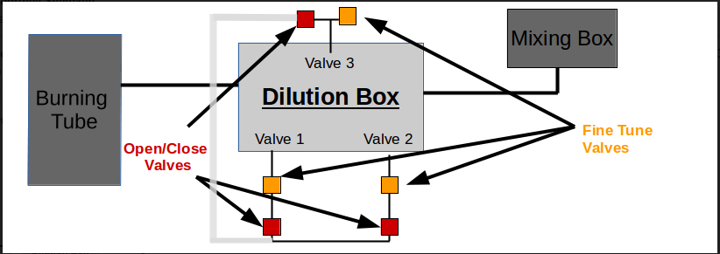

Figure : An illustration of the valve dilution system being tested. The dilution system takes air from the burning tube and provides a reduced concentration in the mixing box which is sampled by instruments such as the SMPS and CPC. The dilution system has three needle metering valves (Fine Tune Valves); two on the side and one on the top. The head of each needle valve is a stop valve (Open/Close Valves).

A screenshot of a cell phone

Description generated with high confidence

Figure 3: An illustration of the tank dilution system. The tank has a gauge for monitoring pressure. A vacuum line and compressed air filter line is attached for changing pressure within the tank. The inlet line, vacuum line, compressed air filter line, and sampling lines all have stop valves. There is an ejection port for the syringe to deposit a sample.

# Results and Discussion

To test the dilution system, the two blowers without the filter boxes are used, producing an air flow of 56.2 knots. Figure 4 shows the two blowers without filter boxes produce a lot of small particles that decrease in concentration with increasing particle size. The CPC started to count the diameter of the size distribution at 3 nm. The concentration of particles on the CPC were stabilized and consistent before the size distribution was collected. The log normalized concentration changes from about 100,000 particles at a diameter of 5 nm to 1,000 particles at 60 nm (Figure 4).

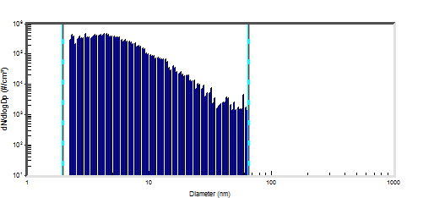

Figure 4: Size distribution of particles produced by the blowers measured on November 2nd, 2017 using a SMPS with a model 3775 CPC. The x-axis has the diameter of particles in nm starting at 3 nm and the y-axis has the concentration of particles in # cm-3.

Figure 5 shows the size distribution of the sample with both filter boxes and the blowers. The CPC started to count the diameter of the size distribution at 10 nm in Figure 5. The concentration is less than without the filter boxes (Figure 4) with concentrations between 10 to 1,000 # cm-3. Small diameter particles have higher concentration than larger diameter particles. Without the filter boxes, there are approximately 20,000 # cm-3 at 20 nm, while with filter boxes, there are approximately 200 # cm-3 at 20 nm. This is a two order difference in magnitude decrease. Hence, the filter boxes are effectively removing some of the particles produced by the blowers.

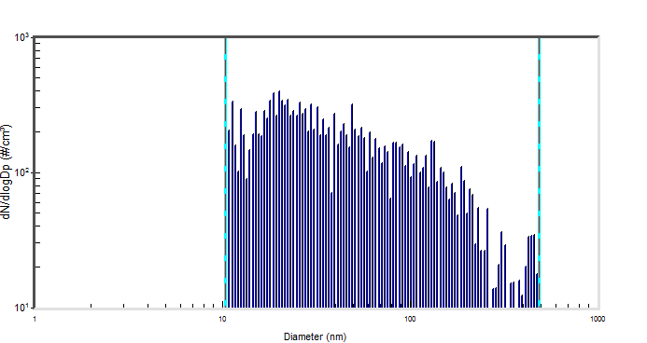

Figure 5: The size distribution measured using a SMPS and model 3772 CPC obtained on November 7th, 2017 with filter boxes used to reduce the particle concentration from the blowers. The x-axis is the diameter of particles in nm starting at 10 nm and the y-axis is the normalized concentration.

Figure 6 shows the concentration when testing the valve dilution system with both blowers and filter boxes operating. The metering valve has mixed in sufficient filter air to reduce the concentration from about a 1 to 10 to 1 to 100 dilution ratio. In Figure 6, 62,000 # cm-3 is the total concentration, and a 6,200±300 # cm-3 the amount factored by 10. Likewise, the second metering valve have reduced the concentration by a factor of 10. The combination of the two valves should have reduced the concentration sufficiently more than a factor of 100. Such a large decrease is difficult to achieve and maintain using the valve system to obtain high dilution ratios. Figure 6 shows the concentration decreasing to almost zero particles. Additionally, the two metering valves must be fine-tuned to produce the 1 to 100 dilution ratio, which is time consuming. Overall, the valve dilution system took approximately 2.5 hours to adjust (Figure 6).

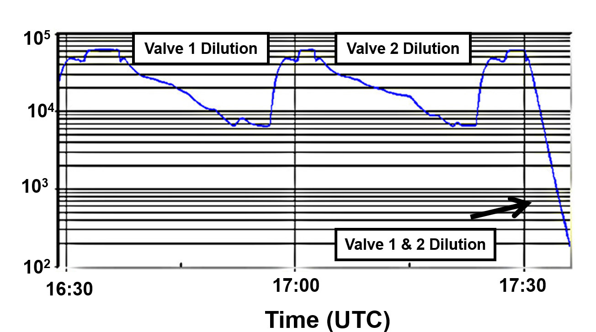

Figure 6: A time series plot of the CPC (model 3775) concentration obtain while testing the valve dilution system. The decreasing concentration is due to adjustment of the valves. Once a 1:10 dilution ratio was obtained, the concentration was sampled to determine how stable it is. After 17:30, both stop valves are opened to sample the combined dilution of both valves.

Equation 2 provides the numerical values applied to Equation 1 for a 10 gallon tank.

|  |  |
| --- | --- |
| $$10 gallon tank=\frac{3,785.41 ml}{1 gallon}=\frac{37,854.1 ml}{1 ml}=3.8*{10}^{4}$$ | (2) |
|  |  |

Using the full 1.0 ml collected by the syringe gives a $3.8*{10}^{4}$ dilution ratio. The dilution ratio can be increased by decreasing the volume of the syringe used or increasing the tank size. For example, if 1.0 ml of the syringe is changed to tenths, the dilution ratio would increase to 3.8 ${10}^{5}$* in a 10 gallon tank. Table 1 shows the dilution ratio for different size tanks using 1.0 ml syringe sample. The tank, in any type of gallons, must be over pressurized to provide an air sample for measurement instruments. Hence, the concentration within the tank is reduced. Table 2 gives the tank dilution ratios at different pressures using the Ideal Gas Law. Since sampling is done at reduced pressures, and not the tank pressure, the sample concentration is given by Equation 2. However, there was a dilution done when burning the AgI flares in the burning tube with an approximately 70 knot air flow inside of the burning tube (Delene and Otto 2017). As discussed before, the inside area of the burning tube is 4,188 mm2. The used AgI flares are 150 g and 5.68 g cm-3 density producing particles with an average diameter of 25 nm and burn for 4 minutes. Therefore, that brings the burning tube to produce 8.9* # cm-3 article concentration.

Table 1: The dilution ratio for different size tanks with the injection of 1.0 ml of a sample.

|  |  |
| --- | --- |
| Type of Tank(Gallon) | Dilution Ratio |
| 10 | 3.8 ${10}^{4}$* |
| 30 | 1.1 ${10}^{5}$* |
| 60 | 2.3 ${10}^{5}$* |
| 100 | 3.8 ${10}^{5}$* |

Table 2: The relationship between tank pressure and particle concentration ratio within the tank assuming a 10 gallon tank and 1.0 ml of sample. The concentration ratios are calculated using the Ideal Gas Law.

|  |  |
| --- | --- |
| Pressure [PSI] | Ratio |
| 5 | 1.3 |
| 10 | 1.7 |
| 15 | 2 |
| 20 | 2.4 |
| 25 | 2.7 |
| 30 | 3.1 |

# Conclusion

The filter boxes successfully reduced the particle concentration produced by the blowers. The SMPS measurements indicated that the filter boxes reduced the concentration in all particles sizes as expected. The valve dilution was found to be time consuming to obtain required dilution ratios. Meanwhile, the particle concentration from the two valves brought the values lower than the 1 to 100 dilution ratio. In the tank dilution system, a 0.1 ml sample injected to a 10 gallon tank provides a 3.8 ${10}^{5}$* dilution ratio. With 30 PSI tank pressure, the 10 gallon tank can provide a 3 Imp of flow for over 30 minutes. Initial tests of the tank dilution system indicate it is less time consuming than the valve dilution system: therefore, the tank dilution system will be used at MTU’s PI Cloud Chamber to test for effectiveness of the material in a controlled environment.

# Acknowledgement

I would like to acknowledge and thank my committee chair, David Delene, and my committee member, Mike Poellot for helping with my experiments, paper, and presentation. I’ll acknowledge the Senior Project course, and the students in the Atmospheric Science program at UND for guiding and pushing me to explore the options at the University. Finally, I would like to acknowledge and thank the one funding agency used in this project, the Department of Commerce: Research ND. All this help concludes the Characteristics of Silver Iodide used for Weather Modification Project; with results that will hopefully further experiments performed at MTU in their PI Cloud Chamber.

# References

Bergeron, T., 1935: On the physics of cloud and precipitation. Proc. 5th Assembly U.G.G.I. Lisbon. Vol. 2. p. 156

Delene, D. and Boe, B., 2016: Size Distribution Measurements of Seeding Nuclei. Weather Modification Incorporated, Accessed 27 November 2017, http://aerosol.atmos.und.edu/DeleneBoe_WMA2016_Presentation_160427.pdf.

Delene, D. and Otto, A., 2017: Design and Testing of a Sampling System for the ICE Flare Testing Project. Accessed 12 November 2017, http://aerosol.atmos.und.edu/ICEFlarePoster170511.pdf.

Findeisen, W., 1938: Kolloid-meteorologische Vorgänge bei Neiderschlags-bildung. *Meteor. Z.*, **55,**121–133

Schaefer, V. J., 1946: The production of ice crystals in a cloud of supercooled water droplets. *Science*, **104**, 457–459.

TSI, 2010: Model 3936 Scanning Mobility Particle Sizer™ (SMPS™) Spectrometer Operation and Service Manual. Accessed 10 May 2018, http://cires1.colorado.edu/jimenez-group/Manuals/SMPS_manual.

TSI, 2007: Model 3772/3771 Condensation Particle Counter Operation and Service Manual. Accessed 10 May 2018, http://www.wmo-gaw-wcc-aerosol-physics.org/files/cpc_3772-3771.pdf.

TSI, 2004: Model 3321 Aerodynamic Particle Sizer® Spectrometer Instruction Manual. Accessed 10 May 2018, http://www.wmo-gaw-wcc-aerosol-physics.org/files/aps_3321.pdf.

Weather Modification Association, 2001-2017: Project Location Map. MaltaNetwork, Accessed 3 May 2018, http://www.weathermodification.org/projectlocations.php.

Wegener, A., 1911: *Thermodynamik der Atmosphäre*. Barth, Leipzig.