**Snow and Rain Precipitation as Related to Red River Streamflow**

**Steven Sobus**

**University of North Dakota, Atmospheric Sciences Department, 4149 University Ave, Grand Forks, ND 58202**

**Abstract**

In a warming world, it can be gathered that areas that once saw snow will see more rain going forward. In areas such as the Red River Valley, winter snow has a large impact on the hydrology of the area, particularly concerning spring flood season, when all the snow melts. This study examines how precipitation is changing over time in the valley and see how that is influencing peak streamflow in the Red River. Data from the National Weather Service as well as the United States Geological Survey were used to analyze trends in winter snowfall, winter rainfall, and peak streamflow for the month of April. With this information, it has been determined that winter snowfall is increasing in Grand Forks. Winter rainfall is also increasing, but not as quickly as snowfall. Therefore, Grand Forks winters are trending snowier with an overall trend towards more moisture. This contradicts the hypothesis that Grand Forks is seeing increasing more rain than snow in the winter months. River flow rates during springtime are also increasing. This supports the hypothesis that increased snowfall leads to increased peak streamflow in the springtime, but results from the study were opposite of what was expected.

**Introduction**

The Red River Valley of the north is notorious for its seasonal spring floods. The long winters of the Northern Plains accumulate a substantial snowpack throughout the season. Come the thaw of spring warmth, all of this frozen water is melted. Naturally, the melt water will flow to the lowest point, which entails using existing rivers and streams. Eventually this meltwater all converges into the Red River, causing it to swell to several times its size in some places. Fortunately, much of the valley is rural farmland that will be largely unscathed once the water recedes. However, there are a few cities, such as Grand Forks and Fargo, that must pay close attention to the river heights during flood season. Consequences of ignoring river heights during spring flooding can be catastrophic, as seen in the great Grand Forks flood of 1997.

Typically, the winter season produces snow as the main source of precipitation. A warming world could cause much of the frozen precipitation we see in the Northern Plains to come in the form of rain instead. Such a shift in precipitation type could have a large effect on the streamflow of the Red River, particularly in the spring during flood season. This has already been seen in other parts of the world. One such example is in the Indus river basin in Pakistan. Like Grand Forks, the Indus river widens and floods its banks in the springtime as the winter snow melts in the Himalayas at the river’s headwaters. Romshoo & Marazi (2022) have conducted research showing a decrease in snowfall in the upper Indus basin. This in conjunction with warmer temperatures melting it sooner, have changed the timing of river flooding in the lower Indus river, as well as decreasing the streamflow of the river at its peak. These observations can be translated to the Red River Valley. A warmer world would likely mean less snow that needs to be melted. Everything else being the same, one can assume the peak flow rate would also be lower.

The purpose of this project is to determine how peak streamflow changes over the years as the climate warms. Studies showing this have been conducted around the world. One of interest was the previously mentioned Romshoo and Marazi (2022). This project will be unique in that it will focus on the Red River Valley, particularly in North Dakota and Minnesota. With the help of Dr. David Delene, streamflow around the valley will be collected and analyzed. Analysis similar to Romshoo and Mazari’s paper will be conducted to determine the changes in Red River streamflow. Using the trends that will be found, a better forecast for long range flooding in the Red River Valley can be conducted.

**Methodology**

Firstly, data needs to be gathered. Using data from the USGS, analysis can be conducted of the river flow rates of the Red River in Grand Forks. With that, data from the National Weather Service will provide precipitation data for the same period in the form of snowfall and total precipitation. Overlaying the data will bring to light possible trends. This will help determine if a decrease in snow affects the streamflow of the Red River.

The USGS has provided streamflow data for many points throughout the Red River Valley. Looking closely at the flow rate at Grand Forks and a few others can provide a bit of a picture for the region as a whole.

As seen in Figure 1, a sample period of seven years, 2007-2014 has been plotted. Shown is the river flow data for the Red River at East Grand Forks. Peaks in river flow correspond with the annual spring melting of snow in the region. Generally, the lowest troughs just before the sharp peaks are in wintertime when the river is frozen over. This seven year period mirrors the same seven year period Romshoo & Marazi used to make a similar plot. Using all available data, a plot focusing on the spring flood season can be made for a long period of time.

Data from the National Weather Service will be collected as well. The National Weather Service has total snowfall data per month available dating back to 1893. THis monthly data can be used to determine the total snowfall for each winter season by adding the total snowfalls of October through March. Next, total precipitation data is available. With the same procedure as snowfall, total winter precipitation can be calculated for each winter season. Winter rainfall can be calculated from there by subtracting the snow-water equivalent from the total precipitation.

Looking at seasonal precipitation type and amount, it can be determined the extent of increased rainfall or decrease in snowfall. Overlaying the data with the stream flow, or analyzing them side by side will show how streamflow has changed as a result in shifting precipitation type.

**Results**

Using precipitation data from the NWS in conjunction with river flow data from the USGS, trends can be detected over the past 130 years in the Red River Valley. Firstly, looking at total snowfall for months October-March, it can be seen that there is a general increase in seasonal snowfall gradually over the past 100 years. This can be seen in Figure 2, which shows the snow-water equivalent when using a constant ratio of twenty-one inches of snow to one inch of rain.

Snow-Water Equivalent = Snowfall / 21

Next, winter rainfall was calculated to find the total. No rainfall data was available, so a formula was used to find it by taking the difference of the snow-water equivalent with ratio 21:1 and the total precipitation for the winter.

Rainfall = Total Precipitation - Snow-Water Equivalent

Using anything less than this 21:1 ratio resulted in several years with negative values for rainfall. Although 21:1 is a higher ratio than desired, it is still useful to explore trends in the data. Rainfall for winter months for years 1883-2023 can be seen in Figure 3. A ratio between the total precipitation for the winter and the total snow-water equivalent was taken and is shown in Figure 4. Ratio values near 1 indicate years of more snow and less rain while values much greater than 1 indicate less snow and more rain.

Ratio = Total Precipitation / Snow-Water Equivalent

The other piece to the puzzle is river flow data. How has precipitation variation influenced the stream flow in the Red River for the month of April, which has traditionally been the peak month? The average for each year was calculated by averaging the streamflow for each of the 30 days in April for the years 1882-2024.

Yearly Average April Flow Rate = (Σ 1-30 April Daily Flow Rates) / 30

Yearly average April flow rate can be seen in Figure 5. With the yearly average April flow rate, it can be compared to the total precipitation / snow-water equivalent to locate any trends. Figure 6 illustrates the correlation between the two variables. Lower values near one for (snow+rain)/snow indicate snowier years. Those lower values largely coincide with years of higher yearly average April flow rates.

**Discussion**

Total snowfall seems to be increasing in the past 100 years, despite a general global trend of warming temperatures. A possible explanation for this is warmer air can hold more moisture, but it is still below freezing so it falls as snow. If warming continues, it would be interesting to see if this trend reverses in another 100-200 years. Winter rainfall is also increasing, which supports that Grand Forks is getting warmer and wetter in the winter months. The total precipitation to snow ratio has a slight trend towards snowier winters with less rain however. A simple linear trend line decreases towards 1 in Figure 4 (values of 1 indicate only snow for Oct-Mar). A possible explanation for this is winters are getting wetter, but autumn and spring could be getting dryer. Spring and autumn is when most of the liquid precipitation for this study would fall, in the months of October, November, and March, but research would need to be done.

Flow rates of the Red River have increased tremendously, especially in the last 40-50 years. Interestingly, snowfall has also increased drastically over that same time period. It seems more snow is falling in the winter, so more snow is on the ground that needs to be melted in the springtime. When it all becomes liquid, the river increases its flow rate even higher. This is highlighted by Figure 7, which compares the flow rate of the river with the winter precipitation ratio. The figure shows that years with values near one, years with mostly snow, river flow rates are higher. Compare that with years with very high ratios, years with lots of winter rain, and it can be seen those years have much lower flow rates.

**Conclusion**

Snowfall in the Red River Valley has increased contrary to the initial hypothesis. However, winter rainfall has also increased, indicating Grand Forks is getting wetter. Snowfall is increasing at a faster rate than rainfall is. This trend indicates winter precipitation is trending towards snow. An initial hypothesis suggested, similar to Romshoo and Marazi, that Grand Forks would see less snow and more rain, with precipitation trending towards more rainy winters. With the data gathered and the research conducted, it seems the opposite is happening. A second hypothesis suggested that a decrease in snowfall would lead to a decrease in peak river stream flow in the Red River. The Red River at Grand Forks is seeing an increasing trend in peak river streamflow, but this is paired with a trend of increasing snowfall. Therefore the principles behind the hypothesis are correct, but the outcomes were opposite of what was expected. Higher winter snowfall leads to higher peak streamflows in the spring compared to rainier winters leading to lower peak streamflow in the springtime. In the Red River valley, since we are seeing more winter snowfall in recent years, we are also seeing a higher April streamflow.

**Acknowledgements**

This report would not have been possible without the help of my committee members as well as some crucial data resources. Specifically, I would like to thank Dr. David Delene for his help with this research project. I would also like to thank Dr. Jianglong Zhang for his assistance to the research as well. This project would not have been possible without large, public datasets with climate and hydrologic data. I would like to thank the NOAA for having climate data and weather measurements available such as precipitation and snowfall. For hydrology, I’d like to thank the USGS for having Red River flow rate data publicly available going back over 100 years. It has been a pleasure to conduct this research with all this assistance.

**Figures**

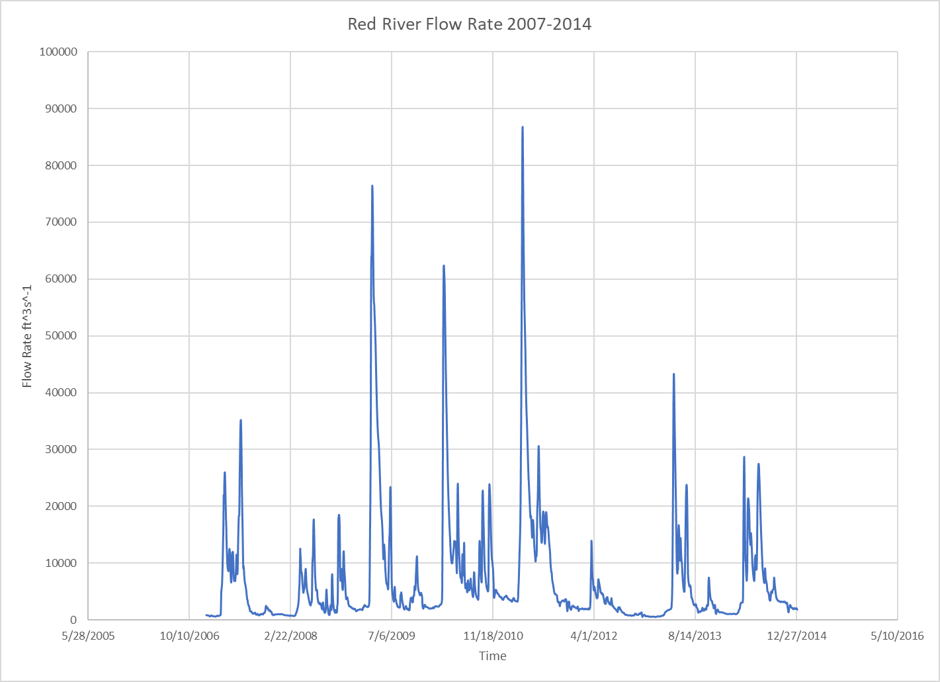

*Fig. 1: Red River Streamflow for seven year period 2007-2014.*

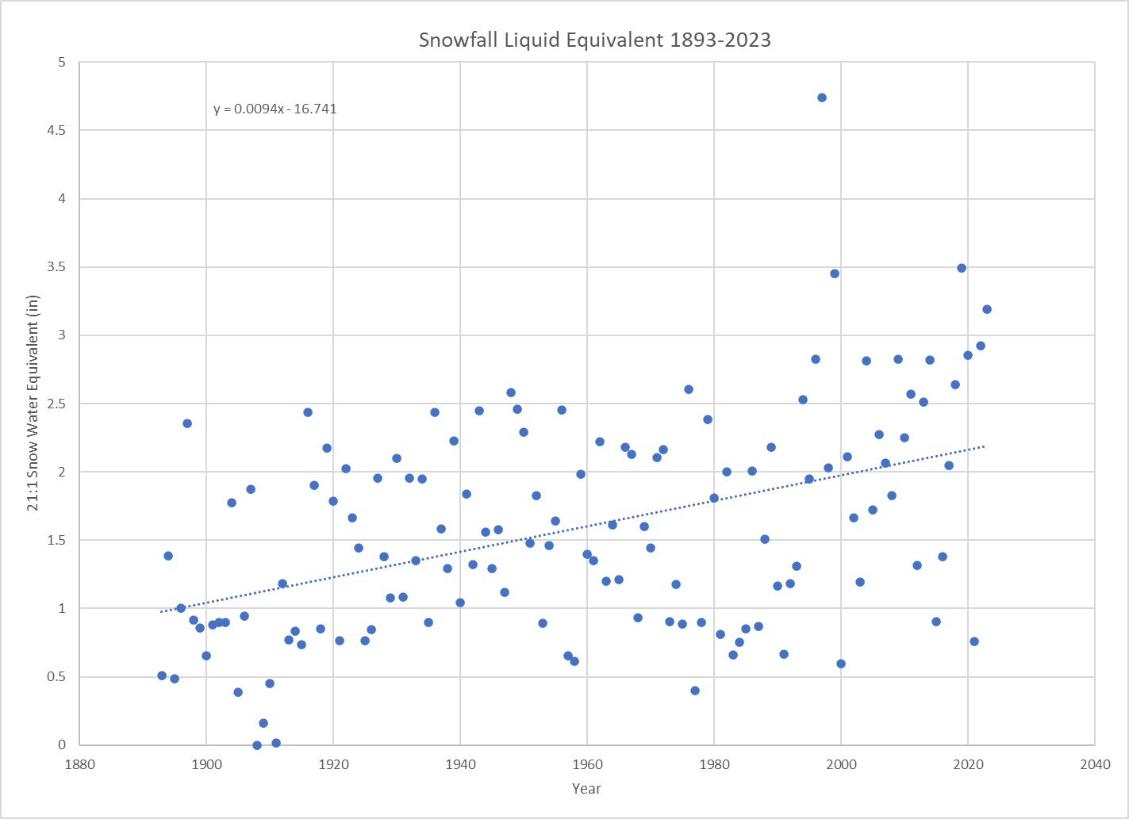

*Figure 2: Total Snowfall water equivalent when using a 21:1 snow to rain ratio for years 1883-2023.*

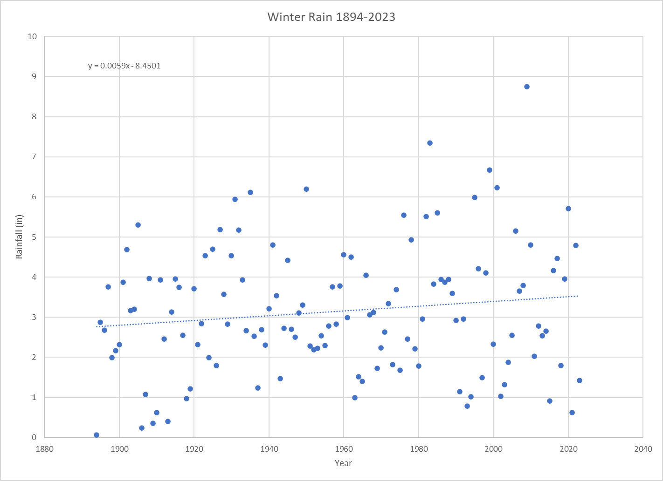

*Figure 3: Total winter rainfall for winters 1883-2023.*

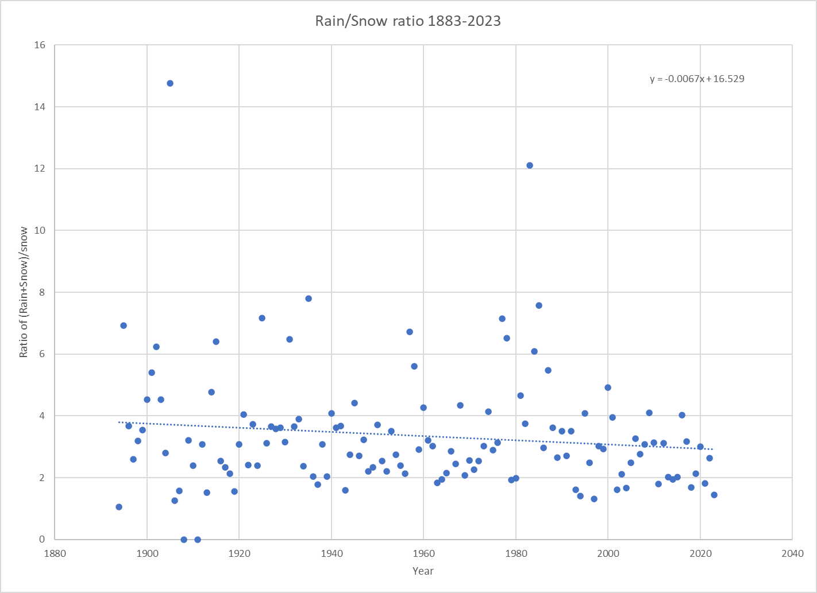

*Figure 4: Ratio of total winter precip/snow. Values closest to 1 indicate less rain.*

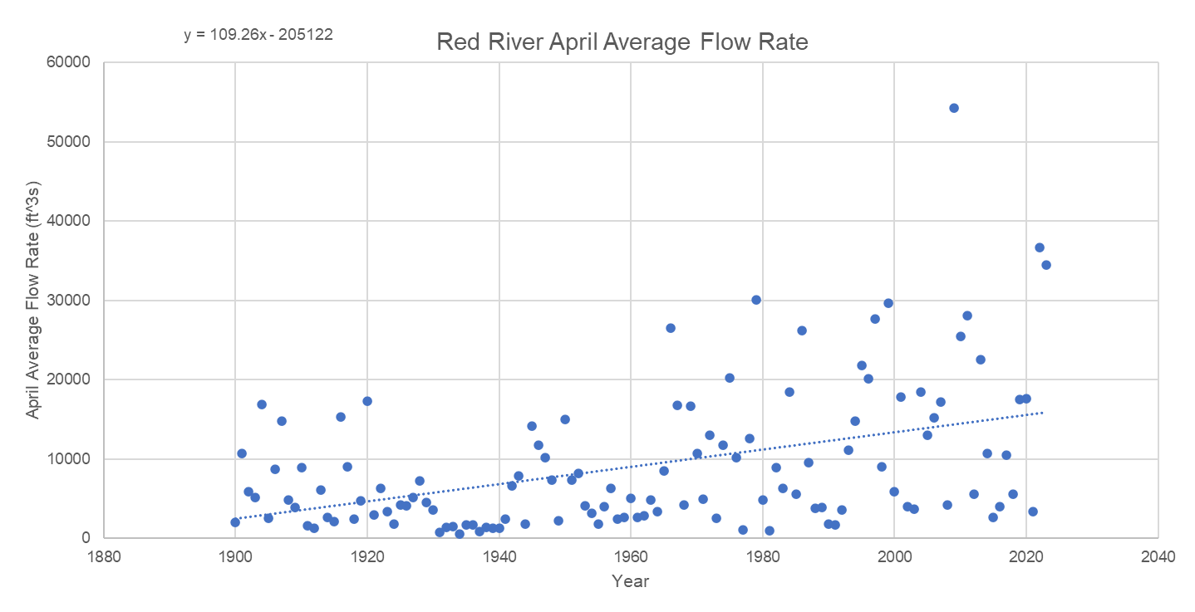

*Figure 5: Red River April Average Flow Rate in cubic feet per second for years 1900-2023.*

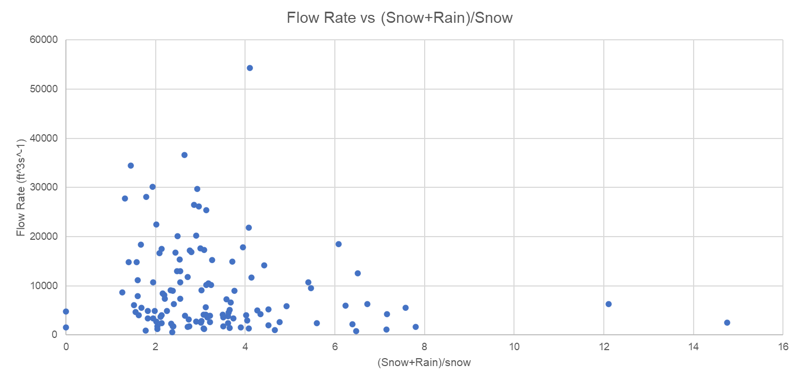

*Figure 6: Comparison of average April flow rate in the Red River vs the total precipitation divided by the snow water equivalent for the season's snowfall.*

**References**

Author links open overlay panelMatthew E. Tuftedal a b, a, b, Highlights•Western North Dakota rain gauges are used to analyze cloud seeding project.•Single and double target/control ratios are calculated to determine effectiveness of project.•Bootstrapping statistics determine natural variation in precipitation and , & AbstractThe North Dakota Cloud Modification Project (NDCMP) is a state-managed. (2021, December 29). Precipitation evaluation of the North Dakota Cloud Modification Project (NDCMP) using rain gauge observations. Atmospheric Research. Elsevier. https://www.sciencedirect.com/science/article/pii/S0169809521005524?via%3Dihub. Accessed 25 September 2023

Berghuijs, W. R., Woods, R. A., & Hrachowitz, M. (2014, May 18). A precipitation shift from snow towards rain leads to a decrease in streamflow. Nature News. Nature Publishing Group. https://www.nature.com/articles/nclimate2246. Accessed 25 September 2023

Clow, D. (2010, May 1). AMETSOC. https://journals.ametsoc.org/. Accessed 25 September 2023

Hale, K. E., Jennings, K. S., Musselman, K. N., Livneh, B., & Molotch, N. P. (2023, May 22). Recent decreases in snow water storage in western North America. Nature News. Nature Publishing Group. https://www.nature.com/articles/s43247-023-00751-3. Accessed 25 September 2023

Orkodjo, T., Kranjac-Berisevijevic, G., & Abagale, F. (2022, June). Impact of climate change on future precipitation amounts. Heliyon. https://www.cell.com/heliyon/fulltext/S2405-8440(22)00999-9. Accessed 26 September 2023

Romshoo, S.A., Marazi, A. Impact of climate change on snow precipitation and streamflow in the Upper Indus Basin ending twenty-first century. *Climatic Change* 170, 6 (2022). <https://doi-org.ezproxy.library.und.edu/10.1007/s10584-021-03297-5>