Dispersion and Mixing of Low Carbon Dioxide (CO2) Concentration Air from a Direct Air Capture (DAC) Module
Dr. David Delene1 and Liz Cardoza2
1Research Professor and Aerospace Research Fellow, University of North Dakota
2Undergraduate Student Researcher, University of North Dakota

Summary
The diffusion and mixing of air with lower carbon dioxide (CO2) concentration is important for assessing direct air capture (DAC) modules’ impact on the local atmosphere. A DAC module releases air to the atmosphere after passing through the chemical sorption within the system. DAC modules releasing air at three different CO2 concentrations (252 ppm for 40 % removal, 168 ppm for 60 % removal, and 4 ppm for 99 % removal) are evualated. The current, seasonally averaged ambient air has a CO2 concentration of approximately 420 ppm. Note that in 1960, the CO2 concentration was approximately 320 ppm. Using gas diffusion equations, the CO2 modules in the low CO2 concentration air travels a distance of 18 m in approximately 10 s. Using a Gaussian dispersion model and a 3 m/s wind speed, the CO2 concentration is determined to return to background levels in 56 m (183 ft) for 40 % removal, 75 m (246 ft) for 60 % removal, and 102 m (324 ft) for 99 % removal. Hence, the overall area affected (with wind in any direction) is relatively small at approximately at 12,544 m2 (3.1 acres) for 40 % CO2 removal and approximately 41,616 m2 (10.3 acres) for 99 % CO2 removal.

Methodology
Gas particle movement from high to low concentration is directly proportional to the concentration gradient. The change in concentration with time can be predicted using the diffusion equation. The diffusion equation is a partial differential equation that describes the macroscopic behavior of many gas particles in Brownian (random) motion. The diffusion equation describes a type of mass transport that relies on random motions of the particles to gradually distribute mass according to the conditions of the system. Atmospheric diffusion is in three dimensions and follows a linear differential equation. The diffusion coefficient of CO2 at 1 atm (atmosphere) of pressure and an air temperature of 20 oC is 0.16 cm2/s (The Engineering ToolBox 2018). Using the CO2 diffusion coefficient and a diffusion time of 10 s, the average distance traveled is by a CO2 molecule is 18 mm. These types of simple textbook diffusion calculations can be extended to include atmospheric conditions and used to determine the amount of time a parcel of air with reduced CO2 concentration takes to return to ambient levels.
While there have been studies modeling the dispersion of CO2 release from pipeline leakages (Herzog and Egbers 2013), the dispersion of low concentration of CO2 into the atmosphere is much simpler because the mixing gases are ideal gases at typical atmospheric pressure and temperature. For atmospheric mixing, it is best to use a Gaussian dispersion model that takes the emission rate, emission height, atmospheric stability, and wind speed into account to determine the concentration downwind. The WKC Group has a Gaussian model (WKC Group) available online, which is used to determine the concentration of CO2 downwind of a DAC module using parameter that represent a “worst-case” (lowest CO2) evaluations. The DAC module is assumed to produce an air parcel with low concentration CO2 air having the properties given in Table 1. Assuming an atmospheric CO2 of 420 ppm (Figure 1), the DAC capture fraction of 60 % indicates a plume emission concentration of 252 ppm. Note that in 1960, the CO2 concentration was approximately 320 ppm. Based on ice core data, the CO2 concentration in 1750 was approximately 278 ppm (MacFarling Meure et al. 2006).
Table 1: List of properties related to a direct air capture (DAC) module. DAC size and area are given in length (L), width (W) and height (H) dimensions. The plume equivalent diameter is the diameter of a circle with the same area as the DAC module area, using the length multiplied by height (LxH) dimensions.
Description | Parameter
Air Flow Rate | 100,000 m3 / hr
Evaluated Capture Fractions | 40 %; 60 %; 99 %
Module Size (LxWxH) | 19.5 m x 9.8 m x 10.4 m (64 ft x 32 ft x 34 ft)
Module Area (LxH) | 202.8 m2
Plume Equivalent Diameter | 16.1 m
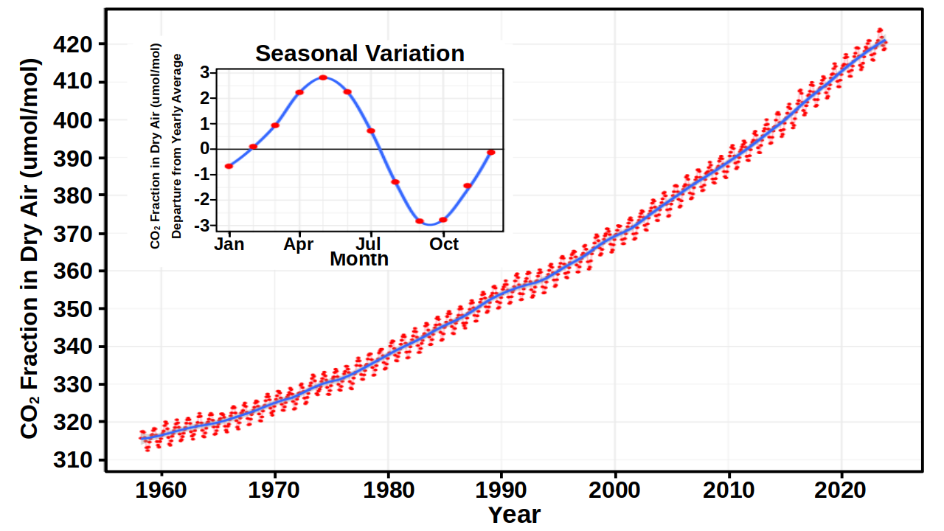
Figure 1: Plot showing the atmospheric CO2 concentration measured at Mauna Loa Observatory in Hawaii. Concentration has units of μmole per mole, or parts-per-million (ppm, 10-6). Data is from Dr. Pieter Tans, NOAA/ESRL (https://gml.noaa.gov/ccgg/trends) and Dr. Ralph Keeling, Scipps Institution of Oceanography (https://scrippsco2.ucsd.edu/), with the plot access on 2023-12-15, https://w.wiki/4ZWn, which is enhanced from the original version.
While Gaussian plume dispersion models are typically used to determine the downwind concentration of pollutants released from stacks, the physics of dispersion is not restricted to pollutants; therefore, CO2 reduction from a DAC can be determined using Gaussian dispersion model. Parameters for this Gaussian dispersion model are based on average June conditions in North Dakota (Table 2). These atmospheric conditions are based on when crops are rapidly growing, and removing CO2 from the atmosphere (Figure 1). The seasonal variation subplot in Figure 1 shows the greatest decrease in CO2 concentration in June and July. North Dakota has strong, summer, day-time insolation (solar radiation) and surface wind speed of 2-3 m/s (Figure 2), which results in an atmospheric stability class of “A” in accordance with the Pasquill-Guifford scheme. While the June monthly average wind speed is used for the evaluation, the July and August monthly averaged wind speeds are the similar. While there are periods with wind speeds much higher than the monthly average, the high wind speed produces a more turbulence near surface atmosphere, which will enhance mixing. Therefore, the use of the average wind speed in June is the worst-case wind speed option. We use 20 oC as the ambient atmosphere since it is an often used temperature and is representative of day-time North Dakota. Additionally, atmospheric temperature has little effect on the modeling results. To keep things as simple as possible, we also used 20 oC as the stack gas exit temperature since DAC emitted gas is not very hot and should quickly reach equilibrium with the ambient environment. The Gaussian dispersion model also uses coefficients based on North Dakota being a rural environment.
Table 2: List of parameters used for the Gaussian dispersion model. The Stack Gas Velocity is calculated using the 100,000 m3 / hr DAC flow rate (Table 1) and the stack area.
Description | Parameter
Anemometer Height | 5 m
Wind Speed at Anemometer Height | 3 m/s
Stack Height (H/2) | 5.2 m
Stack Diameter | 16.1 m
Stack Gas Exit Velocity | 0.0 m/s
Stack Gas Exit Temperature | 293.15 K (20.0 oC)
Ambient Air Temperature | 293.15 K (20.0 oC)
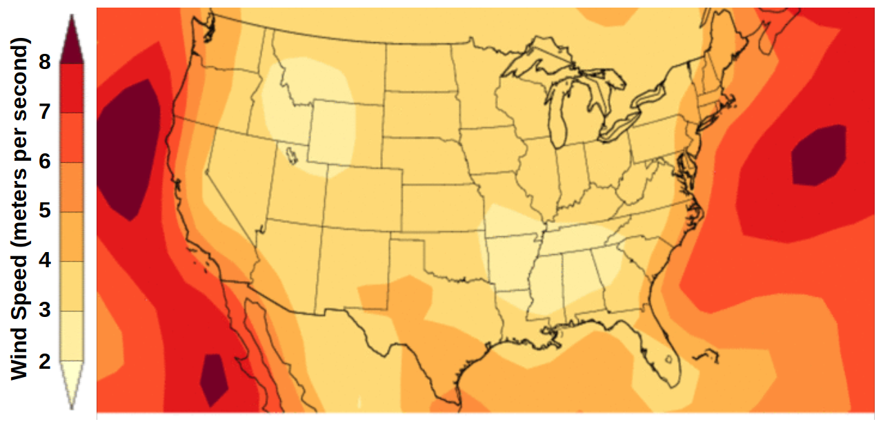
Figure 2: Plot showing the average 3 m wind speed for June 2023. Plot is produced by enhancing version obtained from the National Centers for Environmental Information, National Oceanic and Atmospheric Administration (NOAA), see plot available at https://www.ncei.noaa.gov/access/monitoring/wind/maps/202306.

Analysis and Discussion
Using the Gaussian dispersion model parameter, the concentration along the center-line of the air parcel is calculated at different distances downwind (Table 3). The air parcel center-line is a worst-case option; as ambient, higher CO2 concentration air mixes in from the sides of the air parcel, the CO2 concentration has a higher concentration than at the center-line. Likewise, the height above ground where the CO2 concentration removal is the highest is used to determine the atmospheric concentration, and a 0.0 m/s vertical velocity is used that provides the lowest CO2 concentration at the surface, where plants take in CO2 as they grow.
Table 3: List of the Gaussian dispersion model determined CO2 concentration downwind of the Direct Air Capture (DAC) module using different percentages of CO2 initially removed by a DAC module. The calculations uses an unperturbed CO2 concentration of 420 ppm, a rate of 8.53 g/s of CO2 removed, a stack exit velocity of 0.0 m/s and parameters listed in Table 2. Height is the distance above ground level (AGL) of the maximum amount of CO2 removal. The CO2 Concentration Removed is the greatest amount of CO2 removed at the Downwind Distance, which is provided by the Gaussian dispersion model. The Atmospheric Concentration is the lowest concentration of atmospheric CO2 at the Downwind Distance.
DAC CO2 Removal | Downwind Distance | Height (AGL) | CO2 Concentration Removed | Atmospheric Concentration
40 % | 0 m (0 ft) | N/A | 307 mg/m3 | 252 ppm
40 % | 5 m (16 ft) | 5.2 m | 159 mg/m3 | 333 ppm
40 % | 30 m (98 ft) | 4.1 m | 12 mg/m3 | 354 ppm
40 % | 56 m (183 ft) | 0.0 m | 5 mg/m3 | 417 ppm
60 % | 0 m (0 ft) | N/A | 461 mg/m3 | 168 ppm
60 % | 5 m (16 ft) | 5.2 m | 238 mg/m3 | 289 ppm
60 % | 30 m (98 ft) | 4.1 m | 18 mg/m3 | 410 ppm
60 % | 75 m (246 ft) | 0.0 m | 5 mg/m3 | 417 ppm
99 % | 0 m (0 ft) | N/A | 761 mg/m3 | 4 ppm
99 % | 5 m (16 ft) | 5.2 m | 394 mg/m3 | 205 ppm
99 % | 30 m (98 ft) | 4.1 m | 30 mg/m3 | 404 ppm
99 % | 102 m (324 ft) | 0.0 m | 5 mg/m3 | 417 ppm
The analysis parameter and conditions used the Gaussian dispersion model (Table 3) are for the worst-case conditions, in terms of having the lowest concentration of CO2 the furthest away from the DAC module. A 3 ppm level is used for the return to ambient condition level since 3 ppm is the range of seasonal CO2 variation (Figure 1). For example, using the 3 ppm of ambient atmospheric concentration level, it takes 102 m (324 ft) from the DAC module for CO₂ concentrations to return to background levels. Hence, the area affected is approximately 12,544 m2 ((56m*2)*(56m*2)) for 40 % CO2 removal and approximately 41,616 m2 ((102m*2)*(102m*2)) for 99 % CO2 removal. Therefore, the distance and amount of land affected by a DAC module is relatively small. If multiple DAC modules are arranged in an array, regardless of the amount, the approximate distance of affected areas of lower CO2 concentration is estimated to be no more than double the distance impacted by one DAC module. Further modeling would be needed to determine the exact distance.

About the Authors
Dr. David Delene is a Research Professor in the Department of Atmospheric Sciences, the Aerospace Research Fellow in the John D. Odegard School of Aerospace Sciences and President of Open Science Associates. Dr. Delene received a Bachelor of Science (B.S.) in Applied Physics from Michigan Technological University in May 1993. As a graduate student in Geophysics at Michigan Technological University, Dr. Delene conducted research on remote sensing of volcanic ash clouds. During Ph.D. research at the University of Wyoming, Dr. Delene worked on balloon-borne aerosol observations. Dr. Delene spent two years as a Research Associate at the Cooperative Institute for Research in Environmental Sciences in Boulder Colorado, working on evaluating uncertainties in satellite retrievals of aerosol optical depth before coming to the University of North Dakota (UND) in 2001. At UND, Dr. Delene has focused on conducting airborne measurements to understand aerosol-cloud interaction and precipitation formation. Measurements from research aircraft, radar, surface and satellite observations provides new information for understanding cloud and precipitation processes.
Dr. Delene leads an internationally known team of researchers conducting atmospheric measurements and research projects. Dr. Delene is co-author on over 25 peer-reviewed papers and over 200 conference presentations, is lead developer of the Airborne Data Processing and Analysis software package, has been involved with the creation of over 40 scientific data sets, and has mentored 50 undergraduate students and 30 graduate students on research projects. Dr. Delene’s LLC company, Open Science Associates, customers include the Korea Meteorological Administration, the National Science Foundation, Weather Modification International, and Environmental Canada. Dr. Delene teaches the Atmospheric Chemistry, Air Quality, Measurement Systems, and Applied Weather Modification courses in the Department of Atmospheric Sciences at UND. A comprehensive list of Dr. Delene’s scientific career is available in his online Curriculum Vitae, see http://aerosol.atmos.und.edu/vitae.html.
Liz Cardoza is one of 10 students at UND during the summer of 2024 as part of a National Science Foundation (NSF) Research Experience for Undergraduates program. Liz Cardoza is a student at Drury University studying Biochemistry, with minors in Physics, Environmental Policy, and Pre-Law. Cardoza has designed science curricula for the Discovery Center of Springfield, Missouri since 2018. In 2021, Cardoza researched nanoparticle interactions with bacterial systems and accessible lab equipment design with The University of Miami’s Chemistry Department. In 2023, Cardoza was a scholar through the Reagan Presidential Foundation’s Leadership in the American Presidency program and wrote for the International Virtual Reality in Healthcare Association.

Acknowledgment
Dr. David Delene’s support for work related to this article is provided by the service proportion of his annual contract with the University of North Dakota as a Research Professor in the Department of Atmospheric Sciences. Liz Cardoza has support provided by a National Science Foundation (NSF) award to the University of North Dakota, which has the awarded number of 2244530 and title of “REU Site: Interdisciplinary Renewable and Environmental Collaborative (IREC)”. In accordance with the author’s obligation as researchers, the authors declare that they no financial or business interest that may have affected the research reported in this article.

References
MacFarling Meure, C., D. Etheridge, C. Trudinger, P. Steele, R. Langenfelds, T. van Ommen, A. Smith, and J. Elkins, 2006: Law Dome CO2, CH4 and N2O ice core records extended to 2000 years BP. Geophys. Res. Lett., 33, https://doi.org/10.1029/2006GL026152.
The Engineering ToolBox, 2018: Air - Diffusion Coefficients of Gases in Excess of Air. Eng. ToolBox,. https://www.engineeringtoolbox.com/air-diffusion-coefficient-gas-mixture-temperature-d_2010.html (Accessed May 28, 2024).
WKC Group, Online Air Dispersion Model. WKC Group,. https://www.wkcgroup.com/tools-room/online-air-dispersion-model/ (Accessed May 29, 2024).

